**PM-SIU-CTP手冊**

目錄

PM-SIU-TC00 5

PM-SIU相關主機 5

1. 可連續每十五分鐘收集PM file，測兩個十五分鐘資料 6

2. TC02: 比對NBI與網管PM的R/H/D內容一筆，包含10個Counter/KPI 7

2.1 驗證項目 7

2.2 驗證方式 7

2.3 驗證條件 7

2.4 驗證流程 9

2.4.1 ​​從NBI BO R查出一筆資料的10個counter/KPI 9

2.4.2 從網管Raw Data R查出一筆資料的10個counter/KPI 9

2.4.3 比對NBI BO R和網管Raw Data R的結果 11

2.4.4 從NBI BO H查出一筆資料的10個counter/KPI 11

2.4.5 從網管Raw Data H查出一筆資料的10個counter/KPI 11

2.4.6 比對NBI BO H和網管Raw Data H的結果 13

2.4.7 從NBI BO D查出一筆資料的10個counter/KPI 13

2.4.8 從網管Raw Data D查出一筆資料的10個counter/KPI 13

2.4.9 比對NBI BO D和網管Raw Data D的結果 15

2.5 ​​驗證總結 15

3. PM Server收到轉入DB所需時間 (15分鐘內處理完) 16

4. PM Server PM KPI處理效能(15分鐘KPI處理完成) 17

5. PM資料回補一個15分鐘場景的測試 18

6. PM資料回補一個小時場景的測試 21

7. PM資料回補一天場景的測試 25

8. 指定一天測試 RAW DATA R/H分別套用公式計算是否等於D 30

9. 指定一天測試 KPI R/H分別套用合併公式是否等於D 33

10. 測試GUI各篩選功能是否正常 34

10.1 Raw Data網頁查詢結果與DB查詢結果一致 34

10.1.1 Raw Data時間類型-Daily 34

10.1.2 Raw Data時間類型-30 Days 37

10.1.3 Raw Data時間類型-Hourly 42

10.1.4 Raw Data時間類型- RealTime (1 day) 46

10.1.5 Raw Data時間類型- RealTime (3 days) 50

10.2 KPI網頁查詢結果與DB查詢結果一致 54

10.2.1 KPI時間類型-Daily 54

10.2.2 KPI時間類型-30 Days 59

10.2.3 KPI時間類型-Hourly 63

10.2.4 KPI時間類型- RealTime (1 day) 68

10.2.5 KPI時間類型- RealTime (3 days) 72

10.3 自訂Web KPI及驗算 77

10.3.1 查詢KPI Table現有的column 77

10.3.2 利用現有column自訂一個KPI 77

10.3.3 驗算網頁查詢結果 78

10.3.4 刪除自訂KPI 79

附件1. SIU KPI對照表 81

11. 檢查PM raw file housekeeping 機制正常 82

12. 檢查PM MySQL housekeeping 機制正常 84

13. TC_13 檢查下載檔案數量低於告警門檻值時發Alert email 87

13.1 驗證項目 87

13.2 驗證方式 87

13.3 驗證條件 87

13.4 驗證流程 87

13.4.1 登入Raw Data Server檢查2個時段檔案數量 87

13.4.2 登入到AP Server 檢查原始文件2個時段的檔案數量 88

13.4.3 從DB Server檢查下載紀錄的2個時段的檔案數量 88

13.4.4 比對前面3點上的2個時段檔案數量相同 89

13.4.5 在DB Server修改SIU的告警門檻值為原值的2倍 90

13.4.6 手動執行Alert回查機制產生Raw Data的告警訊息 91

13.4.7 Alert機制的發email功能使User可收到Alert email 93

13.4.8 擷取User的Alert email 93

13.4.9 驗證Alert email與Alert DB告警數一致 94

13.4.10 驗證Alert email與Alert DB測試告警內容一致 94

13.4.11 環境復原 96

13.4.12 環境復原驗證 96

13.5 驗證總結 97

14. TC_14 檢查KPI R/H/D 資料筆數低於告警門檻值時發Alert email 98

14.1 驗證項目 98

14.2 驗證方式 98

14.3 驗證條件 98

14.4 驗證流程 98

14.4.1 登入到KPI DB查詢R/H/D各1個sdate的資料量 98

14.4.2 從Alert DB檢查KPI執行紀錄R/H/D各1個sdate的資料量 99

14.4.3 比對KPI DB和Alert DB上的相同sdate的資料量相同 100

14.4.4 在DB Server修改SIU的告警門檻值為原值的2倍 100

14.4.5 手動執行Alert回查機制產生R/H/D時段的告警訊息 101

14.4.6 Alert機制的發email功能使User可收到Alert email 102

14.4.7 擷取User的Alert email並計算筆數 103

14.4.8 驗證Alert email與Alert DB告警數一致 104

14.4.9 驗證Alert email與Alert DB測試告警內容一致 104

14.4.10 環境復原 106

14.4.11 環境復原驗證 106

14.5 驗證總結 107

15. 檢查counter (MAX/MIN/AVG/SUM)的值正確 108

16. 能自訂counter 的滙整規則( MAX/MIN/AVG/SUM) 113

17. 驗證Parsing Log 是否生成 123

PM-SIU-TC00

CTP測試項目:

TC01: 可連續每十五分鐘收集PM file，測兩個十五分鐘資料

TC02: 比對NBI與網管PM的R/H/D內容一筆，包含10個Counter/KPI

TC03: PM Server收到Counter轉入DB 所需時間 (15分鐘內處理完)

TC04: PM Server PM KPI處理效能(15分鐘KPI處理完成)

TC05: PM資料回補一個15分鐘場景的測試

TC06: PM資料回補一個小時場景的測試

TC07: PM資料回補一天場景的測試

TC08: 指定一天測試 RAW DATA R/H分別套用公式計算是否等於D

TC09: 指定一天測試 KPI R/H分別套用合併公式是否等於D

TC10: 測試GUI各篩選功能是否正常

TC11: 檢查PM raw file housekeeping 機制正常

TC12: 檢查PM MySQL housekeeping 機制正常

TC13: 檢查下載檔案數量低於告警門檻值時發Alert email

TC14: 檢查KPI R/H/D 資料筆數低於告警門檻值時發Alert email

TC15: 檢查counter (MAX/MIN/AVG/SUM)的值正確

TC16: 能自訂counter 的滙整規則( MAX/MIN/AVG/SUM)

TC17: 驗證Parsing Log 是否生成

PM-SIU相關主機

* AP server: 172.26.37.4
* DB server: 172.26.37.4
* RAW file server: 172.26.60.56
* mail server: 10.108.58.152
* Raw Data web address:  
  <http://172.21.1.181/ERT_PM/release/SIU/SIU_Raw.php>
* KPI web address:  
  <http://172.21.1.181/ERT_PM/release/SIU/SIU_KPI.php>

# 可連續每十五分鐘收集PM file，測兩個十五分鐘資料

|  |  |  |
| --- | --- | --- |
| Test Case | TC_01 | |
| Description | 每15分鐘可下載檔案，觀察2個週期 | |
| Test Execution | 1. 驗證ERT產檔時間(一般會比end date晚5分鐘) 2. 驗證crontab設定的執行時間，抓檔時間會設在end date+8分鐘啟動 | |
| Excepted Result | 1. ERT產檔時間      1. crontab設定的執行時間      1. 檢驗下載程式及執行log | |
| Result: | ■ OK □ NOK |

# TC02: 比對NBI與網管PM的R/H/D內容一筆，包含10個Counter/KPI

## 驗證項目

* ​NBI BO R和​網管Raw Data R一筆資料的10個counter/KPI數值一致
* ​NBI BO H和網管Raw Data H一筆資料的10個counter/KPI數值一致
* ​​NBI BO D和網管Raw Data D一筆資料的10個counter/KPI數值一致

## 驗證方式

* 從NBI BO R查出一筆資料的10個counter/KPI
* 從網管Raw Data R查出一筆資料的10個counter/KPI
* 比對NBI BO R和網管Raw Data R的結果
* 從NBI BO H查出一筆資料的10個counter/KPI
* 從網管Raw Data H查出一筆資料的10個counter/KPI
* 比對NBI BO H和網管Raw Data H的結果
* 從NBI BO D查出一筆資料的10個counter/KPI
* 從網管Raw Data D查出一筆資料的10個counter/KPI
* 比對NBI BO D和網管Raw Data D的結果

## 驗證條件

* 取得日期為2019-05-01 的3個NBI BO的R/H/D report

NBI BO R文件: IP RAN, Transport Integrity (Day)_SIU-Test_R_20190501.xlsx

NBI BO H文件: IP RAN, Transport Integrity (Day)_SIU-Test(Hourly)_20190501.xlsx

NBI BO D文件: IP RAN, Transport Integrity (Day)_SIU-Test_20190501.xlsx

* R資料過濾條件
  + sdate: 2019-05-01 10:30:00
  + SIU: SIU_521007
  + MOID
    - Counter
      * Ethernet Interface=4G_RBS
    - KPI
      * VLAN=4G_RBS;4G_DATA
      * TGTransport=AC521007
* H資料過濾條件
  + sdate: 2019-05-01 10:00:00
  + SIU: SIU_220077
  + MOID
    - Counter
      * Ethernet Interface=4G_RBS
    - KPI
      * VLAN=4G_RBS;4G_DATA
      * TGTransport=AN220077
* D資料過濾條件
  + sdate: 2019-05-01 00:00:00
  + SIU: SIU_981011
  + MOID
    - Counter
      * Ethernet Interface=4G_RBS
    - KPI
      * VLAN=4G_RBS;4G_DATA
      * TGTransport=AN981011
* Ethernet Interface Counter查詢條件
  + 7個counter
    - ifHCInOctets
    - ifHCOutOctets
    - ifHCInUcastPkts
    - ifHCOutUcastPkts
    - ifHCOutBroadcastPkts
    - ifHCInMulticastPkts
    - ifHCOutMulticastPkts
* 3個KPI公式
  + - 展開

|  |  |  |
| --- | --- | --- |
| 週期 | KPI Name | KPI Formula |
| R | VLAN Ingress (frames/s) | (VLAN.ifHCInBroadcastPkts+ VLAN.ifHCInMulticastPkts+ VLAN.ifHCInUcastPkts)/(15*60) |
| R | GSM Downstream (kbit/s) | (TGTransport.inAbisOctets*8)/ (15*60*1000) |
| R | VLAN Egress (kbit/s) | (VLAN.ifHCOutOctets*8)/(15*60*1000) |
| H | VLAN Ingress (frames/s) | (VLAN.ifHCInBroadcastPkts+ VLAN.ifHCInMulticastPkts+ VLAN.ifHCInUcastPkts) /(60*60) |
| H | GSM Downstream (kbit/s) | (TGTransport.inAbisOctets*8)/ (60*60*1000) |
| H | VLAN Egress (kbit/s) | (VLAN.ifHCOutOctets*8)/ (60*60*1000) |
| D | VLAN Ingress (frames/s) | (VLAN.ifHCInBroadcastPkts+ VLAN.ifHCInMulticastPkts+ VLAN.ifHCInUcastPkts) /(1440*60) |
| D | GSM Downstream (kbit/s) | (TGTransport.inAbisOctets*8)/ (1440*60*1000) |
| D | VLAN Egress (kbit/s) | (VLAN.ifHCOutOctets*8)/ (1440*60*1000) |

* + - Stored Procedure形式
      * R: @PeriodMinutes = 15
      * H: @PeriodMinutes = 60
      * D: @PeriodMinutes = 1440

|  |  |
| --- | --- |
| KPI Name | KPI Formula |
| VLAN Ingress (frames/s) | (VLAN.ifHCInBroadcastPkts+ VLAN.ifHCInMulticastPkts+ VLAN.ifHCInUcastPkts)/(@PeriodMinutes*60) |
| GSM Downstream (kbit/s) | (TGTransport.inAbisOctets*8)/ (@PeriodMinutes*60*1000) |
| VLAN Egress (kbit/s) | (VLAN.ifHCOutOctets*8)/ (@PeriodMinutes*60*1000) |

## 驗證流程

### ​​從NBI BO R查出一筆資料的10個counter/KPI

* 請網管人員從NBI BO查出符合驗證條件-R資料過濾條件且符合驗證條件-Ethernet Interface查詢條件的資料
  + sdate: 2019-05-01 10:30:00
  + SIU: SIU_521007
  + MOID
    - Counter
      * Ethernet Interface=4G_RBS
    - KPI
      * VLAN=4G_RBS;4G_DATA
      * TGTransport=AC521007
* 從資料選出

|  |  |  |
| --- | --- | --- |
|  | counter/KPI | NBI BO R |
| ifHCInOctets | counter | 69741364 |
| ifHCOutOctets | counter | 717654377 |
| ifHCInUcastPkts | counter | 334574 |
| ifHCOutUcastPkts | counter | 642441 |
| ifHCOutBroadcastPkts | counter | 0 |
| ifHCInMulticastPkts | counter | 899 |
| ifHCOutMulticastPkts | counter | 898 |
| VLAN Ingress (frames/s) | KPI | 345.955555555556 |
| GSM Downstream (kbit/s) | KPI | 10.0856355555556 |
| VLAN Egress (kbit/s) | KPI | 6356.96278222222 |

### 從網管Raw Data R查出一筆資料的10個counter/KPI

* 登入SIU DB Server 主機，​IP為172.26.37.4，用戶名為ert_pm_parser
* 網管Raw Data R查出符合驗證條件-R資料過濾條件的驗證條件-Ethernet Interface查詢條件
  + sdate: 2019-05-01 10:30:00
  + SIU: SIU_521007
  + MOID
    - Counter
      * Ethernet Interface=4G_RBS
    - KPI
      * VLAN=4G_RBS;4G_DATA
      * TGTransport=AC521007
* 查詢命令如下

用putty登入172.26.37.4後

mysql -uert_pm_parser -p

-- 指定DB為Raw Data R

USE ERT_SIU_R;

-- 設定@PeriodMinutes參數

SET @PeriodMinutes = 15;

-- 驗證條件-R資料過濾條件

SET @sdate = '2019-05-01 10:30:00', @SIU_ID = 'SIU_521007', @EthernetInterface = '4G_RBS', @VLAN='4G_RBS;4G_DATA', @TGTransport='AC521007';

SELECT ifHCInOctets, ifHCOutOctets, ifHCInUcastPkts, ifHCOutUcastPkts, ifHCOutBroadcastPkts, ifHCInMulticastPkts, ifHCOutMulticastPkts

INTO @ifHCInOctets, @ifHCOutOctets, @ifHCInUcastPkts, @ifHCOutUcastPkts, @ifHCOutBroadcastPkts, @ifHCInMulticastPkts, @ifHCOutMulticastPkts

FROM EthernetInterface WHERE sdate = @sdate AND ManagedElement = @SIU_ID AND EthernetInterface = @EthernetInterface;

SELECT

(VLAN.ifHCInBroadcastPkts+VLAN.ifHCInMulticastPkts+VLAN.ifHCInUcastPkts)/(@PeriodMinutes*60),

(VLAN.ifHCOutOctets*8)/(@PeriodMinutes*60*1000)

INTO @VLANIngressFPS, @VLANEgressBPS

FROM VLAN WHERE sdate = @sdate AND ManagedElement = @SIU_ID AND VLAN = @VLAN;

SELECT

(TGTransport.inAbisOctets*8)/(@PeriodMinutes*60*1000)

INTO @GsmDownlinkKbps

FROM TGTransport WHERE sdate = @sdate AND ManagedElement = @SIU_ID AND TGTransport = @TGTransport;

SELECT

@ifHCInOctets, @ifHCOutOctets, @ifHCInUcastPkts, @ifHCOutUcastPkts, @ifHCOutBroadcastPkts, @ifHCInMulticastPkts, @ifHCOutMulticastPkts,

@VLANIngressFPS, @GsmDownlinkKbps, @VLANEgressBPS\G

*************************** 1. row ***************************

@ifHCInOctets: 69741364

@ifHCOutOctets: 717654377

@ifHCInUcastPkts: 334574

@ifHCOutUcastPkts: 642441

@ifHCOutBroadcastPkts: 0

@ifHCInMulticastPkts: 899

@ifHCOutMulticastPkts: 898

@VLANIngressFPS: 345.955555555

@GsmDownlinkKbps: 10.085635555

@VLANEgressBPS: 6356.962782222

### 比對NBI BO R和網管Raw Data R的結果

* 將NBI BO R和網管Raw Data R查詢結果整合成下表，從表裡的數值可知數值一致(誤差小於10的-8次方)

|  |  |  |  |
| --- | --- | --- | --- |
|  | counter/KPI | NBI BO R | 網管Raw Data R |
| ifHCInOctets | counter | 69741364 | 69741364 |
| ifHCOutOctets | counter | 717654377 | 717654377 |
| ifHCInUcastPkts | counter | 334574 | 334574 |
| ifHCOutUcastPkts | counter | 642441 | 642441 |
| ifHCOutBroadcastPkts | counter | 0 | 0 |
| ifHCInMulticastPkts | counter | 899 | 899 |
| ifHCOutMulticastPkts | counter | 898 | 898 |
| VLAN Ingress (frames/s) | KPI | 345.955555555556 | 345.955555555 |
| GSM Downstream (kbit/s) | KPI | 10.0856355555556 | 10.085635555 |
| VLAN Egress (kbit/s) | KPI | 6356.96278222222 | 6356.962782222 |

### 從NBI BO H查出一筆資料的10個counter/KPI

* 請網管人員從NBI BO查出符合驗證條件-H資料過濾條件且符合驗證條件-Ethernet Interface查詢條件的資料
  + sdate: 2019-05-01 10:00:00
  + SIU: SIU_220077
  + MOID
    - Counter
      * Ethernet Interface=4G_RBS
    - KPI
      * VLAN=4G_RBS;4G_DATA
      * TGTransport=AN220077
* 從資料選出

|  |  |  |
| --- | --- | --- |
|  | counter/KPI | NBI BO H |
| ifHCInOctets | counter | 283605127 |
| ifHCOutOctets | counter | 1373189846 |
| ifHCInUcastPkts | counter | 1098901 |
| ifHCOutUcastPkts | counter | 1589877 |
| ifHCOutBroadcastPkts | counter | 0 |
| ifHCInMulticastPkts | counter | 3597 |
| ifHCOutMulticastPkts | counter | 3594 |
| VLAN Ingress (frames/s) | KPI | 286.178611111111 |
| GSM Downstream (kbit/s) | KPI | 5.51785111111111 |
| VLAN Egress (kbit/s) | KPI | 3032.47246222222 |

### 從網管Raw Data H查出一筆資料的10個counter/KPI

* 登入SIU DB Server 主機，​IP為172.26.37.4，用戶名為ert_pm_parser
* 網管Raw Data H查出符合驗證條件-H資料過濾條件的驗證條件-Ethernet Interface查詢條件
  + sdate: 2019-05-01 10:00:00
  + SIU: SIU_220077
  + MOID
    - Counter
      * Ethernet Interface=4G_RBS
    - KPI
      * VLAN=4G_RBS;4G_DATA
      * TGTransport=AN220077
* 查詢命令如下

用putty登入172.26.37.4後

mysql -uert_pm_parser -p

-- 指定DB為Raw Data H

USE ERT_SIU_H;

-- 設定@PeriodMinutes參數

SET @PeriodMinutes = 60;

-- 驗證條件-R資料過濾條件

SET @sdate = '2019-05-01 10:00:00', @SIU_ID = 'SIU_220077', @EthernetInterface = '4G_RBS', @VLAN='4G_RBS;4G_DATA', @TGTransport='AN220077';

SELECT ifHCInOctets, ifHCOutOctets, ifHCInUcastPkts, ifHCOutUcastPkts, ifHCOutBroadcastPkts, ifHCInMulticastPkts, ifHCOutMulticastPkts

INTO @ifHCInOctets, @ifHCOutOctets, @ifHCInUcastPkts, @ifHCOutUcastPkts, @ifHCOutBroadcastPkts, @ifHCInMulticastPkts, @ifHCOutMulticastPkts

FROM EthernetInterface WHERE sdate = @sdate AND ManagedElement = @SIU_ID AND EthernetInterface = @EthernetInterface;

SELECT

(VLAN.ifHCInBroadcastPkts+VLAN.ifHCInMulticastPkts+VLAN.ifHCInUcastPkts)/(@PeriodMinutes*60),

(VLAN.ifHCOutOctets*8)/(@PeriodMinutes*60*1000)

INTO @VLANIngressFPS, @VLANEgressBPS

FROM VLAN WHERE sdate = @sdate AND ManagedElement = @SIU_ID AND VLAN = @VLAN;

SELECT

(TGTransport.inAbisOctets*8)/(@PeriodMinutes*60*1000)

INTO @GsmDownlinkKbps

FROM TGTransport WHERE sdate = @sdate AND ManagedElement = @SIU_ID AND TGTransport = @TGTransport;

SELECT

@ifHCInOctets, @ifHCOutOctets, @ifHCInUcastPkts, @ifHCOutUcastPkts, @ifHCOutBroadcastPkts, @ifHCInMulticastPkts, @ifHCOutMulticastPkts,

@VLANIngressFPS, @GsmDownlinkKbps, @VLANEgressBPS\G

*************************** 1. row ***************************

@ifHCInOctets: 283605127

@ifHCOutOctets: 1373189846

@ifHCInUcastPkts: 1098901

@ifHCOutUcastPkts: 1589877

@ifHCOutBroadcastPkts: 0

@ifHCInMulticastPkts: 3597

@ifHCOutMulticastPkts: 3594

@VLANIngressFPS: 286.178611111

@GsmDownlinkKbps: 5.517851111

@VLANEgressBPS: 3032.472462222

### 比對NBI BO H和網管Raw Data H的結果

* 將NBI BO H和網管Raw Data H查詢結果整合成下表，從表裡的數值可知數值一致(誤差小於10的-8次方)

|  |  |  |  |
| --- | --- | --- | --- |
|  | counter/KPI | NBI BO H | 網管Raw Data H |
| ifHCInOctets | counter | 283605127 | 283605127 |
| ifHCOutOctets | counter | 1373189846 | 1373189846 |
| ifHCInUcastPkts | counter | 1098901 | 1098901 |
| ifHCOutUcastPkts | counter | 1589877 | 1589877 |
| ifHCOutBroadcastPkts | counter | 0 | 0 |
| ifHCInMulticastPkts | counter | 3597 | 3597 |
| ifHCOutMulticastPkts | counter | 3594 | 3594 |
| VLAN Ingress (frames/s) | KPI | 286.178611111111 | 286.178611111 |
| GSM Downstream (kbit/s) | KPI | 5.51785111111111 | 5.517851111 |
| VLAN Egress (kbit/s) | KPI | 3032.47246222222 | 3032.472462222 |

### 從NBI BO D查出一筆資料的10個counter/KPI

* 請網管人員從NBI BO查出符合驗證條件-D資料過濾條件且符合驗證條件-Ethernet Interface查詢條件的資料
  + sdate: 2019-05-01 00:00:00
  + SIU: SIU_981011
  + MOID
    - Counter
      * Ethernet Interface=4G_RBS
    - KPI
      * VLAN=4G_RBS;4G_DATA
      * TGTransport=AN981011
* 從資料選出

|  |  |  |
| --- | --- | --- |
|  | counter/KPI | NBI BO D |
| ifHCInOctets | counter | 18527896476 |
| ifHCOutOctets | counter | 97625439531 |
| ifHCInUcastPkts | counter | 57929246 |
| ifHCOutUcastPkts | counter | 110832327 |
| ifHCOutBroadcastPkts | counter | 0 |
| ifHCInMulticastPkts | counter | 86317 |
| ifHCOutMulticastPkts | counter | 86258 |
| VLAN Ingress (frames/s) | KPI | 588.9584375 |
| GSM Downstream (kbit/s) | KPI | 7.14992935185185 |
| VLAN Egress (kbit/s) | KPI | 8931.17748648148 |

### 從網管Raw Data D查出一筆資料的10個counter/KPI

* 登入SIU DB Server 主機，​IP為172.26.37.4，用戶名為ert_pm_parser
* 網管Raw Data D查出符合驗證條件-D資料過濾條件的驗證條件-Ethernet Interface查詢條件
  + sdate: 2019-05-01 00:00:00
  + SIU: SIU_981011
  + MOID
    - Counter
      * Ethernet Interface=4G_RBS
    - KPI
      * VLAN=4G_RBS;4G_DATA
      * TGTransport=AN981011
* 查詢命令如下

用putty登入172.26.37.4後

mysql -uert_pm_parser -p

-- 指定DB為Raw Data D

USE ERT_SIU_D;

-- 設定@PeriodMinutes參數

SET @PeriodMinutes = 1440;

-- 驗證條件-R資料過濾條件

SET @sdate = '2019-05-01', @SIU_ID = 'SIU_981011', @EthernetInterface = '4G_RBS', @VLAN='4G_RBS;4G_DATA', @TGTransport='AN981011';

SELECT ifHCInOctets, ifHCOutOctets, ifHCInUcastPkts, ifHCOutUcastPkts, ifHCOutBroadcastPkts, ifHCInMulticastPkts, ifHCOutMulticastPkts

INTO @ifHCInOctets, @ifHCOutOctets, @ifHCInUcastPkts, @ifHCOutUcastPkts, @ifHCOutBroadcastPkts, @ifHCInMulticastPkts, @ifHCOutMulticastPkts

FROM EthernetInterface WHERE sdate = @sdate AND ManagedElement = @SIU_ID AND EthernetInterface = @EthernetInterface;

SELECT

(VLAN.ifHCInBroadcastPkts+VLAN.ifHCInMulticastPkts+VLAN.ifHCInUcastPkts)/(@PeriodMinutes*60),

(VLAN.ifHCOutOctets*8)/(@PeriodMinutes*60*1000)

INTO @VLANIngressFPS, @VLANEgressBPS

FROM VLAN WHERE sdate = @sdate AND ManagedElement = @SIU_ID AND VLAN = @VLAN;

SELECT

(TGTransport.inAbisOctets*8)/(@PeriodMinutes*60*1000)

INTO @GsmDownlinkKbps

FROM TGTransport WHERE sdate = @sdate AND ManagedElement = @SIU_ID AND TGTransport = @TGTransport;

SELECT

@ifHCInOctets, @ifHCOutOctets, @ifHCInUcastPkts, @ifHCOutUcastPkts, @ifHCOutBroadcastPkts, @ifHCInMulticastPkts, @ifHCOutMulticastPkts,

@VLANIngressFPS, @GsmDownlinkKbps, @VLANEgressBPS\G

*************************** 1. row ***************************

@ifHCInOctets: 18527896476

@ifHCOutOctets: 97625439531

@ifHCInUcastPkts: 57929246

@ifHCOutUcastPkts: 110832327

@ifHCOutBroadcastPkts: 0

@ifHCInMulticastPkts: 86317

@ifHCOutMulticastPkts: 86258

@VLANIngressFPS: 588.958437500

@GsmDownlinkKbps: 7.149929351

@VLANEgressBPS: 8931.177486481

### 比對NBI BO D和網管Raw Data D的結果

* 將NBI BO D和網管Raw Data D查詢結果整合成下表，從表裡的數值可知數值一致(誤差小於10的-8次方)

|  |  |  |  |
| --- | --- | --- | --- |
|  | counter/KPI | NBI BO D | 網管Raw Data D |
| ifHCInOctets | counter | 18527896476 | 18527896476 |
| ifHCOutOctets | counter | 97625439531 | 97625439531 |
| ifHCInUcastPkts | counter | 57929246 | 57929246 |
| ifHCOutUcastPkts | counter | 110832327 | 110832327 |
| ifHCOutBroadcastPkts | counter | 0 | 0 |
| ifHCInMulticastPkts | counter | 86317 | 86317 |
| ifHCOutMulticastPkts | counter | 86258 | 86258 |
| VLAN Ingress (frames/s) | KPI | 588.9584375 | 588.958437500 |
| GSM Downstream (kbit/s) | KPI | 7.14992935185185 | 7.149929351 |
| VLAN Egress (kbit/s) | KPI | 8931.17748648148 | 8931.177486481 |

## ​​驗證總結

* NBI BO R和​網管Raw Data R一筆資料的10個counter/KPI數值一致(2.4.3)
* ​NBI BO H和網管Raw Data H一筆資料的10個counter/KPI數值一致(2.4.6)
* ​​NBI BO D和網管Raw Data D一筆資料的10個counter/KPI數值一致(2.4.9)

# PM Server收到轉入DB所需時間 (15分鐘內處理完)

|  |  |  |
| --- | --- | --- |
| Test Case | TC_03 | |
| Description | 驗證解析檔案效能，目標是排程啟動下載Raw Data的15分鐘內完成 | |
| Test Execution | 1. 描述排程時間 2. 檢驗資料庫ERT_SIU_R是否在時間內計算出完整的筆數 3. 驗證網頁是否在時間內可查詢到資料 | |
| Excepted Result | 1. 排程截圖      1. 檢驗資料庫ERT_SIU_R資料筆數及更新時間     最後更新時間距離edate 15分鐘內所以比落檔時間15分鐘內更短，達標。   1. 驗證網頁是否在時間內可查詢到資料 只要系統時間早於 (開始時間+週期15分鐘+8分鐘等待下載時間+15分鐘處理時間) 就能查到資料的話就合格 | |
| Result: | ■ OK □ NOK |

# PM Server PM KPI處理效能(15分鐘KPI處理完成)

|  |  |  |
| --- | --- | --- |
| Test Case | TC_04 | |
| Description | 驗證解析檔案效能，目標是排程啟動下載Raw Data的15分鐘內完成 | |
| Test Execution | 1. 描述排程時間 2. 檢驗資料庫ERT_SIU_KPI_R產生時間是否達標、筆數是否正確 | |
| Excepted Result | 1. 排程        1. 資料庫ERT_SIU_KPI_R產生時間是否達標、筆數是否正確     edate = 2018-10-17 15:15:00加8分鐘等於落檔時間2018-10-17 15:23:00  也就是說應該在2018-10-17 15:38:00前計算出KPI，時間達標，筆數也是正常的數值 | |
| Result: | ■ OK □ NOK |

# PM資料回補一個15分鐘場景的測試

|  |  |  |
| --- | --- | --- |
| Test Case | TC_05 | |
| Description | 測試缺15分鐘資料的回補情境 | |
| Test Execution | 1. 檢視資料量比較大counter table VLAN和KPI table的筆數  |  |  |  | | --- | --- | --- | | id | 動作 | SQL | | 1 | 查詢ERT_SIU_R.VLAN的筆數 | SELECT NOW(), sdate, COUNT(*) FROM ERT_SIU_R.VLAN WHERE  `sdate` = '2018-10-22 18:00:00'; | | 2 | 查詢ERT_SIU_KPI_R.KPI的筆數 | SELECT NOW(), sdate, COUNT(*) FROM ERT_SIU_KPI_R.KPI WHERE  sdate = '2018-10-22 18:00:00'; |  1. 刪除指定小時ERT_SIU_R.VLAN、ERT_SIU_KPI_H.KPI的資料  |  |  |  | | --- | --- | --- | | id | 動作 | SQL | | 1 | 刪除ERT_SIU_R.VLAN資料 | DELETE FROM ERT_SIU_R.VLAN WHERE  `sdate` = '2018-10-22 18:00:00'; SELECT NOW(), sdate, COUNT(*) FROM ERT_SIU_R.VLAN WHERE  `sdate` = '2018-10-22 18:00:00'; | | 2 | 刪除ERT_SIU_KPI_R.KPI資料 | DELETE FROM ERT_SIU_KPI_R.KPI WHERE  sdate = '2018-10-22 18:00:00';  SELECT NOW(), sdate, COUNT(*) FROM ERT_SIU_KPI_R.KPI WHERE  sdate = '2018-10-22 18:00:00'; |  1. 回補R的counter/KPI  |  |  |  |  | | --- | --- | --- | --- | | id | 動作 | 指令 | 檢查是否完成 | | 1 | 回補counter R | date && cd /home/noc/ERT_SIU_PM/download/SCP/ && php scpDownloadFile.php Manual 201810221800 | cd /DATA/ERT_SIU_PM/Parsing/ && ls *2018102210* | wc -l 顯示0筆或是找不到檔案 | | 2 | 回補KPI R | date && cd /home/noc/ERT_SIU_PM/KPI && php KPITool.php R 201810221800 201810221800 | 執行結束 |  1. 檢驗資料筆數是否恢復原樣(沿用1的查詢方法) | |
| Excepted Result | 1. 檢視資料量比較大counter table VLAN和KPI table的筆數  |  |  |  | | --- | --- | --- | | id | 動作 | SQL | | 1 | 查詢ERT_SIU_R.VLAN的筆數 |  | | 2 | 查詢ERT_SIU_KPI_R.KPI的筆數 |  |  1. 刪除指定小時ERT_SIU_R.VLAN、ERT_SIU_KPI_H.KPI的資料  |  |  |  | | --- | --- | --- | | id | 動作 | SQL | | 1 | 刪除ERT_SIU_R.VLAN資料 |  | | 2 | 刪除ERT_SIU_KPI_R.KPI資料 |  |  1. 回補R的counter/KPI  |  |  |  | | --- | --- | --- | | id | 動作 | 指令 | | 1 | 回補counter R | 執行    檢查是否完成 | | 2 | 回補KPI R | 執行 |  1. 檢驗資料筆數是否恢復原樣 (回補後資料略為增加，細節可以參考TC_07解釋)  |  |  |  | | --- | --- | --- | | id | 動作 | SQL | | 1 | 查詢ERT_SIU_R.VLAN的筆數 |  | | 2 | 查詢ERT_SIU_KPI_R.KPI的筆數 |  | | |
| Result: | ■ OK □ NOK |

# PM資料回補一個小時場景的測試

|  |  |  |
| --- | --- | --- |
| Test Case | TC_06 | |
| Description | 驗證缺1小時的資料的回補流程含R/H的counter和KPI | |
| Test Execution | 1. 檢視資料量比較大counter table VLAN和KPI table的筆數  |  |  |  | | --- | --- | --- | | id | 動作 | SQL | | 1 | 查詢ERT_SIU_R.VLAN的筆數 | SELECT NOW(), sdate, COUNT(*) FROM ERT_SIU_R.VLAN WHERE  `sdate` >= '2018-10-21 13:00:00' AND `sdate` < '2018-10-21 14:00:00' GROUP BY sdate | | 2 | 查詢ERT_SIU_H.VLAN的筆數 | SELECT NOW(), sdate, COUNT(*) FROM ERT_SIU_H.VLAN WHERE  `sdate` >= '2018-10-21 13:00:00' AND `sdate` < '2018-10-21 14:00:00' GROUP BY sdate | | 3 | 查詢ERT_SIU_KPI_R.KPI的筆數 | SELECT NOW(), sdate, COUNT(*) FROM ERT_SIU_KPI_R.KPI WHERE  sdate >= '2018-10-21 13:00:00' AND sdate < '2018-10-21 14:00:00' GROUP BY sdate; | | 4 | 查詢ERT_SIU_KPI_H.KPI的筆數 | SELECT NOW(), sdate, COUNT(*) FROM ERT_SIU_KPI_H.KPI WHERE  sdate >= '2018-10-21 13:00:00' AND sdate < '2018-10-21 14:00:00'; |  1. 刪除指定小時ERT_SIU_R、ERT_SIU_H的這個table的資料、ERT_SIU_KPI_H.KPI的資料  |  |  |  | | --- | --- | --- | | id | 動作 | SQL | | 1 | 刪除ERT_SIU_R.VLAN資料 | DELETE FROM ERT_SIU_R.VLAN WHERE  `sdate` >= '2018-10-21 13:00:00' AND `sdate` < '2018-10-21 14:00:00'; SELECT NOW(), sdate, COUNT(*) FROM ERT_SIU_R.VLAN WHERE  `sdate` >= '2018-10-21 13:00:00' AND `sdate` < '2018-10-21 14:00:00'; | | 2 | 刪除ERT_SIU_H.VLAN資料 | DELETE FROM ERT_SIU_H.VLAN WHERE  `sdate` >= '2018-10-21 13:00:00' AND `sdate` < '2018-10-21 14:00:00';  SELECT NOW(), sdate, COUNT(*) FROM ERT_SIU_H.VLAN WHERE  `sdate` >= '2018-10-21 13:00:00' AND `sdate` < '2018-10-21 14:00:00'; | | 3 | 刪除ERT_SIU_KPI_R.KPI資料 | DELETE FROM ERT_SIU_KPI_R.KPI WHERE  sdate >= '2018-10-21 13:00:00' AND sdate < '2018-10-21 14:00:00';  SELECT NOW(), sdate, COUNT(*) FROM ERT_SIU_KPI_R.KPI WHERE  sdate >= '2018-10-21 13:00:00' AND sdate < '2018-10-21 14:00:00'; | | 4 | 刪除ERT_SIU_KPI_H.KPI資料 | DELETE FROM ERT_SIU_KPI_H.KPI WHERE  sdate >= '2018-10-21 13:00:00' AND sdate < '2018-10-21 14:00:00';  SELECT NOW(), sdate, COUNT(*) FROM ERT_SIU_KPI_H.KPI WHERE  sdate >= '2018-10-21 13:00:00' AND sdate < '2018-10-21 14:00:00'; |  1. 回補R的counter/KPI再補H的counter/KPI  |  |  |  |  | | --- | --- | --- | --- | | id | 動作 | 指令 | 檢查是否完成 | | 1 | 回補counter R | date && cd /home/noc/ERT_SIU_PM/download/SCP/ && php scpDownloadFile.php Manual 2018102113 | cd /DATA/ERT_SIU_PM/Parsing/ && ls *2018102105* | wc -l 顯示0筆或是找不到檔案 | | 2 | 回補KPI R | date && cd /home/noc/ERT_SIU_PM/KPI && php KPITool.php R 201810211300 201810211345 | 執行結束 | | 3 | 回補counter H | date && cd /home/noc/ERT_SIU_PM/Cumulation && php CumulationTool.php H 2018102113 2018102113 | 執行結束 | | 4 | 回補KPI H | date && cd /home/noc/ERT_SIU_PM/KPI && php KPITool.php H 2018102113 2018102113 | 執行結束 |  1. 檢驗資料筆數是否恢復原樣(沿用1的查詢方法) | |
| Excepted Result | 1. 檢視資料量比較大counter table VLAN和KPI table的筆數  |  |  |  | | --- | --- | --- | | id | 動作 | 截圖 | | 1 | 查詢ERT_SIU_R.VLAN的筆數 |  | | 2 | 查詢ERT_SIU_H.VLAN的筆數 |  | | 3 | 查詢ERT_SIU_KPI_R.KPI的筆數 |  | | 4 | 查詢ERT_SIU_KPI_H.KPI的筆數 |  |  1. 刪除指定小時ERT_SIU_R、ERT_SIU_H的這個table的資料、ERT_SIU_KPI_H.KPI的資料  |  |  |  | | --- | --- | --- | | id | 動作 | SQL | | 1 | 刪除ERT_SIU_R.VLAN資料 |  | | 2 | 刪除ERT_SIU_H.VLAN資料 |  | | 3 | 刪除ERT_SIU_KPI_R.KPI資料 |  | | 4 | 刪除ERT_SIU_KPI_H.KPI資料 |  |  1. 回補R的counter/KPI再補H的counter/KPI  |  |  |  | | --- | --- | --- | | id | 動作 | 指令 | | 1 | 回補counter R | 執行    檢查是否完成 | | 2 | 回補KPI R | 執行 | | 3 | 回補counter H | 執行 | | 4 | 回補KPI H | 執行 |  1. 檢驗資料筆數是否恢復原樣 (回補後資料略為增加，細節可以參考TC_07解釋)  |  |  |  | | --- | --- | --- | | id | 動作 | SQL | | 1 | 查詢ERT_SIU_R.VLAN的筆數 |  | | 2 | 查詢ERT_SIU_H.VLAN的筆數 |  | | 3 | 查詢ERT_SIU_KPI_R.KPI的筆數 |  | | 4 | 查詢ERT_SIU_KPI_H.KPI的筆數 |  | | |
| Result: | ■ OK □ NOK |

# PM資料回補一天場景的測試

|  |  |  |
| --- | --- | --- |
| Test Case | TC_07 | |
| Description | 驗證缺1小時的資料的回補流程含R/H/D的counter和KPI | |
| Test Execution | 1. 檢視資料量比較大counter table VLAN和KPI table的筆數  |  |  |  | | --- | --- | --- | | id | 動作 | SQL | | 1 | 查詢ERT_SIU_R.VLAN的筆數 | SELECT NOW(), sdate, COUNT(*) FROM ERT_SIU_R.VLAN WHERE  `sdate` >= '2018-10-24 13:00:00' AND `sdate` < '2018-10-24 14:00:00' GROUP BY sdate; | | 2 | 查詢ERT_SIU_H.VLAN的筆數 | SELECT NOW(), sdate, COUNT(*) FROM ERT_SIU_H.VLAN WHERE  `sdate` >= '2018-10-24 13:00:00' AND `sdate` < '2018-10-24 14:00:00' GROUP BY sdate; | | 3 | 查詢ERT_SIU_D.VLAN的筆數 | SELECT NOW(), sdate, COUNT(*) FROM ERT_SIU_D.VLAN WHERE  `sdate` = '2018-10-24'; | | 4 | 查詢ERT_SIU_KPI_R.KPI的筆數 | SELECT NOW(), sdate, COUNT(*) FROM ERT_SIU_KPI_R.KPI WHERE  sdate >= '2018-10-24 13:00:00' AND sdate < '2018-10-24 14:00:00' GROUP BY sdate; | | 5 | 查詢ERT_SIU_KPI_H.KPI的筆數 | SELECT NOW(), sdate, COUNT(*) FROM ERT_SIU_KPI_H.KPI WHERE  sdate >= '2018-10-24 13:00:00' AND sdate < '2018-10-24 14:00:00'; | | 6 | 查詢ERT_SIU_KPI_D.KPI的筆數 | SELECT NOW(), sdate, COUNT(*) FROM ERT_SIU_KPI_D.KPI WHERE  sdate = '2018-10-24'; |  1. 刪除指定小時ERT_SIU_R.VLAN、ERT_SIU_H.VLAN和資料不全的ERT_SIU_D.VLAN的資料、ERT_SIU_KPI_(R/H/D).KPI的資料  |  |  |  | | --- | --- | --- | | id | 動作 | SQL | | 1 | 刪除ERT_SIU_R.VLAN資料 | DELETE FROM ERT_SIU_R.VLAN WHERE  `sdate` >= '2018-10-24 13:00:00' AND `sdate` < '2018-10-24 14:00:00'; SELECT NOW(), sdate, COUNT(*) FROM ERT_SIU_R.VLAN WHERE  `sdate` >= '2018-10-24 13:00:00' AND `sdate` < '2018-10-24 14:00:00'; | | 2 | 刪除ERT_SIU_H.VLAN資料 | DELETE FROM ERT_SIU_H.VLAN WHERE  `sdate` >= '2018-10-24 13:00:00' AND `sdate` < '2018-10-24 14:00:00';  SELECT NOW(), sdate, COUNT(*) FROM ERT_SIU_H.VLAN WHERE  `sdate` >= '2018-10-24 13:00:00' AND `sdate` < '2018-10-24 14:00:00'; | | 3 | 刪除ERT_SIU_D.VLAN資料 | DELETE FROM ERT_SIU_D.VLAN WHERE  `sdate` = '2018-10-24';  SELECT NOW(), sdate, COUNT(*) FROM ERT_SIU_D.VLAN WHERE  `sdate` = '2018-10-24'; | | 4 | 刪除ERT_SIU_KPI_R.KPI資料 | DELETE FROM ERT_SIU_KPI_R.KPI WHERE  sdate >= '2018-10-24 13:00:00' AND sdate < '2018-10-24 14:00:00';  SELECT NOW(), sdate, COUNT(*) FROM ERT_SIU_KPI_R.KPI WHERE  sdate >= '2018-10-24 13:00:00' AND sdate < '2018-10-24 14:00:00'; | | 5 | 刪除ERT_SIU_KPI_H.KPI資料 | DELETE FROM ERT_SIU_KPI_H.KPI WHERE  sdate >= '2018-10-24 13:00:00' AND sdate < '2018-10-24 14:00:00';  SELECT NOW(), sdate, COUNT(*) FROM ERT_SIU_KPI_H.KPI WHERE  sdate >= '2018-10-24 13:00:00' AND sdate < '2018-10-24 14:00:00'; | | 6 | 刪除ERT_SIU_KPI_D.KPI資料 | DELETE FROM ERT_SIU_KPI_D.KPI WHERE  sdate = '2018-10-24';  SELECT NOW(), sdate, COUNT(*) FROM ERT_SIU_KPI_D.KPI WHERE  sdate = '2018-10-24'; |  1. 回補R的counter/KPI再補H的counter/KPI  |  |  |  |  | | --- | --- | --- | --- | | id | 動作 | 指令 | 檢查是否完成 | | 1 | 回補counter R | date && cd /home/noc/ERT_SIU_PM/download/SCP && php scpDownloadFile.php Manual 2018102413 | cd /DATA/ERT_SIU_PM/Parsing/ && ls *2018102405* | wc -l 顯示0筆或是找不到檔案 | | 2 | 回補KPI R | date && cd /home/noc/ERT_SIU_PM/KPI && php KPITool.php R 201810241300 201810241345 | 執行結束 | | 3 | 回補counter H | date && cd /home/noc/ERT_SIU_PM/Cumulation && php CumulationTool.php H 2018102413 2018102413 | 執行結束 | | 4 | 回補KPI H | date && cd /home/noc/ERT_SIU_PM/KPI && php KPITool.php H 2018102413 2018102413 | 執行結束 | | 5 | 回補counter D | date && cd /home/noc/ERT_SIU_PM/Cumulation && php CumulationTool.php D 20181024 20181024 | 執行結束 | | 6 | 回補KPI D | date && cd /home/noc/ERT_SIU_PM/KPI && php KPITool.php D 20181024 20181024 | 執行結束 |  1. 檢驗資料筆數是否恢復原樣(沿用1的查詢方法) | |
| Excepted Result | 1. 檢視資料量比較大counter table VLAN和KPI table的筆數  |  |  |  | | --- | --- | --- | | id | 動作 | SQL | | 1 | 查詢ERT_SIU_R.VLAN的筆數 |  | | 2 | 查詢ERT_SIU_H.VLAN的筆數 |  | | 3 | 查詢ERT_SIU_D.VLAN的筆數 |  | | 4 | 查詢ERT_SIU_KPI_R.KPI的筆數 |  | | 5 | 查詢ERT_SIU_KPI_H.KPI的筆數 |  | | 6 | 查詢ERT_SIU_KPI_D.KPI的筆數 |  |  1. 刪除指定小時ERT_SIU_R.VLAN、ERT_SIU_H.VLAN和資料不全的ERT_SIU_D.VLAN的資料、ERT_SIU_KPI_(R/H/D).KPI的資料  |  |  |  | | --- | --- | --- | | id | 動作 | SQL | | 1 | 刪除ERT_SIU_R.VLAN資料 |  | | 2 | 刪除ERT_SIU_H.VLAN資料 |  | | 3 | 刪除ERT_SIU_D.VLAN資料 |  | | 4 | 刪除ERT_SIU_KPI_R.KPI資料 |  | | 5 | 刪除ERT_SIU_KPI_H.KPI資料 |  | | 6 | 刪除ERT_SIU_KPI_D.KPI資料 |  |  1. 回補R的counter/KPI再補H的counter/KPI  |  |  |  | | --- | --- | --- | | id | 動作 | 指令 | | 1 | 回補counter R | 執行    執行結果 | | 2 | 回補KPI R | 執行 | | 3 | 回補counter H | 執行 | | 4 | 回補KPI H | 執行 | | 5 | 回補counter D | 執行 | | 6 | 回補KPI D | 執行 |  1. 檢驗資料筆數是否恢復原樣   測試之後發現資料筆數較原本還多幾筆，經由oss rc原始檔確認有一個檔案比預定的下載時間還要晚，但是符合資料量達上個週期的98%就不用回補的原則，所以無需自動回補。下圖是檔案的訊息:       |  |  |  | | --- | --- | --- | | id | 動作 | SQL | | 1 | 查詢ERT_SIU_R.VLAN的筆數 |  | | 2 | 查詢ERT_SIU_H.VLAN的筆數 |  | | 3 | 查詢ERT_SIU_D.VLAN的筆數 |  | | 4 | 查詢ERT_SIU_KPI_R.KPI的筆數 |  | | 5 | 查詢ERT_SIU_KPI_H.KPI的筆數 |  | | 6 | 查詢ERT_SIU_KPI_D.KPI的筆數 |  | | |
| Result: | ■ OK □ NOK |

# 指定一天測試 RAW DATA R/H分別套用公式計算是否等於D

|  |  |  |
| --- | --- | --- |
| Test Case | TC_08 | |
| Description | 驗證日資料Counter等於當天小時資料套用公式計算結果，且等於當天15分鐘資料套用公式計算結果 | |
| Test Execution | 1. 查詢計算公式  |  |  | | --- | --- | | 動作 | SQL | | 查詢合併結果 | SELECT * FROM ERT_Config.ERT_merge_formula  WHERE Type = 'ERT_SIU' AND `Table` = 'TrafficManager'; |  1. 查詢檢查R,H合併後與D是否相同  |  |  | | --- | --- | | 動作 | SQL | | 查詢合併結果 | SET @minsdate = '2018-10-17', @maxsdate = '2018-10-18',  @SubNetwork = 'SIU_KH11', @ManagedElement = 'SIU_600001',  @TrafficManager = 'QoS_WAN';  SELECT 'D' Period, COUNT(*), sdate, ManagedElement, ROUND(AVG(tmOutpackets_1))  FROM ERT_SIU_D.TrafficManager  WHERE sdate = @minsdate AND SubNetwork= @SubNetwork  AND ManagedElement = @ManagedElement AND TrafficManager = @TrafficManager  UNION ALL  SELECT 'H' Period, COUNT(*), sdate, ManagedElement, ROUND(AVG(tmOutpackets_1))  FROM ERT_SIU_H.TrafficManager  WHERE sdate >= @minsdate AND sdate < @maxsdate AND SubNetwork=@SubNetwork  AND ManagedElement = @ManagedElement AND TrafficManager = @TrafficManager  UNION ALL  SELECT 'R' Period, COUNT(*), sdate, ManagedElement, ROUND(AVG(tmOutpackets_1))  FROM ERT_SIU_R.TrafficManager  WHERE sdate >= @minsdate AND sdate < @maxsdate AND SubNetwork=@SubNetwork  AND ManagedElement = @ManagedElement AND TrafficManager = @TrafficManager | | |
| Excepted Result | 1. TrafficManager:      1. 下圖是TrafficManager. tmOutpackets_1的R/H/D合併後比較結果 | |
| Result: | ■ OK □ NOK |

# 指定一天測試 KPI R/H分別套用合併公式是否等於D

|  |  |  |
| --- | --- | --- |
| Test Case | TC_09 | |
| Description | 驗證日資料KPI等於當天小時資料合併，且等於當天15分鐘資料合併 | |
| Test Execution | 從資料庫查詢指定日期的  ERT_SIU_KPI_R  ERT_SIU_KPI_H  ERT_SIU_KPI_D  的資料按公式合併 | |
| Excepted Result | EthernetInterface_AVG_ifHCInUcastPkts的合併公式:    驗證結果: | |
| Result: | ■ OK □ NOK |

# 測試GUI各篩選功能是否正常

* 1. Raw Data網頁查詢結果與DB查詢結果一致

連線資訊

Raw Data URL

<http://172.21.1.181/ERT_PM/release/SIU/SIU_Raw.php>

DB IP

172.26.37.4

* + 1. Raw Data時間類型-Daily
       1. 查詢條件與SQL

網頁查詢條件:

|  |  |
| --- | --- |
| 條件 | 輸入值 |
| 日期 | 2019-03-31 |
| 時間類型 | Daily |
| 報表名稱 | E1T1Interface |
| 設備名稱 | SIU_100001 |
| 手動輸入頁碼 | 1 |

比較條件:

畫面中的第2筆資料數值必須完全一致

網頁查詢條件設定:

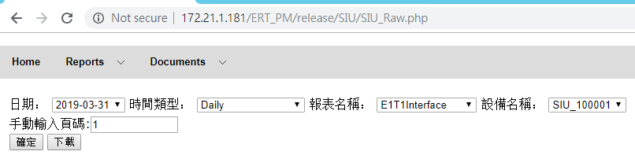

查詢SQL:

|  |
| --- |
| SELECT sdate, ManagedElement, ffv, SubNetwork, nesw, E1T1Interface, gp, ifInOctets, ifInErrors, ifOutOctets, ifOutErrors, erroredBlocks, erroredSeconds, severelyErroredSeconds, backgroundBlockErrors, unavailableTime FROM ERT_SIU_D.E1T1Interface WHERE sdate >= '2019-03-31' AND sdate <= '2019-03-31' AND `ManagedElement` = 'SIU_100001' ORDER BY sdate DESC LIMIT 0, 100 |

* + - 1. 查詢結果

網頁查詢畫面:

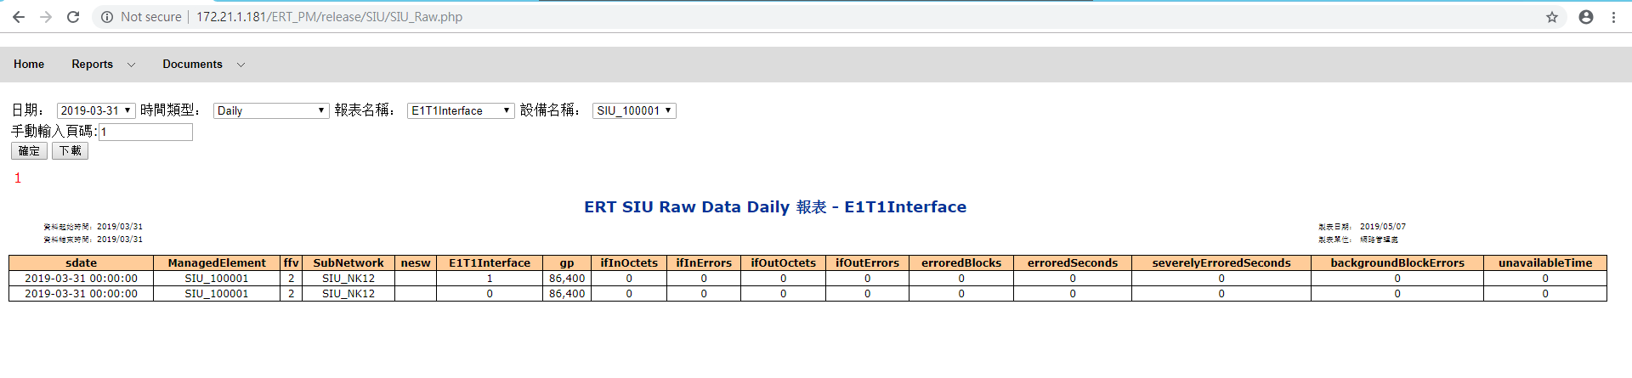

網頁放大切割圖:

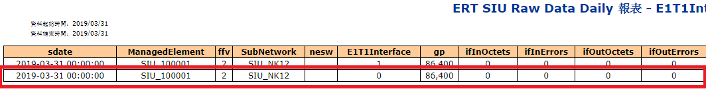

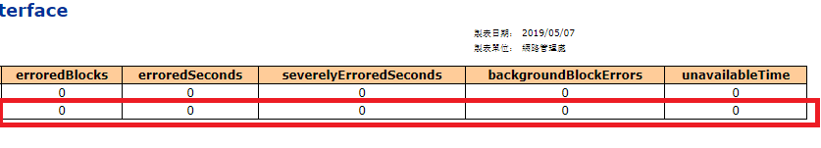

SQL執行畫面:

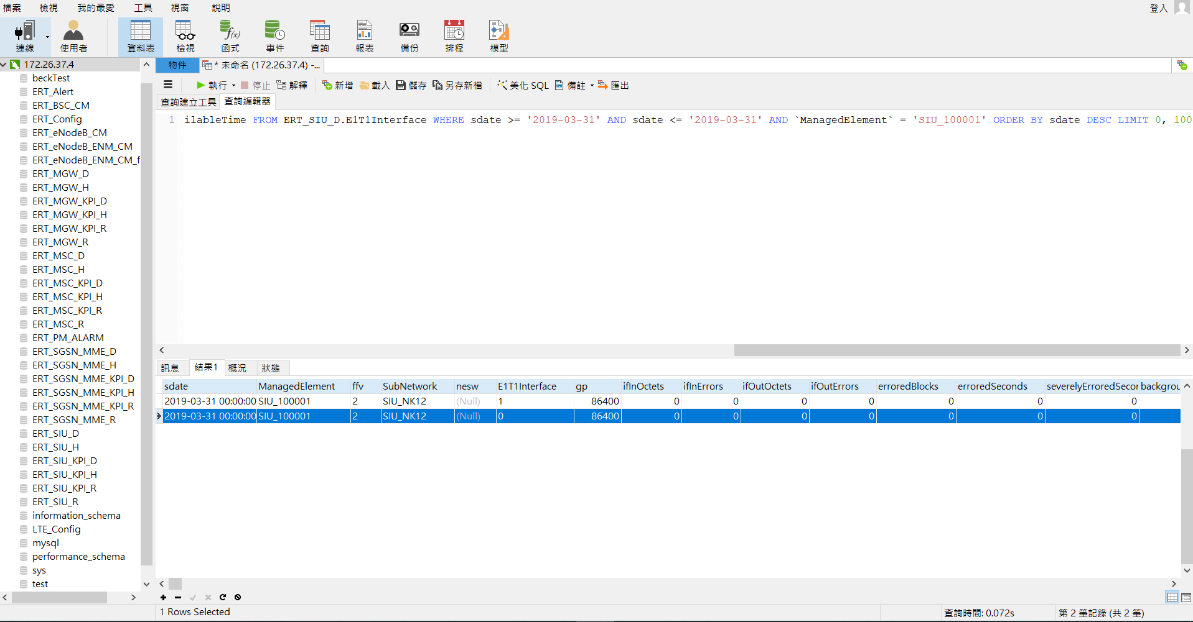

SQL查詢資料截圖:(因為DB瀏覽器沒有完整截圖的功能，所以必須當場截所有的圖片)

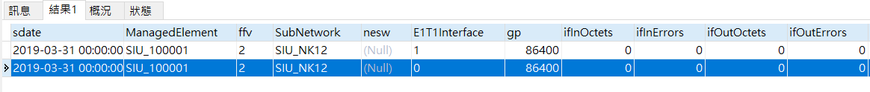



* + - 1. 資料彙整比較

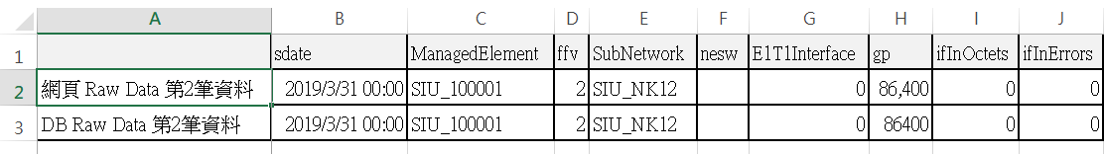

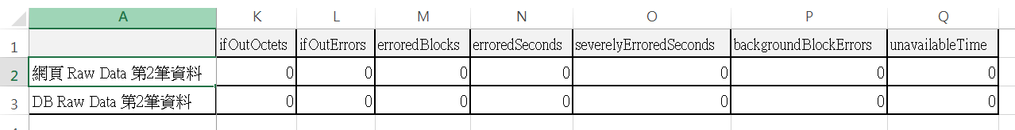

由圖可知完全一致。

* + 1. Raw Data時間類型-30 Days
       1. 查詢條件與SQL

網頁查詢條件:

|  |  |
| --- | --- |
| 條件 | 輸入值 |
| 日期 | 2019-03-31 |
| 時間類型 | 30 Days |
| 報表名稱 | EthernetInterface |
| 設備名稱 | SIU_100002 |
| 手動輸入頁碼 | 1 |

比較條件:

畫面中的第4筆資料數值必須完全一致

網頁查詢條件設定:

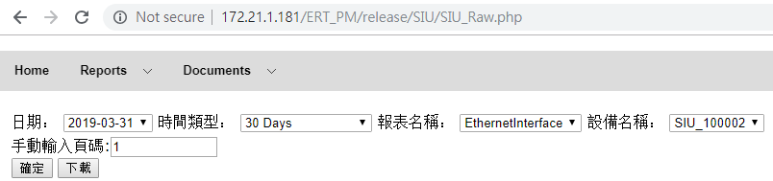

查詢SQL:

|  |
| --- |
| SELECT sdate, ManagedElement, ifInUnknownProtos, globalFrameDiscard, ifHCOutMulticastPkts, ifHCInMulticastPkts, ifHCOutBroadcastPkts, ifHCInBroadcastPkts, ifOutDiscards, ifInDiscards, ifHCOutUcastPkts, ifHCInUcastPkts, ifOutErrors, ifInErrors, ifHCOutOctets, ifHCInOctets, gp, EthernetInterface, nesw, SubNetwork, ffv FROM ERT_SIU_D.EthernetInterface WHERE sdate >= '2019-03-02' AND sdate <= '2019-03-31' AND `ManagedElement` = 'SIU_100002' ORDER BY sdate DESC LIMIT 0, 100 |

* + - 1. 查詢結果

網頁查詢畫面:

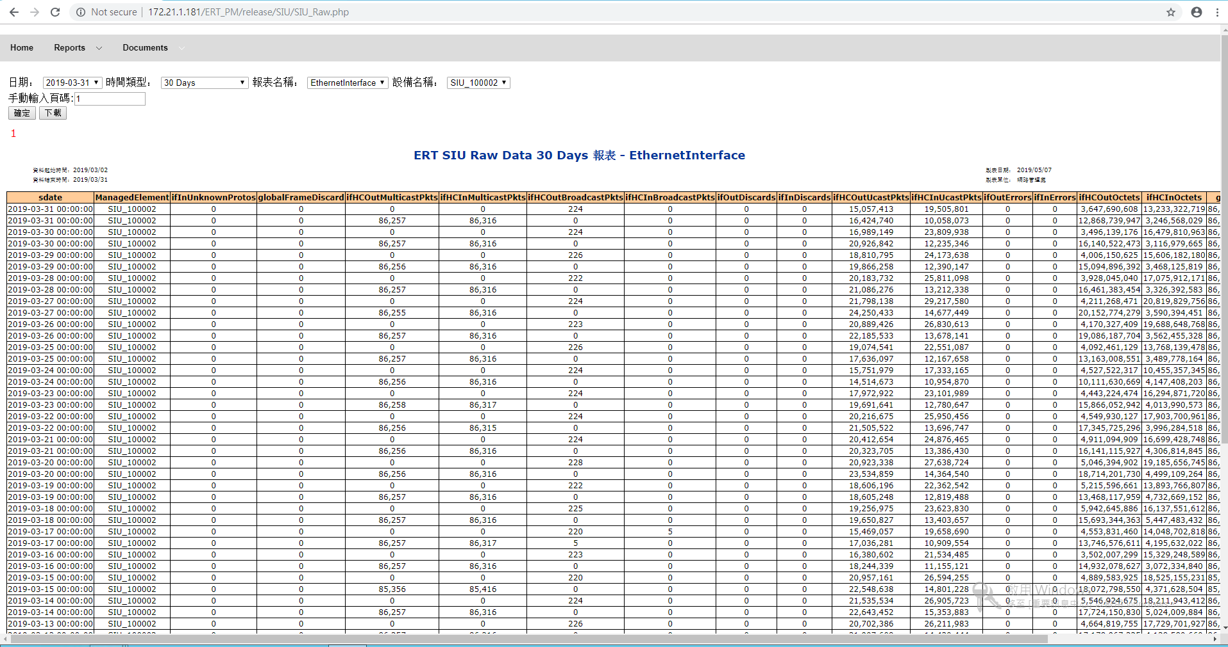

網頁放大切割圖:

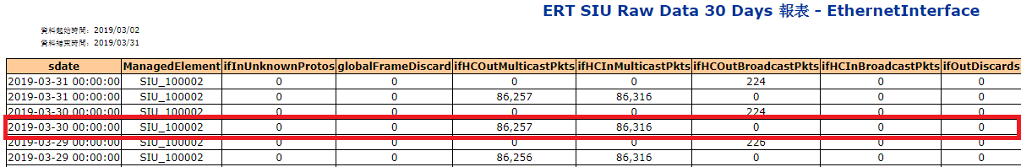

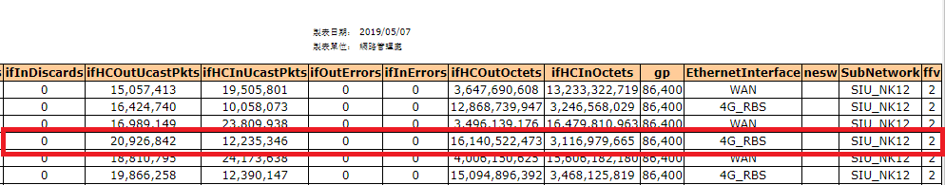

SQL執行畫面:

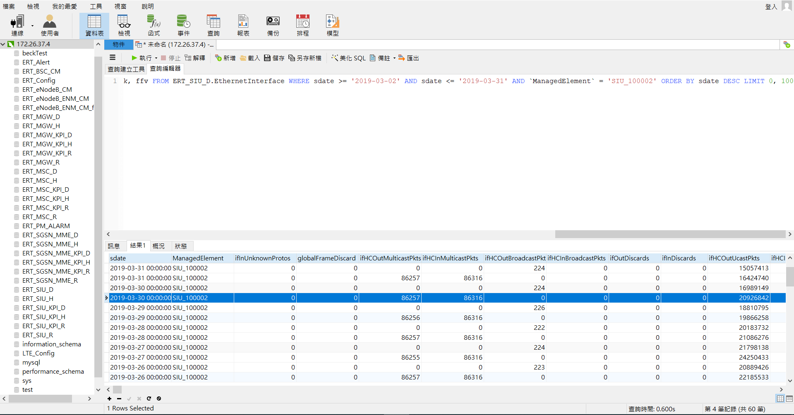

SQL查詢資料截圖:(因為DB瀏覽器沒有完整截圖的功能，所以必須當場截所有的圖片)

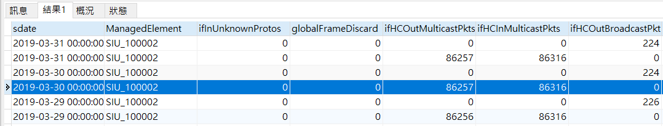

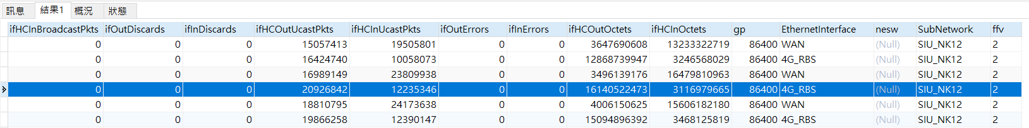

* + - 1. 資料彙整比較

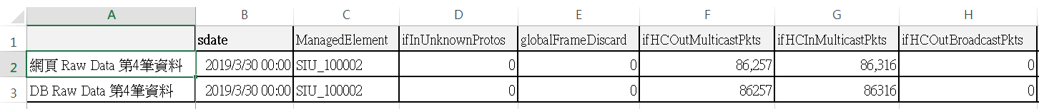



由圖可知完全一致。

* + 1. Raw Data時間類型-Hourly
       1. 查詢條件與SQL

網頁查詢條件:

|  |  |
| --- | --- |
| 條件 | 輸入值 |
| 日期 | 2019-03-31 |
| 時間類型 | Hourly |
| 報表名稱 | SuperChannel |
| 設備名稱 | SIU_100001 |
| 手動輸入頁碼 | 1 |

比較條件:

畫面中的第5筆資料數值必須完全一致

網頁查詢條件設定:

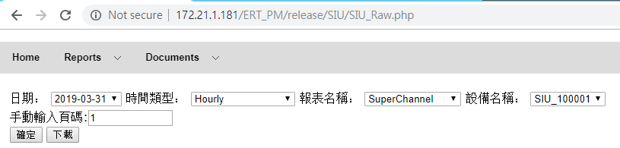

查詢SQL:

|  |
| --- |
| SELECT sdate, ManagedElement, ffv, SubNetwork, nesw, SuperChannel, gp, SC_FramesLostDownlink, SC_FramesDownlink, SC_FramesUplink, SC_InOctets, SC_OutOctets, SC_InError FROM ERT_SIU_H.SuperChannel WHERE sdate >= '2019-03-31 00:00:00' AND sdate <= '2019-03-31 23:00:00' AND `ManagedElement` = 'SIU_100001' ORDER BY sdate DESC LIMIT 0, 100 |

* + - 1. 查詢結果

網頁查詢畫面:

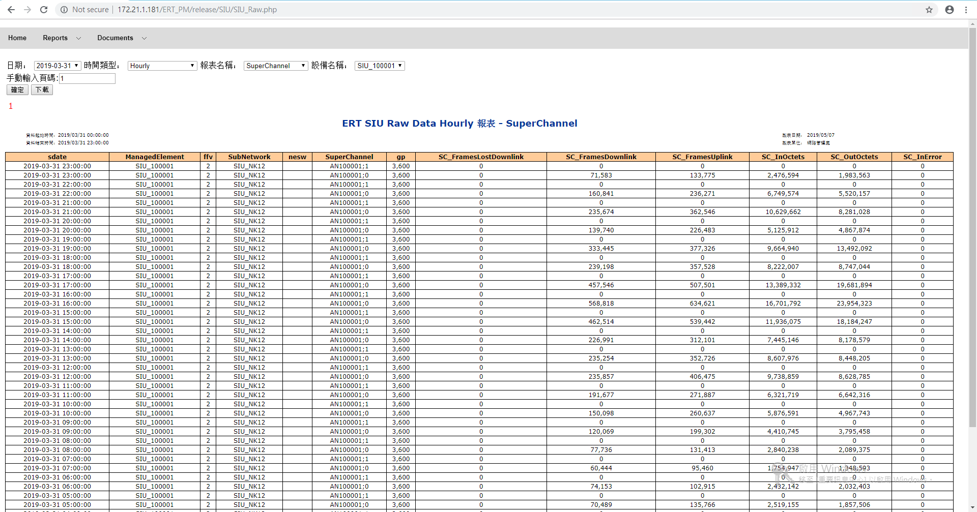

網頁放大切割圖:

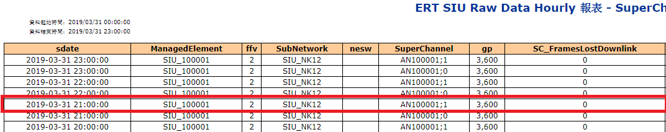

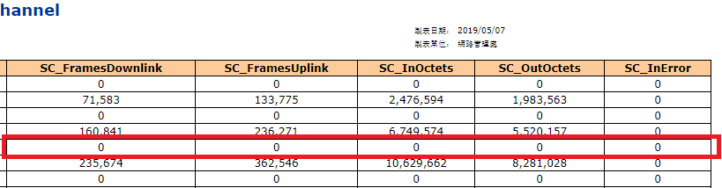

SQL執行畫面:

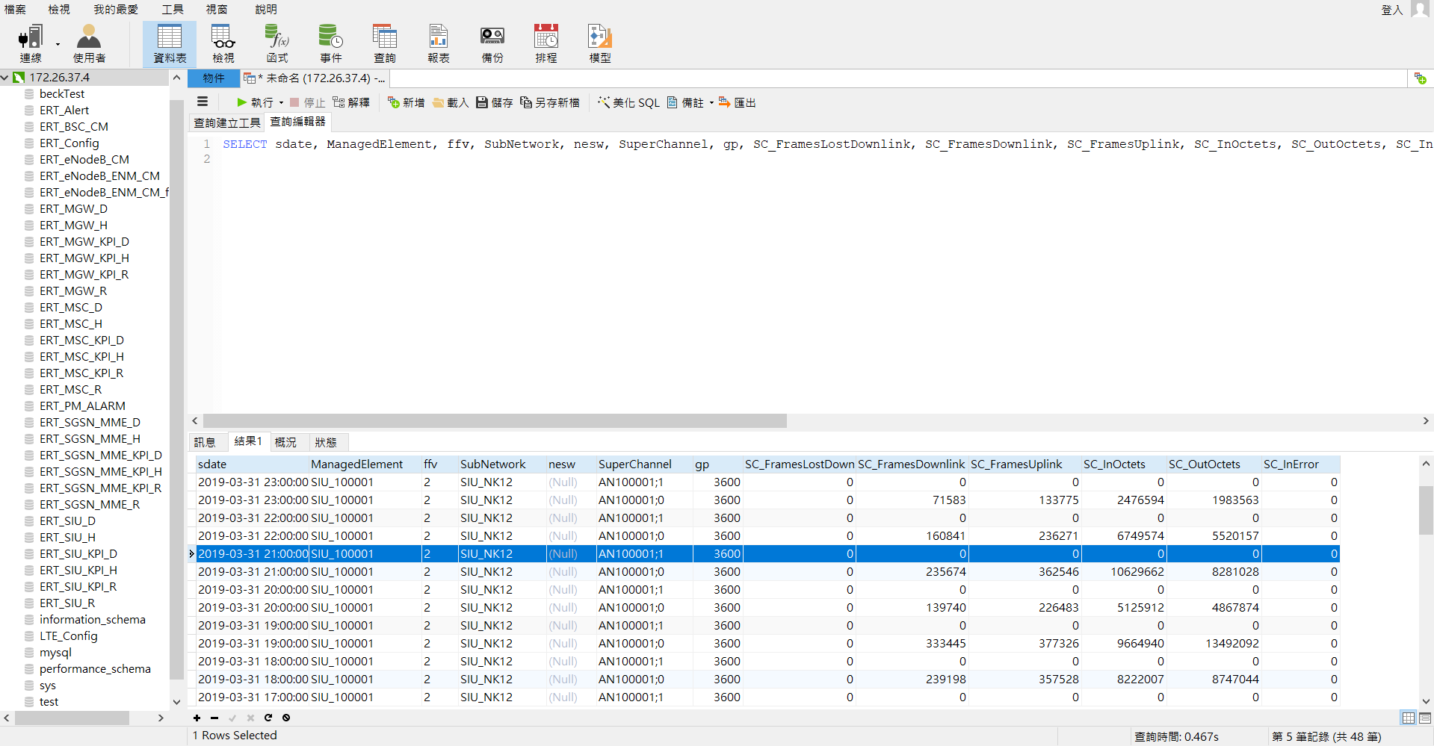

SQL查詢資料截圖:(因為DB瀏覽器沒有完整截圖的功能，所以必須當場截所有的圖片)

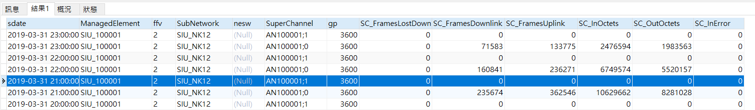

* + - 1. 資料彙整比較

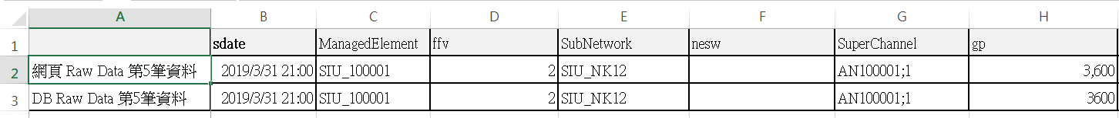

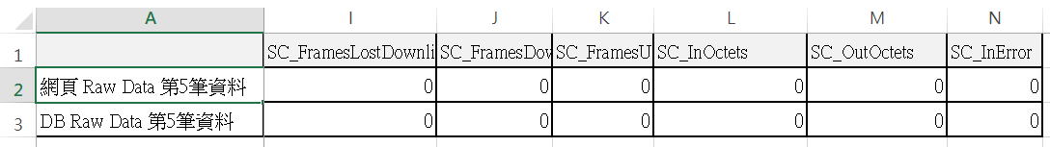

由圖可知完全一致。

* + 1. Raw Data時間類型- RealTime (1 day)
       1. 查詢條件與SQL

網頁查詢條件:

|  |  |
| --- | --- |
| 條件 | 輸入值 |
| 日期 | 2019-03-31 |
| 時間類型 | RealTime (1 day) |
| 報表名稱 | STN |
| 設備名稱 | SIU_100001 |
| 手動輸入頁碼 | 1 |

比較條件:

畫面中的第2筆資料數值必須完全一致

網頁查詢條件設定:

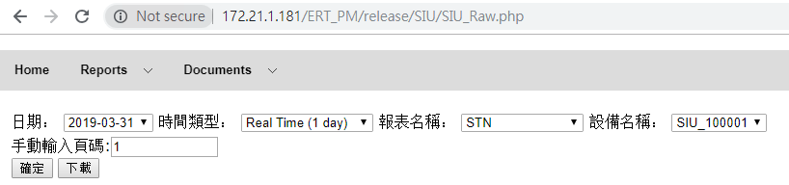

查詢SQL:

|  |
| --- |
| SELECT sdate, ManagedElement, failedPMUploads, CPU_Load, STN, TS_NoTS_Reselections, Synchronization, unavailableTime, backgroundBlockErrors, severelyErroredSeconds, erroredSeconds, erroredBlocks, ifOutErrors, ifOutOctets, ifInErrors, ifInOctets, gp, E1T1Interface, nesw, SubNetwork, ffv FROM ERT_SIU_R.STN WHERE sdate >= '2019-03-31 00:00:00' AND sdate <= '2019-03-31 23:45:00' AND `ManagedElement` = 'SIU_100001' ORDER BY sdate DESC LIMIT 0, 100 |

* + - 1. 查詢結果

網頁查詢畫面:

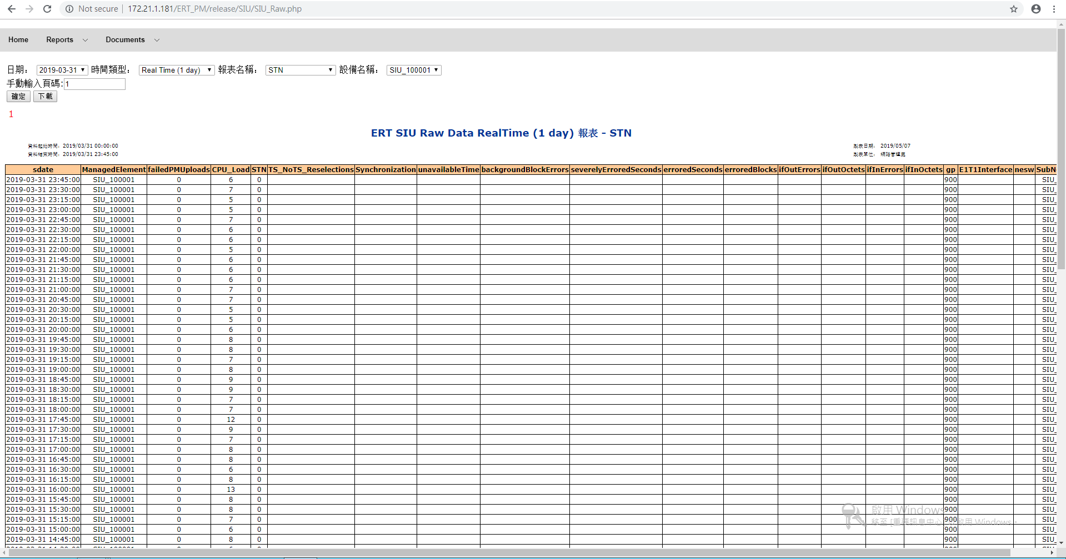

網頁放大切割圖:

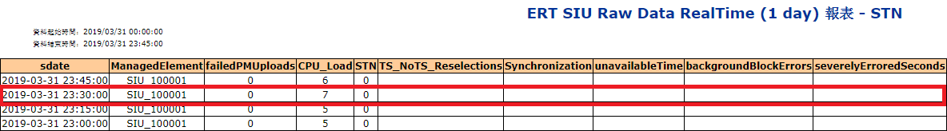

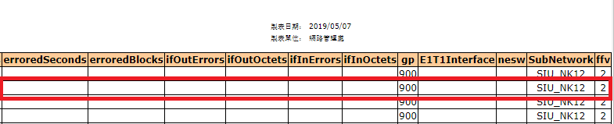

SQL執行畫面:

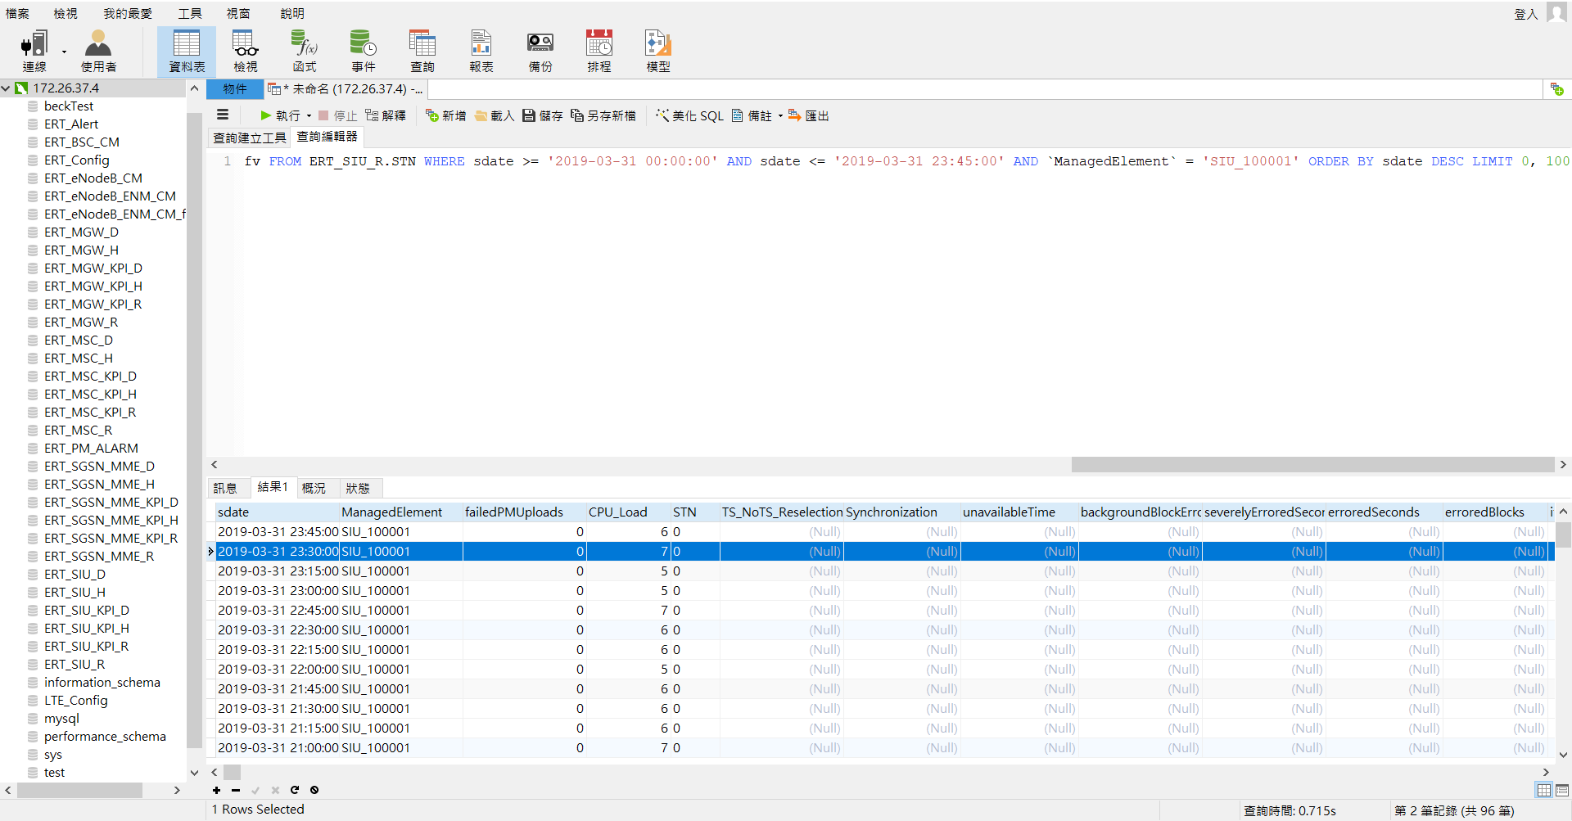

SQL查詢資料截圖:(因為DB瀏覽器沒有完整截圖的功能，所以必須當場截所有的圖片)

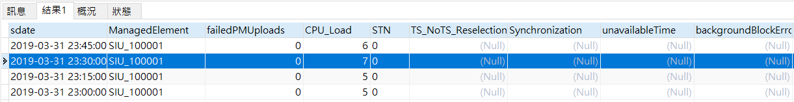



* + - 1. 資料彙整比較

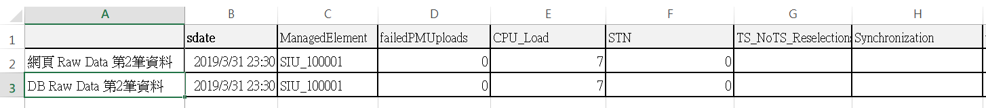



由圖可知完全一致。

* + 1. Raw Data時間類型- RealTime (3 days)
       1. 查詢條件與SQL

網頁查詢條件:

|  |  |
| --- | --- |
| 條件 | 輸入值 |
| 日期 | 2019-03-31 |
| 時間類型 | RealTime (3 days) |
| 報表名稱 | Synchronization |
| 設備名稱 | SIU_100001 |
| 手動輸入頁碼 | 1 |

比較條件:

畫面中的第7筆資料數值必須完全一致

網頁查詢條件設定:

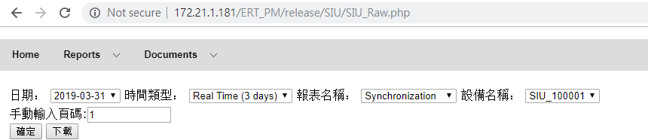

查詢SQL:

|  |
| --- |
| SELECT sdate, ManagedElement, TS_NoTS_Reselections, Synchronization, failedPMUploads, CPU_Load, STN, unavailableTime, backgroundBlockErrors, severelyErroredSeconds, erroredSeconds, erroredBlocks, ifOutErrors, ifOutOctets, ifInErrors, ifInOctets, gp, E1T1Interface, nesw, SubNetwork, ffv FROM ERT_SIU_R.Synchronization WHERE sdate >= '2019-03-29 00:00:00' AND sdate <= '2019-03-31 23:45:00' AND `ManagedElement` = 'SIU_100001' ORDER BY sdate DESC LIMIT 0, 100 |

* + - 1. 查詢結果

網頁查詢畫面:

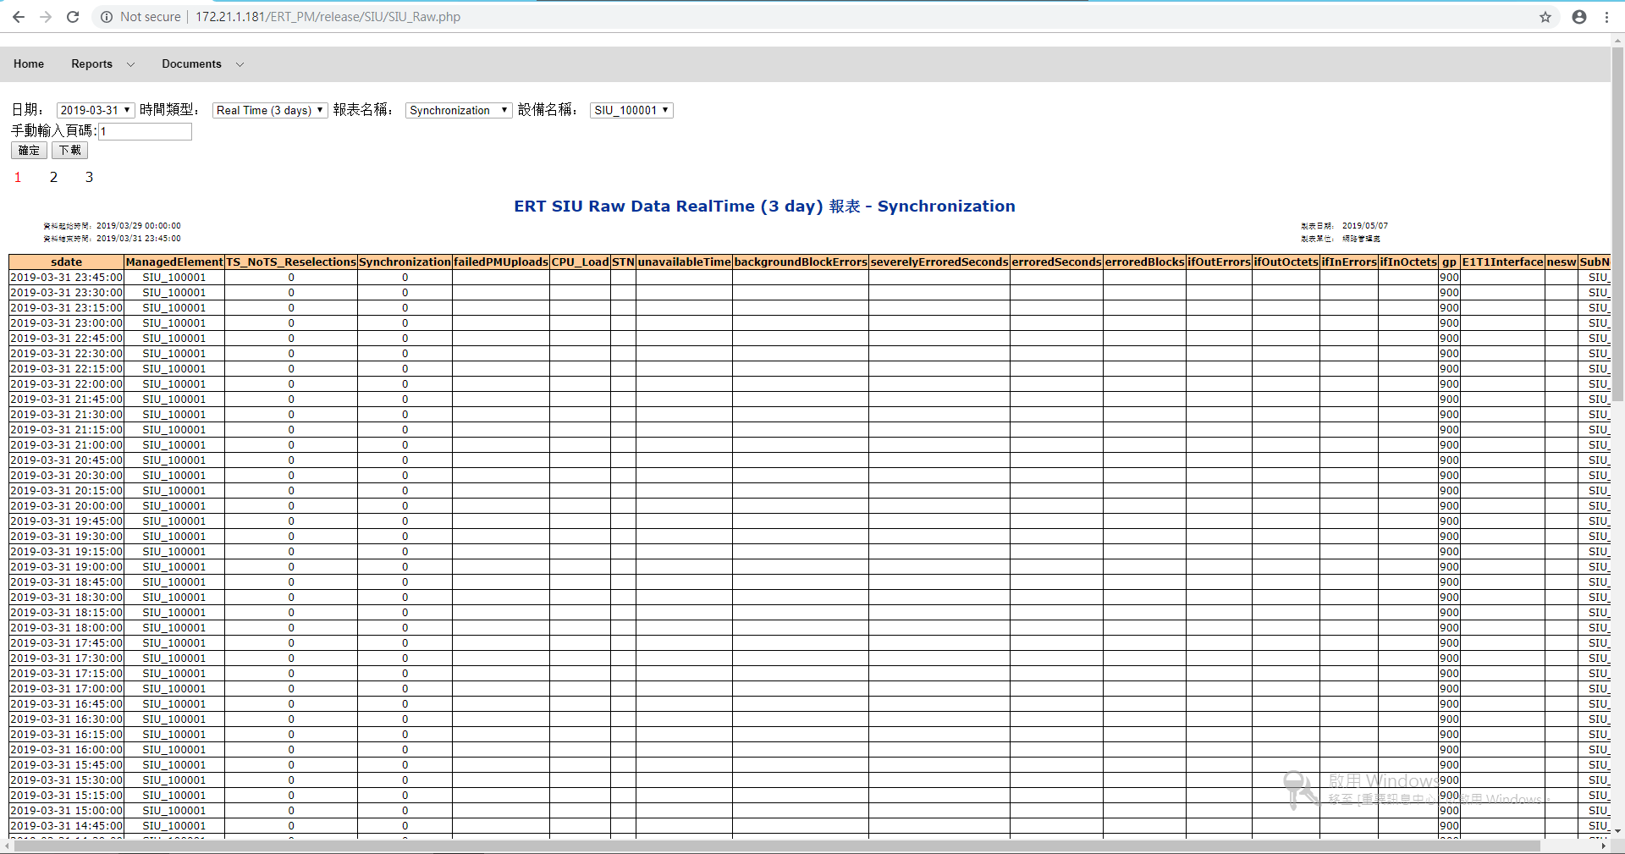

網頁放大切割圖:

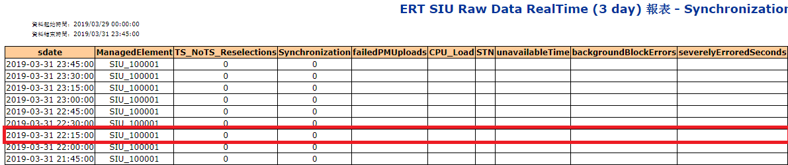

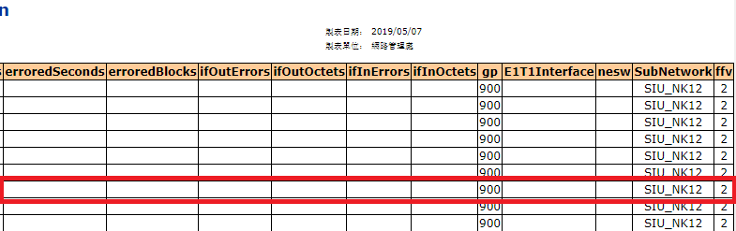

SQL執行畫面:

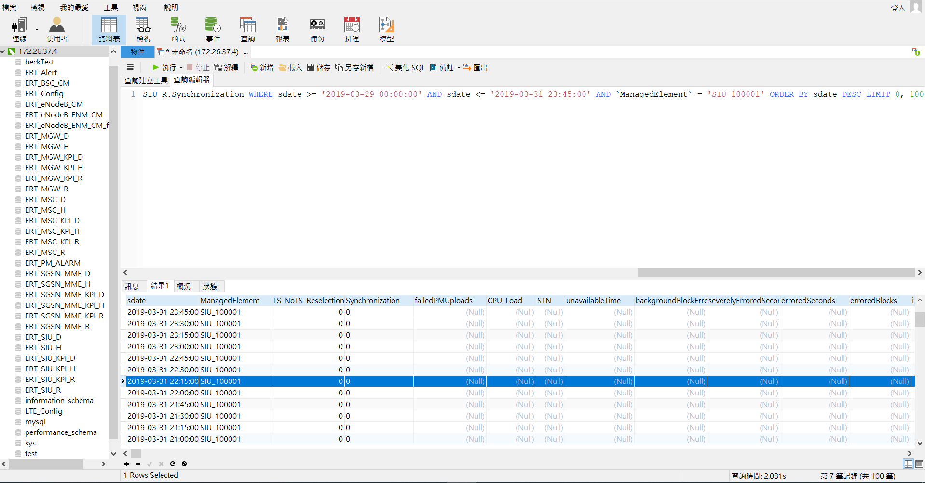

SQL查詢資料截圖:(因為DB瀏覽器沒有完整截圖的功能，所以必須當場截所有的圖片)

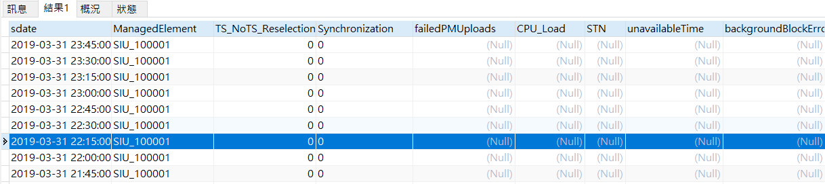

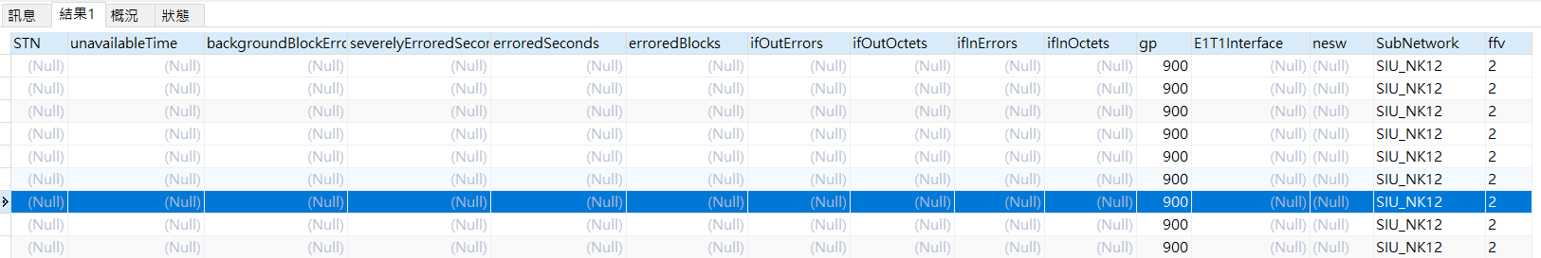

* + - 1. 資料彙整比較

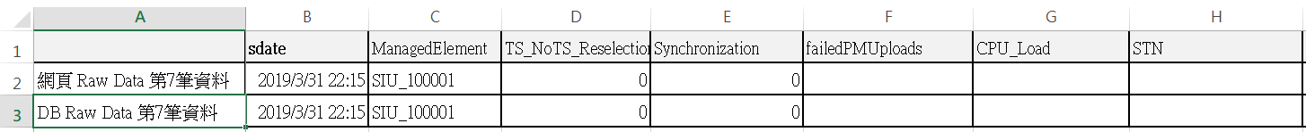



由圖可知完全一致。

* 1. KPI網頁查詢結果與DB查詢結果一致

連線資訊

KPI URL

<http://172.21.1.181/ERT_PM/release/SIU/SIU_KPI.php>

DB IP

172.26.37.4

參考資料

附件1 SIU KPI對照表

內容說明網頁顯示欄位與資料庫欄位的對照對照表

* + 1. KPI時間類型-Daily
       1. 查詢條件與SQL

網頁查詢條件:

|  |  |
| --- | --- |
| 條件 | 輸入值 |
| 日期 | 2019-03-24 |
| 時間類型 | Daily |
| 設備名稱 | SIU_100001 |
| 手動輸入頁碼 | 1 |

比較條件:

畫面中的第1筆資料數值必須完全一致

網頁查詢條件設定:

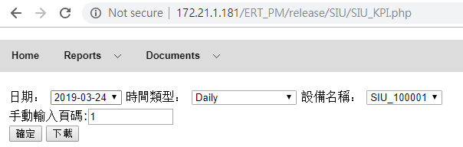

查詢SQL:

|  |
| --- |
| SELECT  sdate AS '日期',  ManagedElement AS 'NE',  ROUND(EthIngressFps,2) AS 'EthIngressFps',  ROUND(EthIngressKbps,2) AS 'EthIngressKbps',  ROUND(EthEgressFps,2) AS 'EthEgressFps',  ROUND(EthEgressKbps,2) AS 'EthEgressKbps',  ROUND(VlanIngressFps,2) AS 'VlanIngressFps',  ROUND(VlanIngressKbps,2) AS 'VlanIngressKbps',  ROUND(VlanEgressFps,2) AS 'VlanEgressFps',  ROUND(VlanEgressKbps,2) AS 'VlanEgressKbps',  ROUND(IpIngressPps,2) AS 'IpIngressPps',  ROUND(IpIngressKbps,2) AS 'IpIngressKbps',  ROUND(IpEgressPps,2) AS 'IpEgressPps',  ROUND(GsmDownlinkKbps,2) AS 'GsmDownlinkKbps',  ROUND(GsmUplinkKbps,2) AS 'GsmUplinkKbps',  ROUND(EthFaultIngress,2) AS 'EthFaultIngress',  ROUND(EthErrorIngress,2) AS 'EthErrorIngress',  ROUND(EthDiscardIngress,2) AS 'EthDiscardIngress'  FROM ERT_SIU_KPI_D.KPI WHERE sdate >= '2019-03-24' AND sdate <= '2019-03-24' AND ManagedElement = 'SIU_100001' ORDER BY sdate DESC, ManagedElement LIMIT 0, 100 |

* + - 1. 查詢結果

網頁查詢畫面:

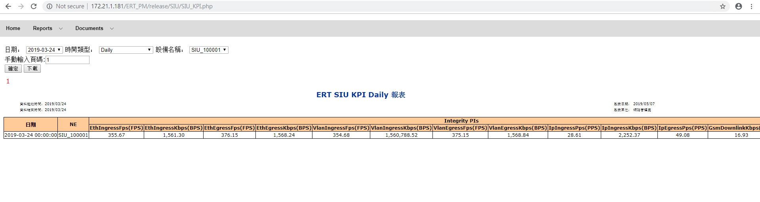

網頁放大切割圖:

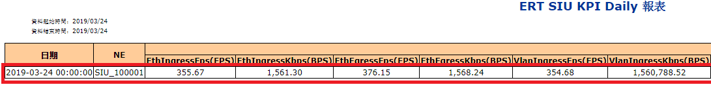

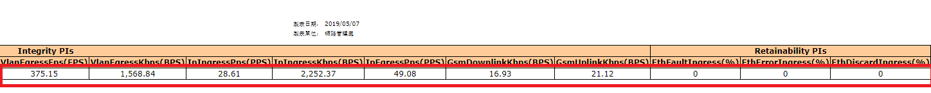

SQL執行畫面:

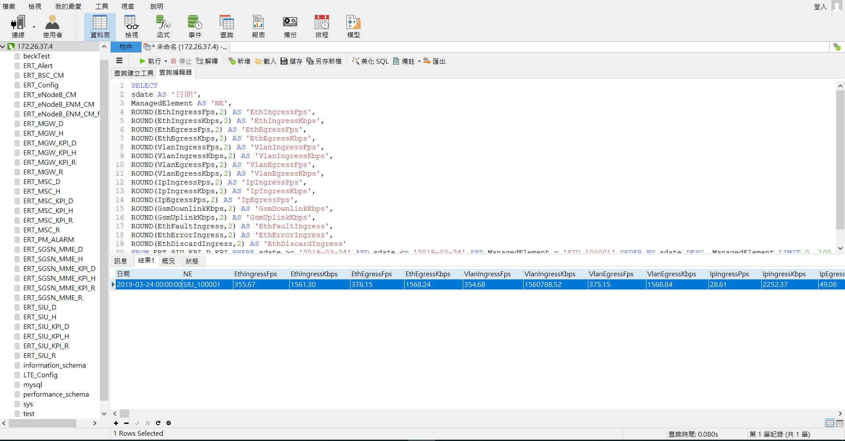

SQL查詢資料截圖:(因為DB瀏覽器沒有完整截圖的功能，所以必須當場截所有的圖片)





* + - 1. 資料彙整比較

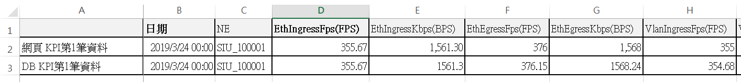

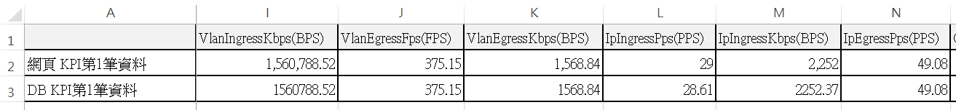

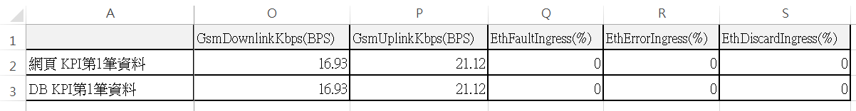

由圖可知完全一致。

* + 1. KPI時間類型-30 Days
       1. 查詢條件與SQL

網頁查詢條件:

|  |  |
| --- | --- |
| 條件 | 輸入值 |
| 日期 | 2019-03-24 |
| 時間類型 | 30 Days |
| 設備名稱 | SIU_100001 |
| 手動輸入頁碼 | 1 |

比較條件:

畫面中的第2筆資料數值必須完全一致

網頁查詢條件設定:

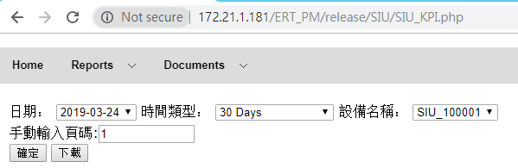

查詢SQL:

|  |
| --- |
| SELECT  sdate AS '日期',  ManagedElement AS 'NE',  ROUND(EthIngressFps,2) AS 'EthIngressFps',  ROUND(EthIngressKbps,2) AS 'EthIngressKbps',  ROUND(EthEgressFps,2) AS 'EthEgressFps',  ROUND(EthEgressKbps,2) AS 'EthEgressKbps',  ROUND(VlanIngressFps,2) AS 'VlanIngressFps',  ROUND(VlanIngressKbps,2) AS 'VlanIngressKbps',  ROUND(VlanEgressFps,2) AS 'VlanEgressFps',  ROUND(VlanEgressKbps,2) AS 'VlanEgressKbps',  ROUND(IpIngressPps,2) AS 'IpIngressPps',  ROUND(IpIngressKbps,2) AS 'IpIngressKbps',  ROUND(IpEgressPps,2) AS 'IpEgressPps',  ROUND(GsmDownlinkKbps,2) AS 'GsmDownlinkKbps',  ROUND(GsmUplinkKbps,2) AS 'GsmUplinkKbps',  ROUND(EthFaultIngress,2) AS 'EthFaultIngress',  ROUND(EthErrorIngress,2) AS 'EthErrorIngress',  ROUND(EthDiscardIngress,2) AS 'EthDiscardIngress'  FROM ERT_SIU_KPI_D.KPI WHERE sdate >= '2019-02-23' AND sdate <= '2019-03-24' AND ManagedElement = 'SIU_100001' ORDER BY sdate DESC, ManagedElement LIMIT 0, 100 |

* + - 1. 查詢結果

網頁查詢畫面:

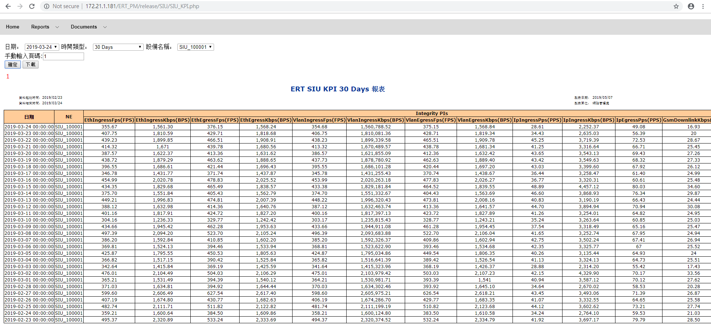

網頁放大切割圖:

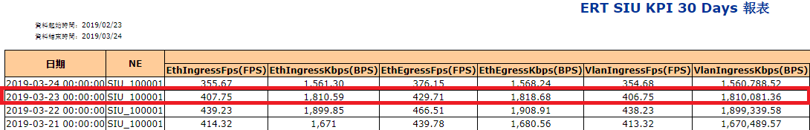

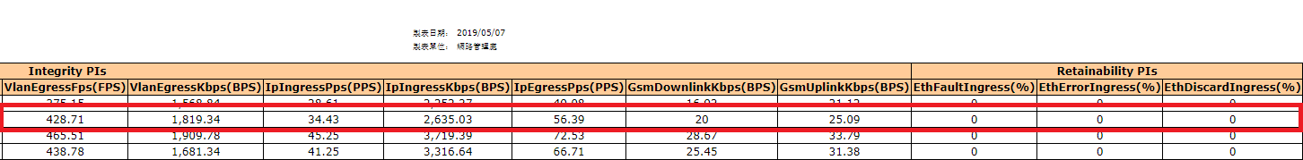

SQL執行畫面:

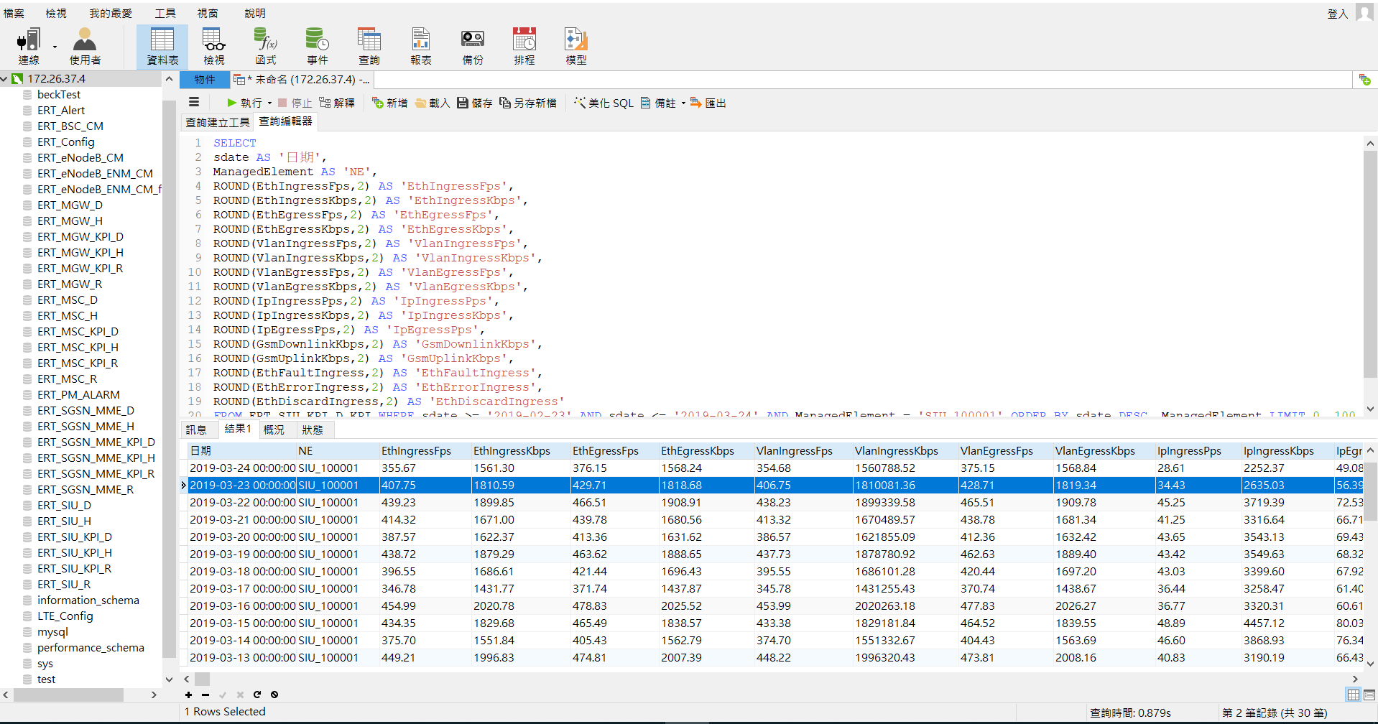

SQL查詢資料截圖:(因為DB瀏覽器沒有完整截圖的功能，所以必須當場截所有的圖片)

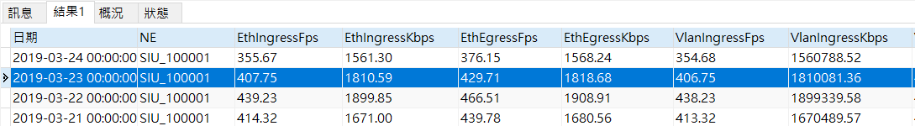

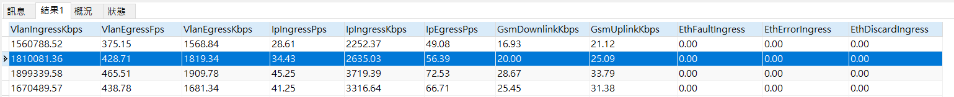

* + - 1. 資料彙整比較

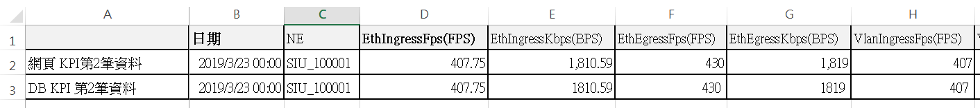

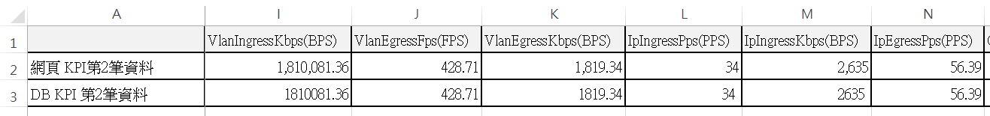

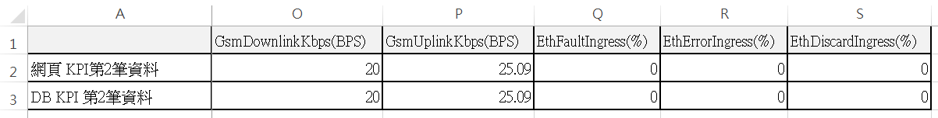

由圖可知完全一致。

* + 1. KPI時間類型-Hourly
       1. 查詢條件與SQL

網頁查詢條件:

|  |  |
| --- | --- |
| 條件 | 輸入值 |
| 日期 | 2019-03-24 |
| 時間類型 | Hourly |
| 設備名稱 | SIU_100001 |
| 手動輸入頁碼 | 1 |

比較條件:

畫面中的第4筆資料數值必須完全一致

網頁查詢條件設定:

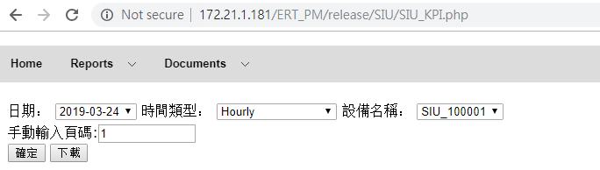

查詢SQL:

|  |
| --- |
| SELECT  sdate AS '日期',  ManagedElement AS 'NE',  ROUND(EthIngressFps,2) AS 'EthIngressFps',  ROUND(EthIngressKbps,2) AS 'EthIngressKbps',  ROUND(EthEgressFps,2) AS 'EthEgressFps',  ROUND(EthEgressKbps,2) AS 'EthEgressKbps',  ROUND(VlanIngressFps,2) AS 'VlanIngressFps',  ROUND(VlanIngressKbps,2) AS 'VlanIngressKbps',  ROUND(VlanEgressFps,2) AS 'VlanEgressFps',  ROUND(VlanEgressKbps,2) AS 'VlanEgressKbps',  ROUND(IpIngressPps,2) AS 'IpIngressPps',  ROUND(IpIngressKbps,2) AS 'IpIngressKbps',  ROUND(IpEgressPps,2) AS 'IpEgressPps',  ROUND(GsmDownlinkKbps,2) AS 'GsmDownlinkKbps',  ROUND(GsmUplinkKbps,2) AS 'GsmUplinkKbps',  ROUND(EthFaultIngress,2) AS 'EthFaultIngress',  ROUND(EthErrorIngress,2) AS 'EthErrorIngress',  ROUND(EthDiscardIngress,2) AS 'EthDiscardIngress'  FROM ERT_SIU_KPI_H.KPI WHERE sdate >= '2019-03-24 00:00:00' AND sdate <= '2019-03-24 23:00:00' AND ManagedElement = 'SIU_100001' ORDER BY sdate DESC, ManagedElement LIMIT 0, 100 |

* + - 1. 查詢結果

網頁查詢畫面:

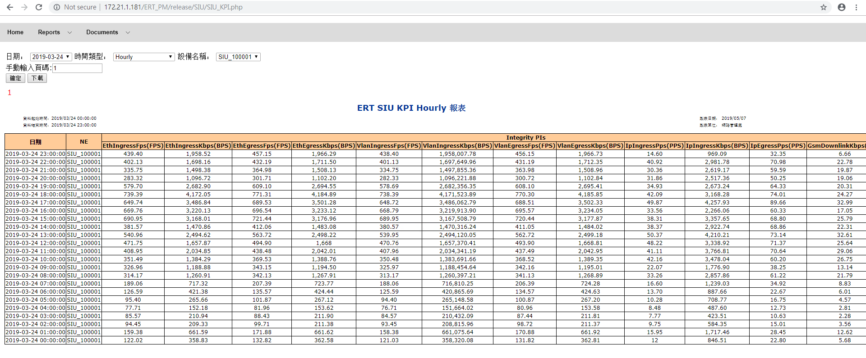

網頁放大切割圖:

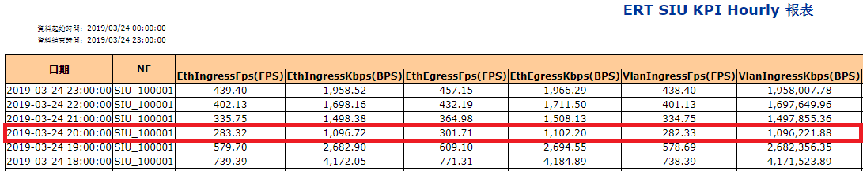

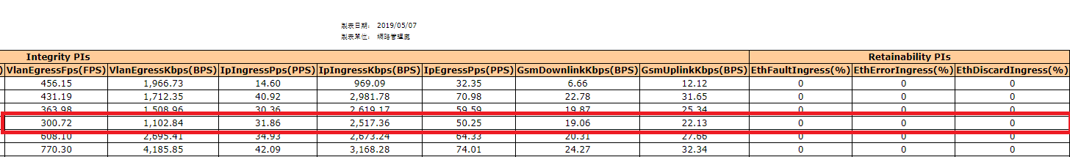

SQL執行畫面:

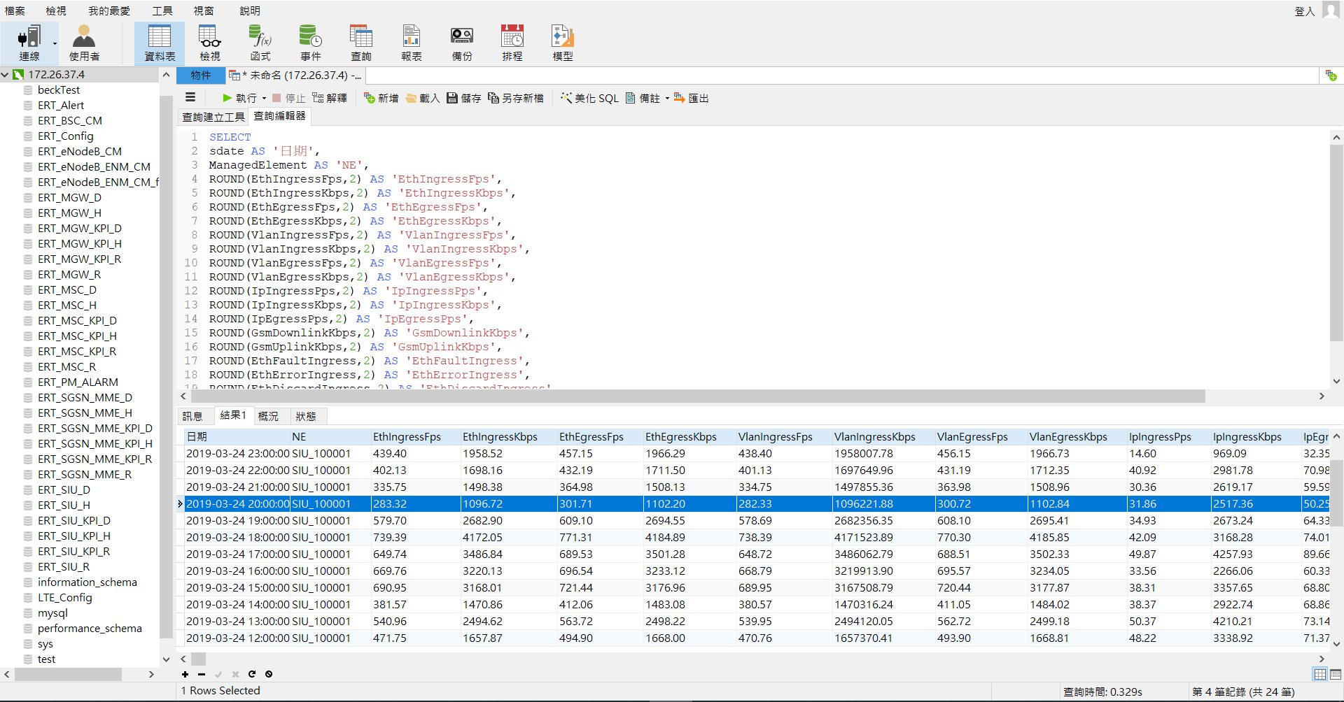

SQL查詢資料截圖:(因為DB瀏覽器沒有完整截圖的功能，所以必須當場截所有的圖片)

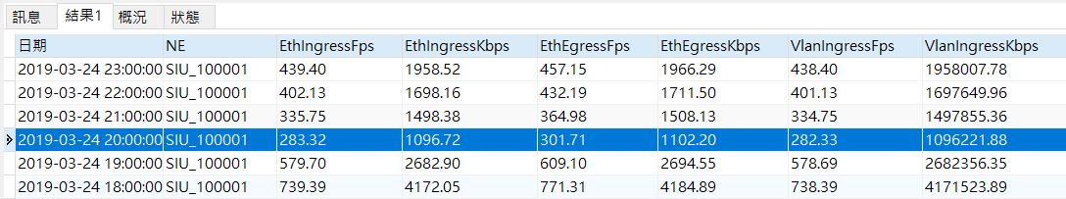

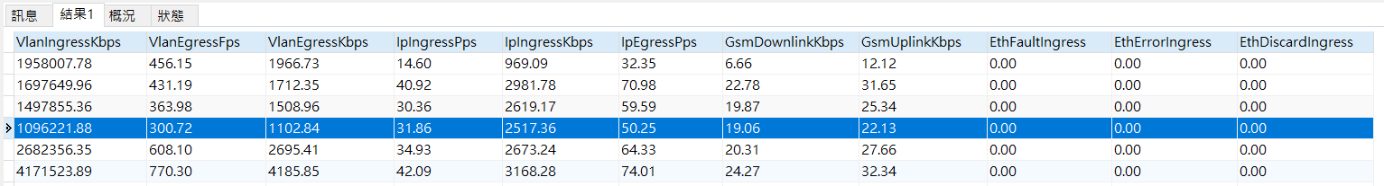

* + - 1. 資料彙整比較

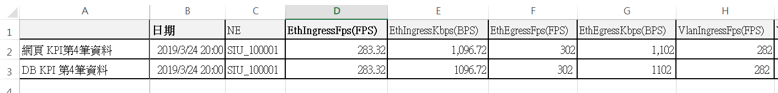

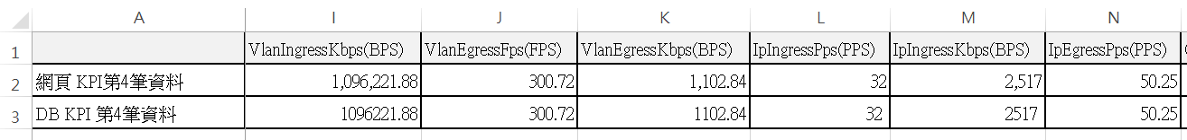

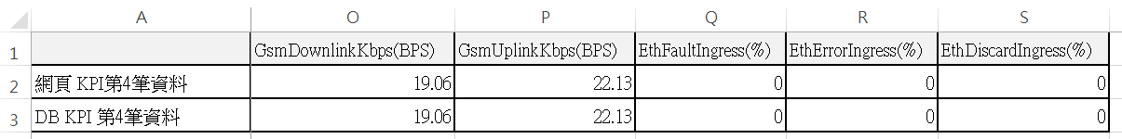

由圖可知完全一致。

* + 1. KPI時間類型- RealTime (1 day)
       1. 查詢條件與SQL

網頁查詢條件:

|  |  |
| --- | --- |
| 條件 | 輸入值 |
| 日期 | 2019-03-24 |
| 時間類型 | RealTime (1 day) |
| 設備名稱 | SIU_100001 |
| 手動輸入頁碼 | 1 |

比較條件:

畫面中的第5筆資料數值必須完全一致

網頁查詢條件設定:

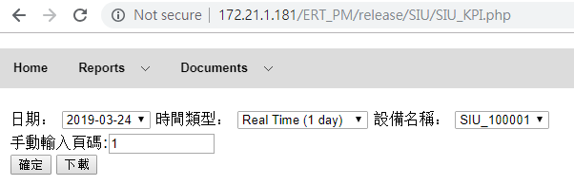

查詢SQL:

|  |
| --- |
| SELECT  sdate AS '日期',  ManagedElement AS 'NE',  ROUND(EthIngressFps,2) AS 'EthIngressFps',  ROUND(EthIngressKbps,2) AS 'EthIngressKbps',  ROUND(EthEgressFps,2) AS 'EthEgressFps',  ROUND(EthEgressKbps,2) AS 'EthEgressKbps',  ROUND(VlanIngressFps,2) AS 'VlanIngressFps',  ROUND(VlanIngressKbps,2) AS 'VlanIngressKbps',  ROUND(VlanEgressFps,2) AS 'VlanEgressFps',  ROUND(VlanEgressKbps,2) AS 'VlanEgressKbps',  ROUND(IpIngressPps,2) AS 'IpIngressPps',  ROUND(IpIngressKbps,2) AS 'IpIngressKbps',  ROUND(IpEgressPps,2) AS 'IpEgressPps',  ROUND(GsmDownlinkKbps,2) AS 'GsmDownlinkKbps',  ROUND(GsmUplinkKbps,2) AS 'GsmUplinkKbps',  ROUND(EthFaultIngress,2) AS 'EthFaultIngress',  ROUND(EthErrorIngress,2) AS 'EthErrorIngress',  ROUND(EthDiscardIngress,2) AS 'EthDiscardIngress'  FROM ERT_SIU_KPI_R.KPI WHERE sdate >= '2019-03-24 00:00:00' AND sdate <= '2019-03-24 23:45:00' AND ManagedElement = 'SIU_100001' ORDER BY sdate DESC, ManagedElement LIMIT 0, 100 |

* + - 1. 查詢結果

網頁查詢畫面:

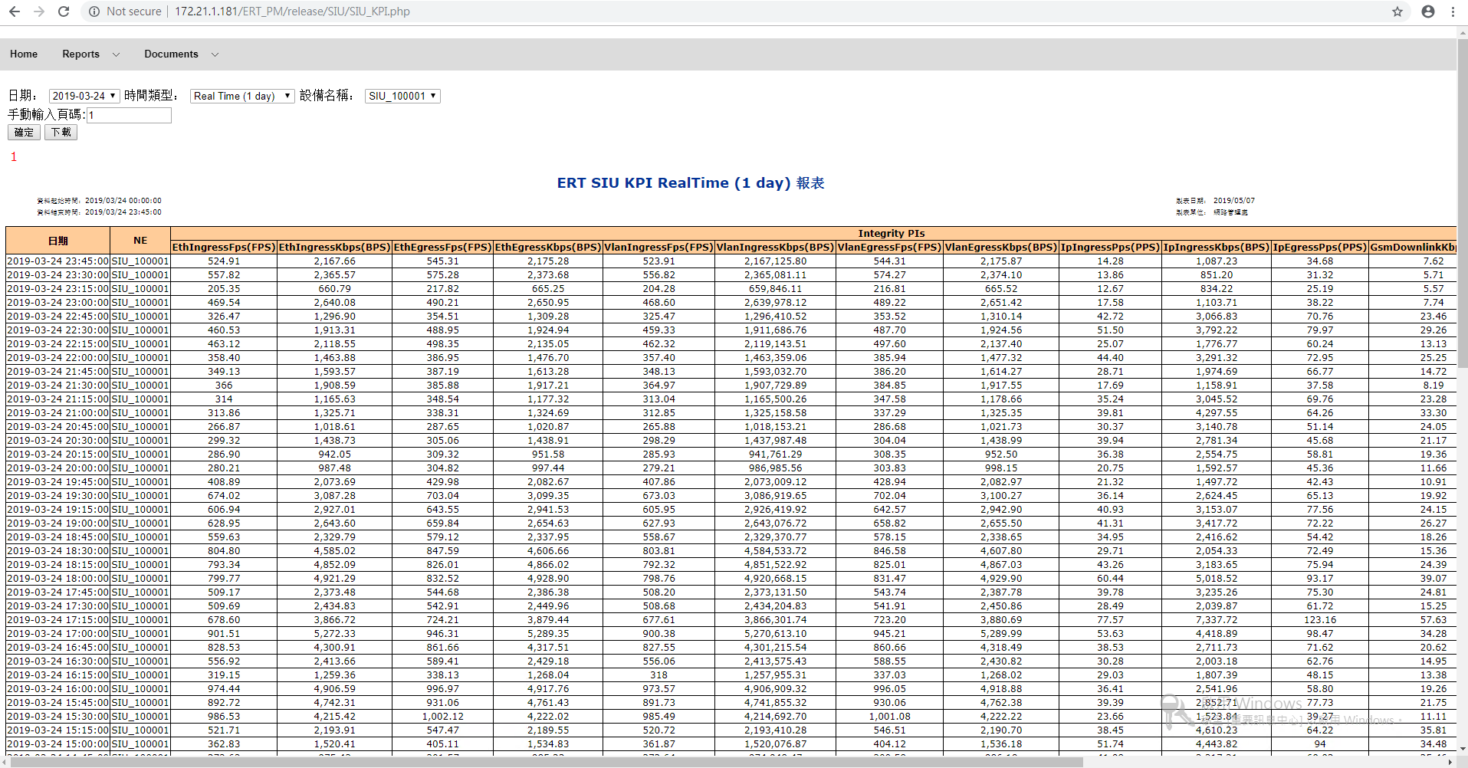

網頁放大切割圖:

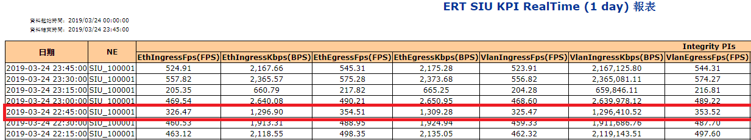

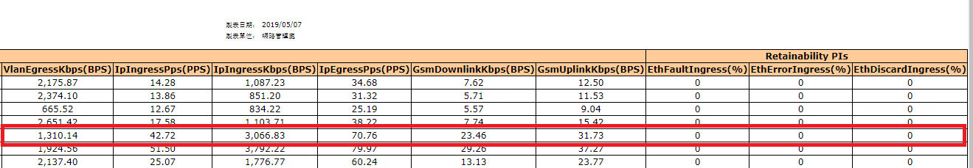

SQL執行畫面:

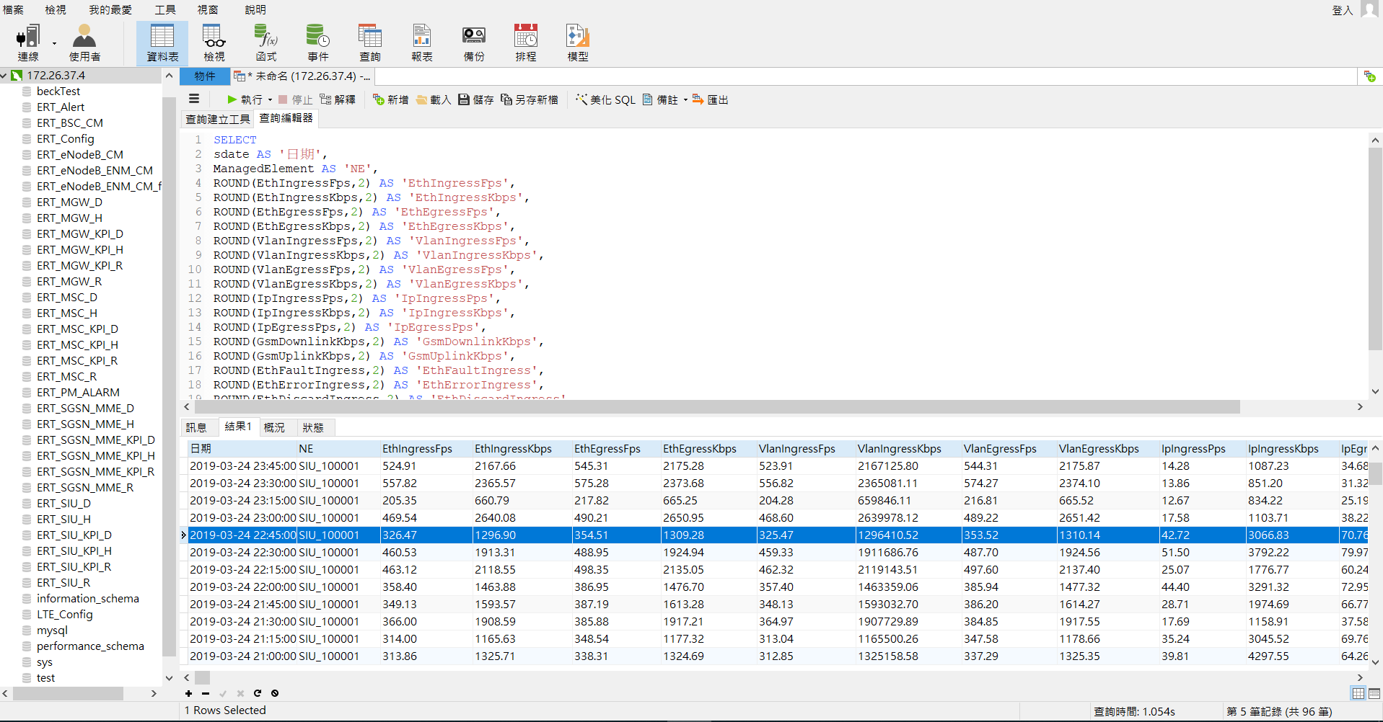

SQL查詢資料截圖:(因為DB瀏覽器沒有完整截圖的功能，所以必須當場截所有的圖片)

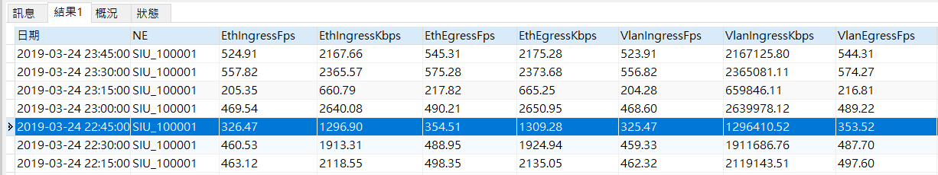

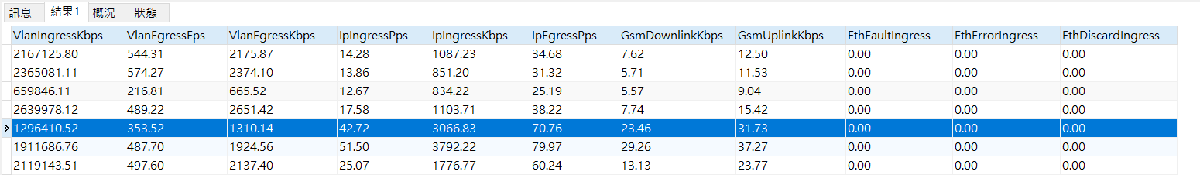

* + - 1. 資料彙整比較

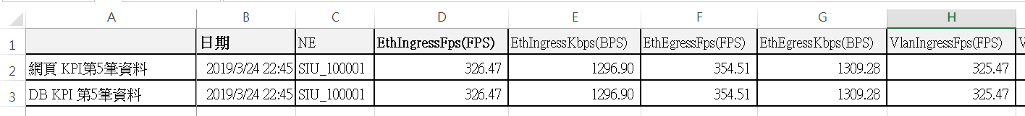

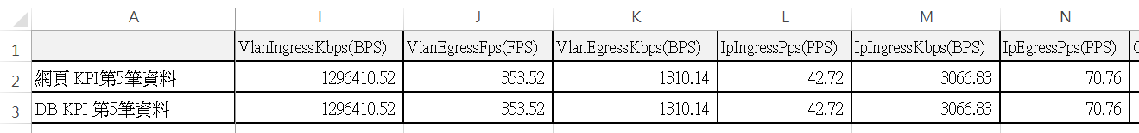

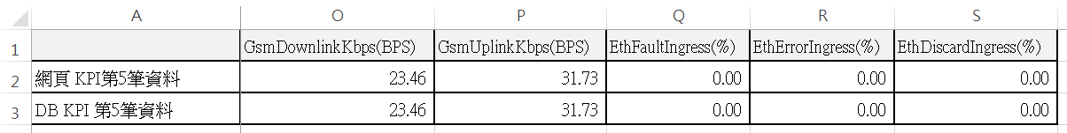

由圖可知完全一致。

* + 1. KPI時間類型- RealTime (3 days)
       1. 查詢條件與SQL

網頁查詢條件:

|  |  |
| --- | --- |
| 條件 | 輸入值 |
| 日期 | 2019-03-24 |
| 時間類型 | RealTime (3 days) |
| 設備名稱 | SIU_100001 |
| 手動輸入頁碼 | 1 |

比較條件:

畫面中的第6筆資料數值必須完全一致

網頁查詢條件設定:

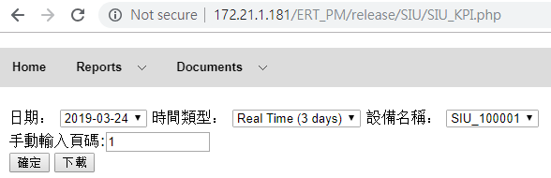

查詢SQL:

|  |
| --- |
| SELECT  sdate AS '日期',  ManagedElement AS 'NE',  ROUND(EthIngressFps,2) AS 'EthIngressFps',  ROUND(EthIngressKbps,2) AS 'EthIngressKbps',  ROUND(EthEgressFps,2) AS 'EthEgressFps',  ROUND(EthEgressKbps,2) AS 'EthEgressKbps',  ROUND(VlanIngressFps,2) AS 'VlanIngressFps',  ROUND(VlanIngressKbps,2) AS 'VlanIngressKbps',  ROUND(VlanEgressFps,2) AS 'VlanEgressFps',  ROUND(VlanEgressKbps,2) AS 'VlanEgressKbps',  ROUND(IpIngressPps,2) AS 'IpIngressPps',  ROUND(IpIngressKbps,2) AS 'IpIngressKbps',  ROUND(IpEgressPps,2) AS 'IpEgressPps',  ROUND(GsmDownlinkKbps,2) AS 'GsmDownlinkKbps',  ROUND(GsmUplinkKbps,2) AS 'GsmUplinkKbps',  ROUND(EthFaultIngress,2) AS 'EthFaultIngress',  ROUND(EthErrorIngress,2) AS 'EthErrorIngress',  ROUND(EthDiscardIngress,2) AS 'EthDiscardIngress'  FROM ERT_SIU_KPI_R.KPI WHERE sdate >= '2019-03-22 00:00:00' AND sdate <= '2019-03-24 23:45:00' AND ManagedElement = 'SIU_100001' ORDER BY sdate DESC, ManagedElement LIMIT 0, 100 |

* + - 1. 查詢結果

網頁查詢畫面:

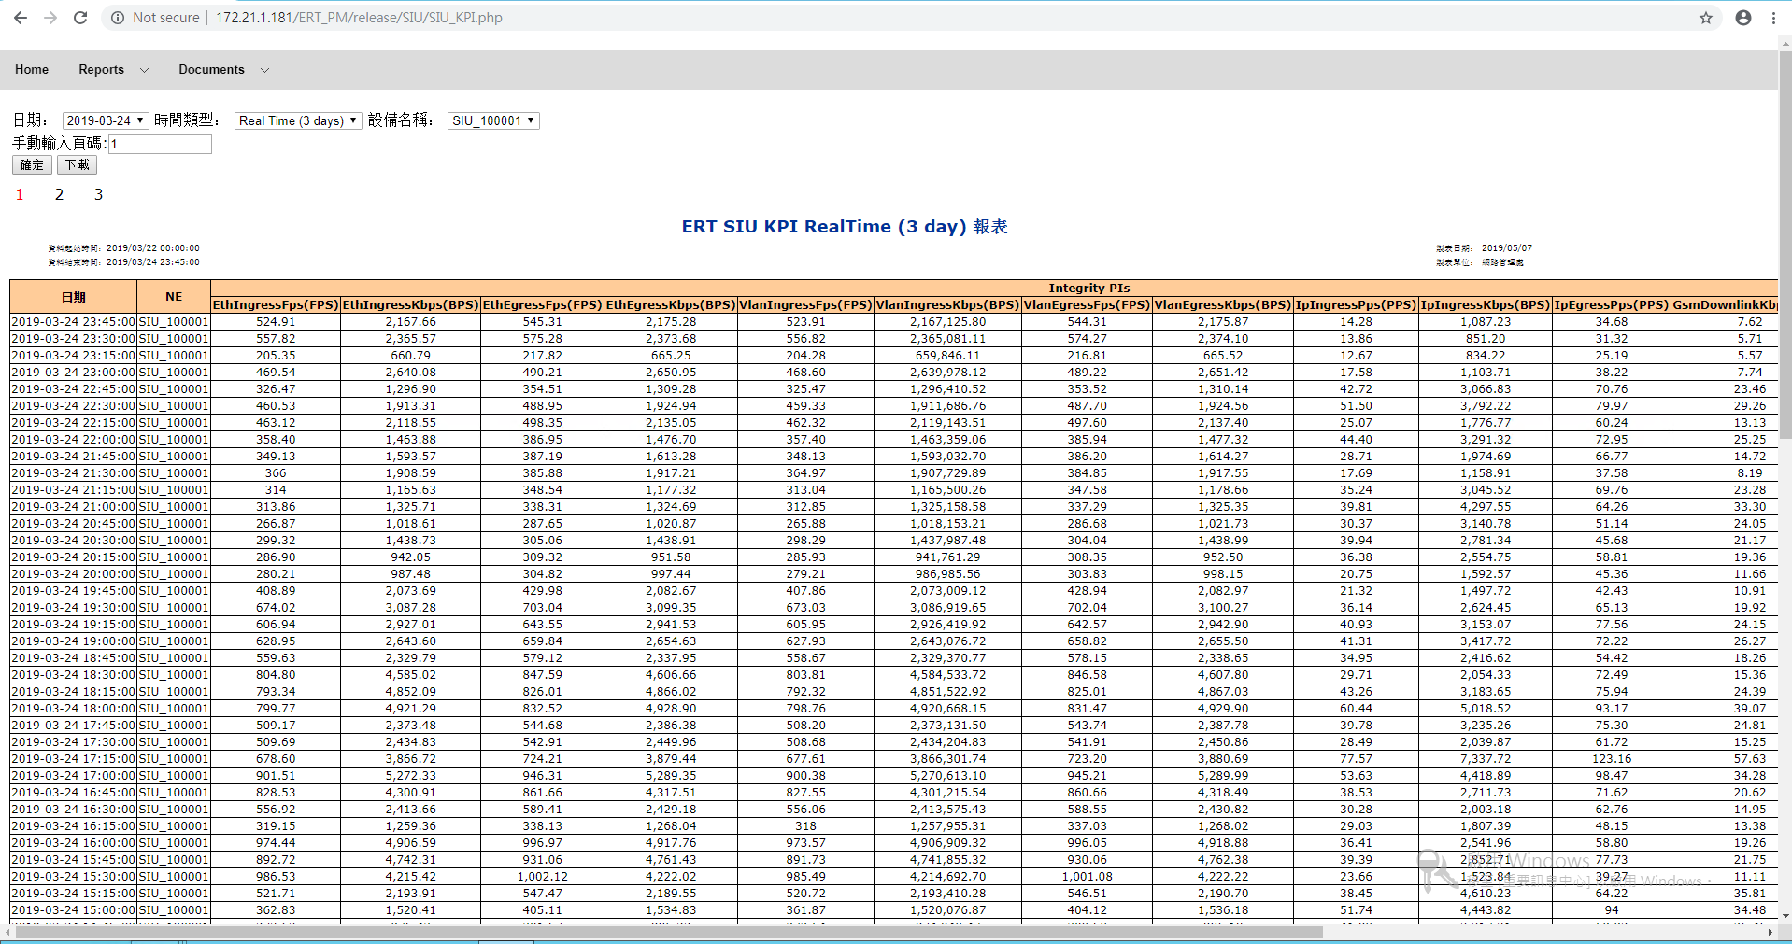

網頁放大切割圖:

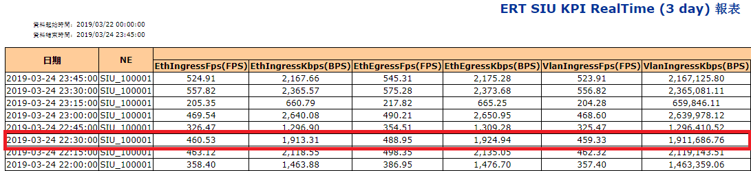

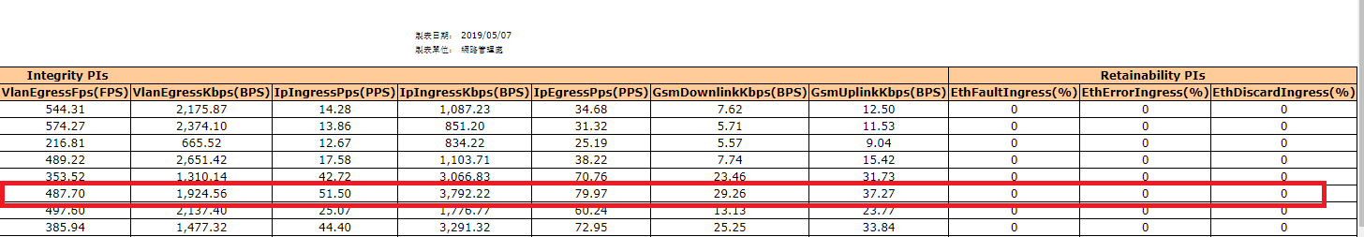

SQL執行畫面:

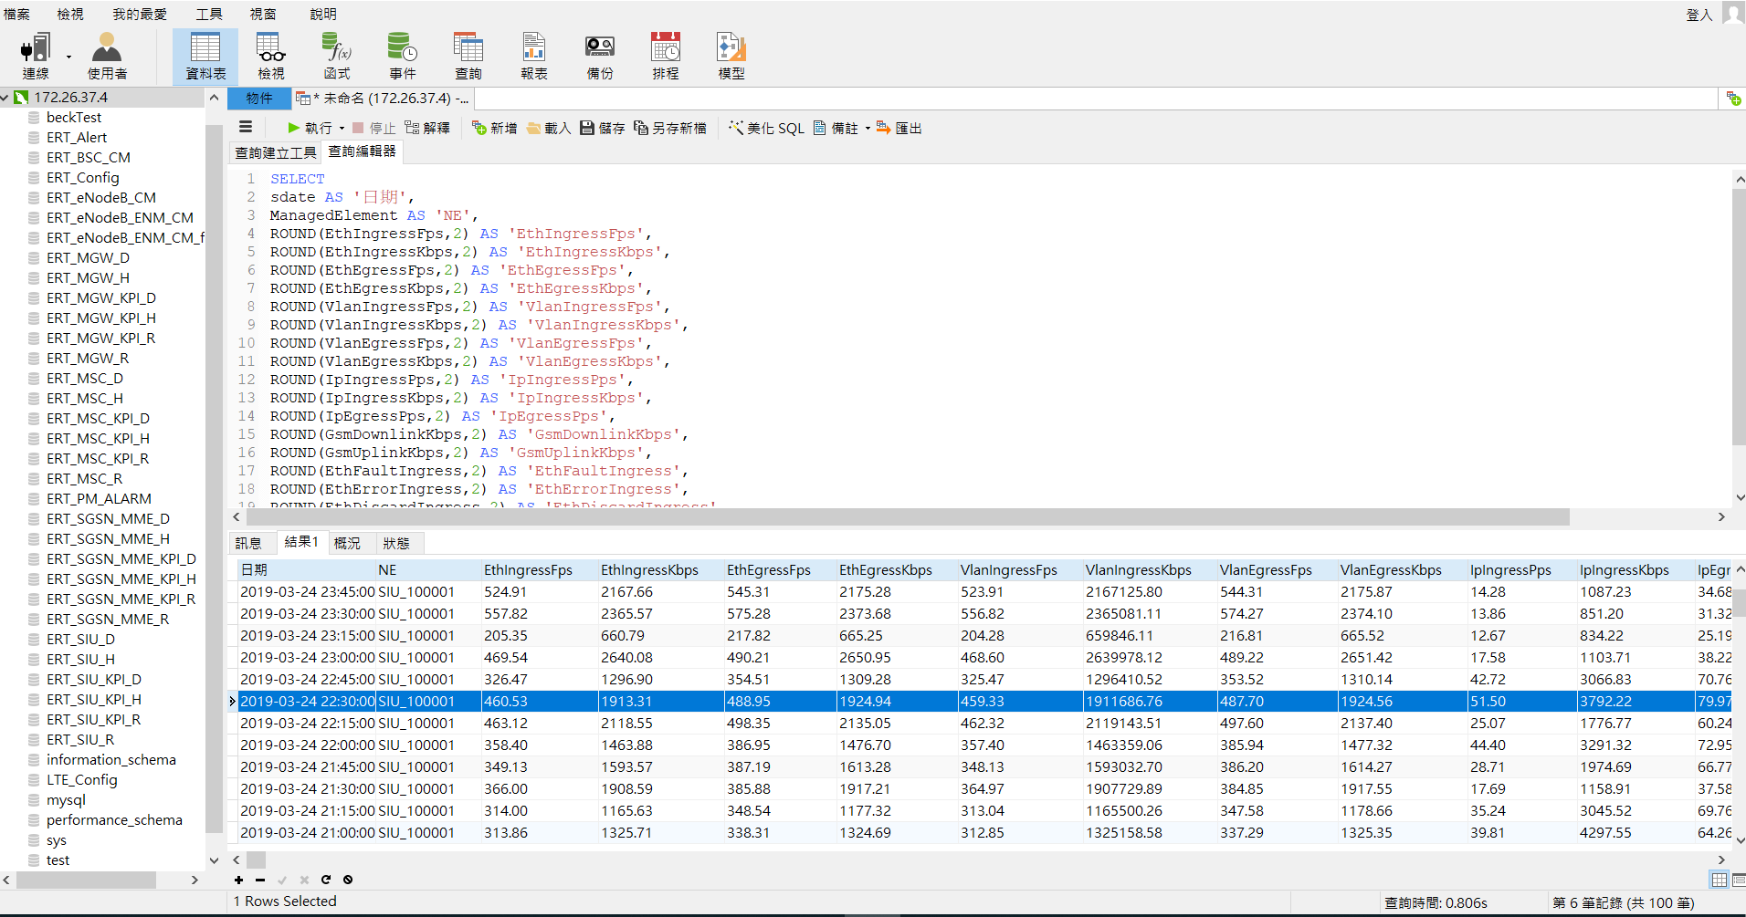

SQL查詢資料截圖:(因為DB瀏覽器沒有完整截圖的功能，所以必須當場截所有的圖片)

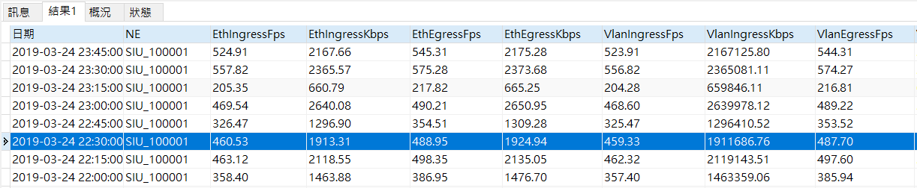

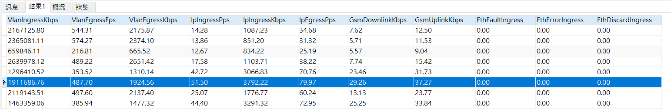

* + - 1. 資料彙整比較

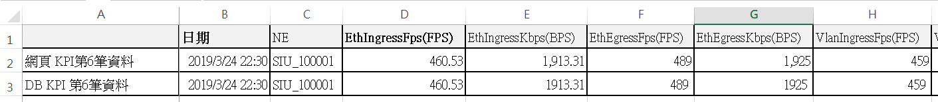

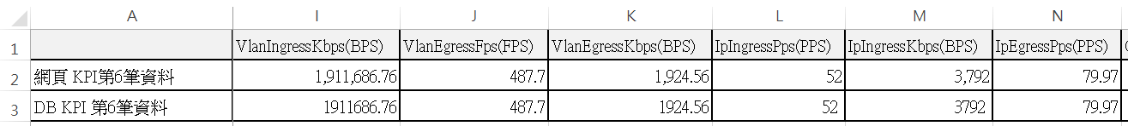

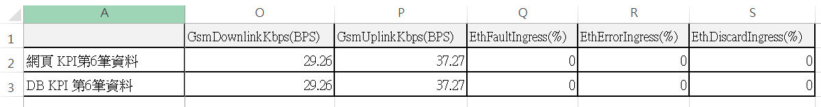

由圖可知完全一致。

* 1. 自訂Web KPI及驗算

連線資訊

KPI URL

[http://172.21.1.181/ERT_PM/release/SIU/SIU_KPI.php](http://172.21.1.181/ERT_PM/release/SGSN_MME/SGSN_MME_KPI.php)

DB IP

172.26.37.4

參考資料

附件1 SIU KPI對照表

內容說明網頁顯示欄位與資料庫欄位的對照對照表

自訂KPI限制

僅能使用KPI Table裡有定義的column建立新的自訂KPI

* + 1. 查詢KPI Table現有的column

查詢KPI Table現有欄位的SQL:

|  |
| --- |
| SELECT COLUMN_NAME FROM information_schema.`COLUMNS` WHERE table_schema = 'ERT_SIU_KPI_D' AND TABLE_NAME = 'KPI'; |

查詢結果:

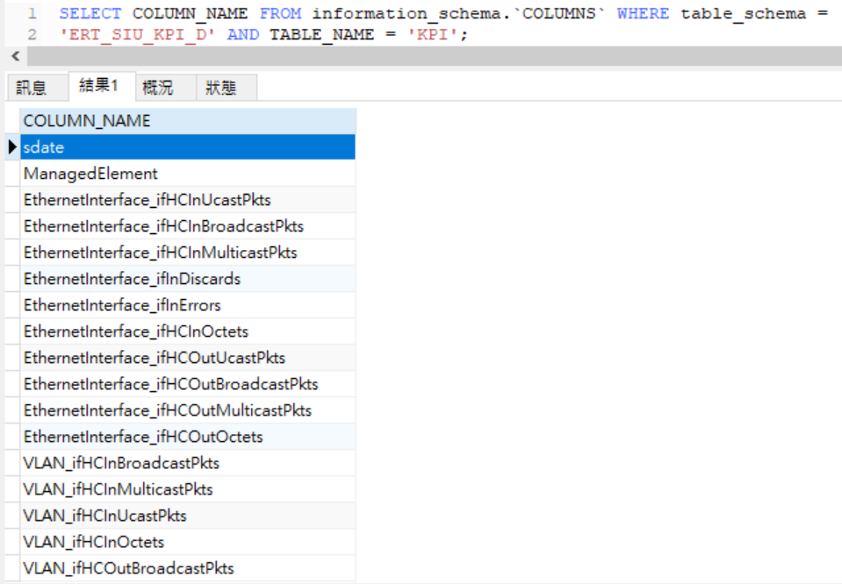

* + 1. 利用現有column自訂一個KPI

建立自訂KPI SQL:

|  |
| --- |
| INSERT INTO `ERT_Config`.`SIU_KPI_Cols_to_Report_Mapping`  (`TableCols`, `Name`, `Unit`, `ColGroup`, `Critical`, `KPI`, `Accessibility`,  `Retainability`, `Mobility`, `Integrity`, `Usage`, `Quality`, `Data`)  VALUES  ('EthernetInterface_ifHCInUcastPkts+EthernetInterface_ifHCInMulticastPkts',  'CTP_Test_KPI', '', 'KPI', '0', '1', '0', '0', '0', '0', '0', '0', '0'); |

執行結果

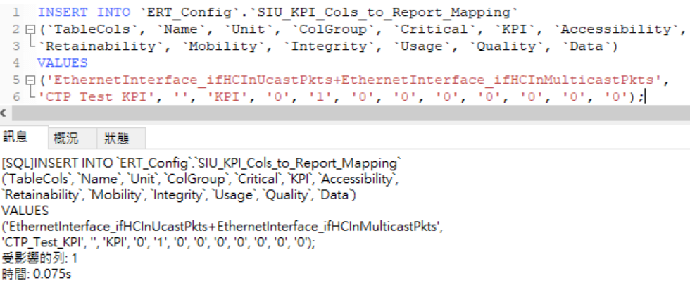

* + 1. 驗算網頁查詢結果

測試查詢條件

|  |  |
| --- | --- |
| 條件 | 輸入值 |
| 日期 | 2019-03-24 |
| 時間類型 | Daily |
| 設備名稱 | SIU_100001 |
| 手動輸入頁碼 | 1 |

網頁查詢條件設定

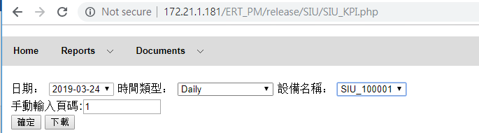

查詢資料庫自訂KPI CTP_Test_KPI及相關因子SQL:

|  |
| --- |
| SELECT  ROUND(EthernetInterface_ifHCInUcastPkts+EthernetInterface_ifHCInMulticastPkts,2) AS 'CTP_Test_KPI',  EthernetInterface_ifHCInUcastPkts,  EthernetInterface_ifHCInMulticastPkts  FROM ERT_SIU_KPI_D.KPI WHERE sdate = '2019-03-24' AND ManagedElement = 'SIU_100001'; |

網頁查詢結果:

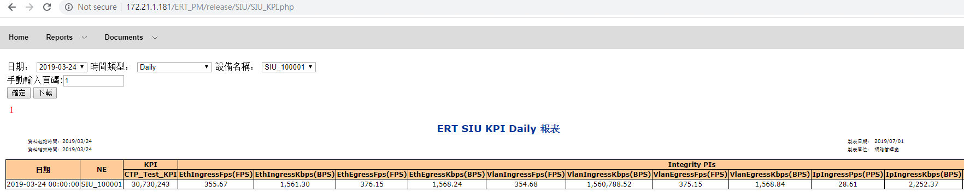

查詢資料庫自訂KPI CTP_Test_KPI及相關因子SQL結果:

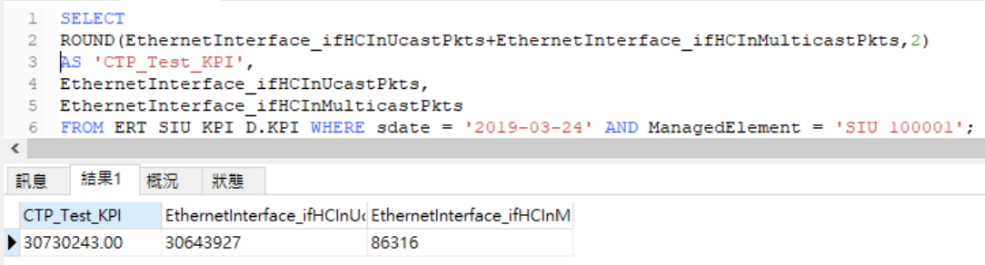

SQL計算結果等於網頁顯示結果且EthernetInterface_ifHCInUcastPkts+EthernetInterface_ifHCInMulticastPkts = 30643927+86316 = 30730243，等於SQL計算結果也等於網頁顯示結果。

所以網頁顯示自訂KPI數值正確

* + 1. 刪除自訂KPI

刪除自訂KPI的SQL:

|  |
| --- |
| DELETE FROM ERT_Config.SIU_KPI_Cols_to_Report_Mapping  WHERE `Name` = 'CTP_Test_KPI'; |

SQL執行結果

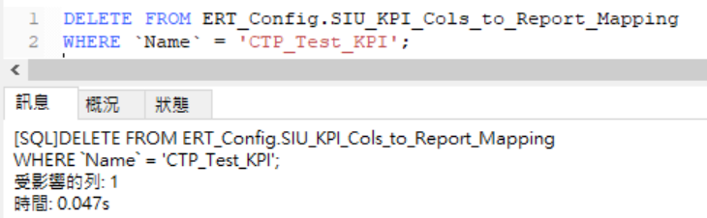

網頁查詢結果:

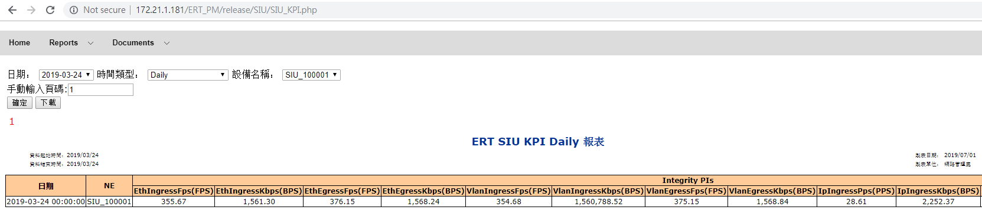

確認已刪除測試用自訂KPI。

1. SIU KPI對照表

網頁顯示名稱 : User從網頁直接看到的欄位名稱

資料庫欄位 : KPI查詢網頁會使用這些欄位在資料庫查詢資料

亞太網管 User自訂KPI公式 : 查詢欄位不是一個欄位，而是多個欄位運算而成

使用範例1.

Q: 想在資料庫查詢「日期」，我該查詢資料庫的哪個欄位?

A: sdate

使用範例2.

Q: 能舉個亞太網管 User自訂KPI公式的實例嗎?

A: 在SIU亞太網管 User沒有啟用這個功能，但是功能在ENB/BSC網頁有CTP案例，想知道是否可用請參考ENB/BSC Web GUI相關測試

|  |  |
| --- | --- |
| 網頁顯示名稱 | 查詢欄位 |
| 日期 | sdate |
| NE | ManagedElement |
| EthIngressFps | EthIngressFps |
| EthIngressKbps | EthIngressKbps |
| EthEgressFps | EthEgressFps |
| EthEgressKbps | EthEgressKbps |
| VlanIngressFps | VlanIngressFps |
| VlanIngressKbps | VlanIngressKbps |
| VlanEgressFps | VlanEgressFps |
| VlanEgressKbps | VlanEgressKbps |
| IpIngressPps | IpIngressPps |
| IpIngressKbps | IpIngressKbps |
| IpEgressPps | IpEgressPps |
| GsmDownlinkKbps | GsmDownlinkKbps |
| GsmUplinkKbps | GsmUplinkKbps |
| EthFaultIngress | EthFaultIngress |
| EthErrorIngress | EthErrorIngress |
| EthDiscardIngress | EthDiscardIngress |

# 檢查PM raw file housekeeping 機制正常

|  |  |  |
| --- | --- | --- |
| Test Case | TC_11 | |
| Description | 減少config設定的天數執行看看資料是否真的減少 | |
| Test Execution | 1. 檢查config設定值 2. 修改設定值 3. 執行housekeeping前 4. 執行housekeeping後 5. 復原config設定值 | |
| Excepted Result | 1. 檢查config設定值      1. 修改設定值      1. housekeeping執行前        1. housekeeping執行 & 執行後          1. 復原config設定值 | |
| Result: | ■ OK □ NOK |

# 檢查PM MySQL housekeeping 機制正常

|  |  |  |
| --- | --- | --- |
| Test Case | TC_12 | |
| Description | 檢查PM MySQL housekeeping 機制正常 | |
| Test Execution | 1. 檢查config設定值 2. 修改設定值 3. 執行housekeeping前  |  |  | | --- | --- | | 動作 | SQL | | 查各資料庫最舊的資料日期以及與今日的日期差距 | SELECT *, DATEDIFF(NOW,MIN_SDATE) 'DIFF_NOW' FROM (  SELECT NOW() AS 'NOW', 'ERT_SIU_R' AS 'DB_NAME', MIN(sdate) AS 'MIN_SDATE'  FROM ERT_SIU_R.VLAN UNION ALL  SELECT NOW(), 'ERT_SIU_KPI_R', MIN(sdate)  FROM ERT_SIU_KPI_R.KPI UNION ALL  SELECT NOW(), 'ERT_SIU_H', MIN(sdate) FROM ERT_SIU_H.VLAN  UNION ALL  SELECT NOW(), 'ERT_SIU_KPI_H', MIN(sdate) FROM ERT_SIU_KPI_H.KPI  UNION ALL  SELECT NOW(), 'ERT_SIU_D', MIN(sdate) FROM ERT_SIU_D.VLAN  UNION ALL  SELECT NOW(), 'ERT_SIU_KPI_D', MIN(sdate) FROM ERT_SIU_KPI_D.KPI  ) a |  1. 執行housekeeping  |  |  | | --- | --- | | 動作 | 指令或SQL | | 執行housekeeping | date && cd /home/noc/PMHousekeeping/ && nohup php schedule.php ERT_SIU > run.log 2>&1 & |  1. 執行housekeeping後  |  |  | | --- | --- | | 動作 | SQL | | 查各資料庫最舊的資料日期 | SELECT *, DATEDIFF(NOW,MIN_SDATE) 'DIFF_NOW' FROM (  SELECT NOW() AS 'NOW', 'ERT_SIU_R' AS 'DB_NAME', MIN(sdate) AS 'MIN_SDATE'  FROM ERT_SIU_R.VLAN UNION ALL  SELECT NOW(), 'ERT_SIU_KPI_R', MIN(sdate)  FROM ERT_SIU_KPI_R.KPI UNION ALL  SELECT NOW(), 'ERT_SIU_H', MIN(sdate) FROM ERT_SIU_H.VLAN  UNION ALL  SELECT NOW(), 'ERT_SIU_KPI_H', MIN(sdate) FROM ERT_SIU_KPI_H.KPI  UNION ALL  SELECT NOW(), 'ERT_SIU_D', MIN(sdate) FROM ERT_SIU_D.VLAN  UNION ALL  SELECT NOW(), 'ERT_SIU_KPI_D', MIN(sdate) FROM ERT_SIU_KPI_D.KPI  ) a |  1. 復原config設定值 | |
| Excepted Result | 1. 檢查config設定值      1. 修改設定值      1. 執行housekeeping前  |  |  | | --- | --- | | 動作 | SQL | | 查各資料庫最舊的資料日期以及與今日的日期差距 |  |  1. 執行housekeeping  |  |  | | --- | --- | | 動作 | 指令或SQL | | 執行housekeeping | 開始    結束 |  1. 執行housekeeping後  |  |  | | --- | --- | | 動作 | SQL | | 查各資料庫最舊的資料日期 |  |  1. 復原config設定值 | |
| Result: | ■ OK □ NOK |

# TC_13 檢查下載檔案數量低於告警門檻值時發Alert email

## 驗證項目

* ​​驗證Raw Data Server的檔案數量與實際下載檔案數量一致
* 驗證實際下載檔案數量與下載紀錄一致
* 驗證告警門檻值調整流程
* 驗證下載紀錄的檔案數量小於告警門檻值會產生告警訊息
* 驗證Alert機制根據告警訊息產生Alert email
* 驗證Alert email告警訊息內容與Alert DB內容一致

## 驗證方式

* 登入Raw Data Server檢查2個時段檔案數量
* 登入到AP Server 檢查2個時段的檔案數量
* 從DB Server檢查下載紀錄的2個時段的檔案數量
* ​​比對前面3點上的2個時段檔案數量相同
* 在DB Server修改SIU的告警門檻值為原值的2倍
* 手動執行Alert回查機制產生Raw Data的告警訊息
* Alert機制的發email功能使User可收到Alert email
* 擷取User的email包含第5點時段的告警的圖片
* 驗證第7點的內容與Alert DB一致

## 驗證條件

* 指定測試2個時間段的sdate為2019-04-29 17:00:00和2019-04-29 17:15:00

## 驗證流程

### 登入Raw Data Server檢查2個時段檔案數量

* ssh登入跳板機SIU AP Server，​IP為172.26.37.4，用戶名為 noc
* ssh登入Raw Data Server，IP為172.26.60.56，用戶名為metm02
* ​​保存位置

2019-04-29 17:00:00(換算成Raw Data Server檔名要減8小時) /var/opt/ericsson/sgw/outputfiles/xml/stn/SIU_*/A201904290900*

2019-04-29 17:15:00(換算成Raw Data Server檔名要減8小時)

/var/opt/ericsson/sgw/outputfiles/xml/stn/SIU_*/A201904290915*

* 時段1：2019-04-29 17:00:00 文件數量為： 4484
* 時段2：2019-04-29 17:15:00 文件數量為： 4485
* 查詢指令如下：

用putty登入172.26.37.4後

ssh metm02@172.26.60.56

ll -h /var/opt/ericsson/sgw/outputfiles/xml/stn/SIU_*/A201904290900* | wc -l

​ 4484

注 ls要增加過濾時間範圍的機制參考find sed awk，第4484是edate+15分才產生

​​ll -h /var/opt/ericsson/sgw/outputfiles/xml/stn/SIU_*/A201904290915* | wc -l

​      4485

### 登入到AP Server 檢查原始文件2個時段的檔案數量

* ​​ssh登入SIU AP Server 主機，​IP 為172.26.37.4，用戶名為 noc
* ​​原始文件分別保存/DATA/ERT_SIU_PM/PM/ERT_SIU_201904291700_201904291715_4.tar.gz

/DATA/ERT_SIU_PM/PM/ERT_SIU_201904291715_201904291730_4.tar.gz

* 時段1：2019-04-29 17:00:00 文件數量為： 4483
* 時段2：2019-04-29 17:15:00 文件數量為： 4484
* 查詢指令如下：

用putty登入172.26.37.4後

cd ~

cp /DATA/ERT_SIU_PM/PM/ERT_SIU_201904291700_201904291715_4.tar.gz ~

tar zxf ERT_SIU_201904291700_201904291715_4.tar.gz

​​ls SIU_4 | wc -l

​ 4483

rm -rf SIU_4/ ERT_SIU_201904291700_201904291715_4.tar.gz

​​cp /DATA/ERT_SIU_PM/PM/ERT_SIU_201904291715_201904291730_4.tar.gz ~

tar zxf ERT_SIU_201904291715_201904291730_4.tar.gz

​​ls SIU_4 | wc -l

​​      4484

rm -rf SIU_4/ ERT_SIU_201904291715_201904291730_4.tar.gz

### 從DB Server檢查下載紀錄的2個時段的檔案數量

* 登入SIU DB Server 主機，​IP為172.26.37.4，用戶名為ert_pm_parser
* ​​資料保存於DB: ERT_Alert、Table: raw_data_monitor
* 時段1：2019-04-29 17:00:00 文件數量為： 4483
* 時段2：2019-04-29 17:15:00 文件數量為： 4484
* 查詢指令如下：

用putty登入172.26.37.4後

mysql -uert_pm_parser -p

SELECT sdate, file_count FROM ERT_Alert.`raw_data_monitor` WHERE system = 'ERT_SIU_PM' AND sdate = '2019-04-29 17:00:00'\G

sdate: 2019-04-29 17:00:00

file_count: 4483

SELECT sdate, file_count FROM ERT_Alert.`raw_data_monitor` WHERE system = 'ERT_SIU_PM' AND sdate = '2019-04-29 17:15:00'\G

sdate: 2019-04-29 17:15:00

file_count: 4484

### 比對前面3點上的2個時段檔案數量相同

* 比較表

|  |  |  |  |  |
| --- | --- | --- | --- | --- |
| Sdate | Raw Data | 下載檔案數 | 下載紀錄 | 差異  (Raw Data -下載檔案數) |
| 2019-04-29 17:00 | 4484 | 4483 | 4483 | 1 |
| 2019-04-29 17:15 | 4485 | 4484 | 4484 | 1 |

* 從上表實際Raw Data的檔案在兩個時段都比下載檔案數多1個
* 驗證Raw Data的產檔時間

用putty登入172.26.37.4後

ssh metm02@172.26.60.56

# 將符合下載條件的檔案清單，依時間遞減排序寫入201904291700.log

ls -lt /var/opt/ericsson/sgw/outputfiles/xml/stn/SIU_*/A201904290900* > 201904291700.log

​vi 201904291700.log

請參考下圖201904291700.log

# 將符合下載條件的檔案清單，依時間遞減排序寫入201904291715.log

ls -lt /var/opt/ericsson/sgw/outputfiles/xml/stn/SIU_*/A201904290915* > 201904291715.log

​vi 201904291715.log

請參考下圖201904291715.log

* 201904291700.log

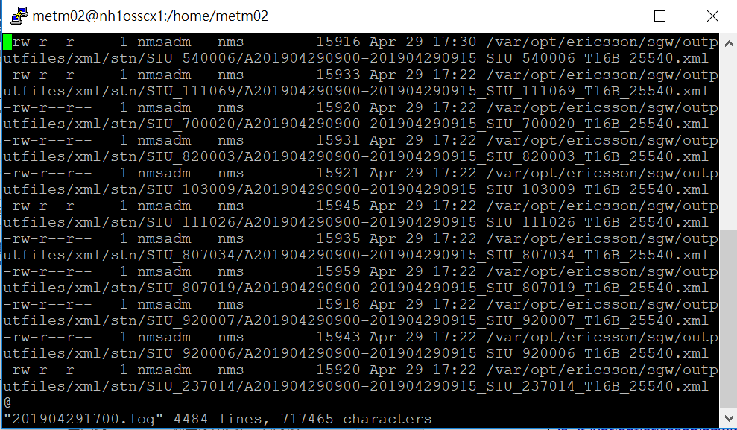

* 201904291715.log

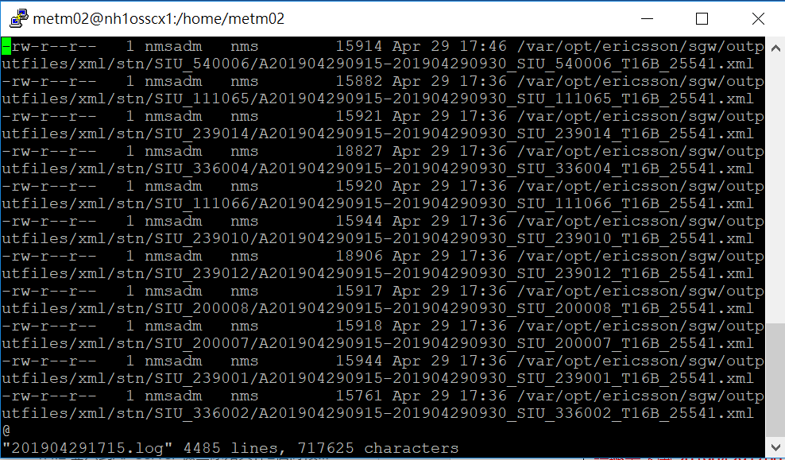

* ​驗證差異的合理性
  + sdate 2019-04-29 17:00:00
    - 下載時間於17:23:00 (系統排程)
    - Raw Data產檔時間早於17:23:00共有4483個檔案
    - Raw Data產檔時間晚於17:23:00共有1個檔案
    - 驗證時間為17:50:00，看到下載檔案數為4483、Raw Data有4484是正常的
  + sdate 2019-04-29 17:15:00
    - 下載時間於17:38:00 (系統排程)
    - Raw Data產檔時間早於17:38:00共有4484個檔案
    - Raw Data產檔時間晚於17:38:00共有1個檔案
    - 驗證時間為17:50:00，看到下載檔案數為4484、Raw Data有4485是正常的

### 在DB Server修改SIU的告警門檻值為原值的2倍

* 登入SIU DB Server 主機，​IP為172.26.37.4，用戶名為ert_pm_parser
* ​​資料保存於DB: ERT_Alert、Table: compare_config
* 目前告警門檻值: 4400
* 修改後告警門檻值: 8800
* 查詢指令如下：

​​用putty登入172.26.37.4後

mysql -uert_pm_parser -p

SELECT min_size FROM ERT_Alert.compare_config WHERE system = 'ERT_SIU_PM'\G

min_size: 4400

UPDATE ERT_Alert.compare_config SET min_size = min_size*2 WHERE system = 'ERT_SIU_PM';

Rows matched: 1 Changed: 1 Warnings: 0

SELECT min_size FROM ERT_Alert.compare_config WHERE system = 'ERT_SIU_PM'\G

min_size: 8800

### 手動執行Alert回查機制產生Raw Data的告警訊息

* ​​ssh登入SIU AP Server 主機，​IP 為172.26.37.4，用戶名為 noc
* 回查時段1：2019-04-29 17:00:00
* 回查時段2：2019-04-29 17:15:00
* 產生告警訊息
  + 告警1:
    - 系統: ERT_SIU_PM
    - 時間區間類型: R
    - 告警建立時間: 2019-04-26 14:19:05
    - sdate: 2019-04-29 17:00:00
    - edate: 2019-04-29 17:15:00
    - 錯誤訊息: [RawData下載異常]下載數量: 2, 小於門檻值: 4; [回補指令]cd /home/noc/ERT_SIU_PM/download/SCP && /opt/rh/rh-php56/root/usr/bin/php scpDownloadFile.php Manual 201904291700
  + 告警2:
    - 系統: ERT_SIU_PM
    - 時間區間類型: R
    - 告警建立時間: 2019-04-26 14:19:14
    - sdate: 2019-04-29 17:15:00
    - edate: 2019-04-26 13:45:00
    - 錯誤訊息: [RawData下載異常]下載數量: 2, 小於門檻值: 4; [回補指令]cd /home/noc/ERT_SIU_PM/download/SCP && /opt/rh/rh-php56/root/usr/bin/php scpDownloadFile.php Manual 201904291715
* 指令

用putty登入172.26.37.4後

#回查時段1

cd /home/noc/ERT_PM_MONITOR/src && /opt/rh/rh-php56/root/usr/bin/php checkAlert.php Manual R 201904291700 201904291700

#回查時段2

cd /home/noc/ERT_PM_MONITOR/src && /opt/rh/rh-php56/root/usr/bin/php checkAlert.php Manual R 201904291715 201904291715

#登入MySQL

mysql -uert_pm_parser -p

-- 查詢告警1

SELECT system AS '系統', period AS '時間區間類型', create_time AS '告警建立時間', sdate, edate, error_info AS '錯誤訊息' FROM ERT_Alert.`system_alert` WHERE sdate = '2019-04-29 17:00:00' AND system = 'ERT_SIU_PM' AND period = 'R' AND type = 'RawData' AND `status`=1\G

*************************** 1. row ***************************

系統: ERT_SIU_PM

時間區間類型: R

告警建立時間: 2019-04-30 13:56:37

sdate: 2019-04-29 17:00:00

edate: 2019-04-29 17:15:00

錯誤訊息: [RawData下載異常]下載數量: 4483, 小於門檻值: 8800; [回補指令]cd /home/noc/ERT_SIU_PM/download/SCP && /opt/rh/rh-php56/root/usr/bin/php scpDownloadFile.php Manual 201904291700

-- 查詢告警2

SELECT system AS '系統', period AS '時間區間類型', create_time AS '告警建立時間', sdate, edate, error_info AS '錯誤訊息' FROM ERT_Alert.`system_alert` WHERE sdate = '2019-04-29 17:15:00' AND system = 'ERT_SIU_PM' AND period = 'R' AND type = 'RawData' AND `status`=1\G

*************************** 1. row ***************************

系統: ERT_SIU_PM

時間區間類型: R

告警建立時間: 2019-04-30 13:56:44

sdate: 2019-04-29 17:15:00

edate: 2019-04-29 17:30:00

錯誤訊息: [RawData下載異常]下載數量: 4484, 小於門檻值: 8800; [回補指令]cd /home/noc/ERT_SIU_PM/download/SCP && /opt/rh/rh-php56/root/usr/bin/php scpDownloadFile.php Manual 201904291715

### Alert機制的發email功能使User可收到Alert email

* ​​從172.26.37.4 ssh登入Mail AP Server 主機，​IP 為10.108.58.152，用戶名為 noc
* 發送email給user
* Log有4筆告警，如下所示
* 發送指令

​​用putty登入172.26.37.4後

ssh noc@10.108.58.152

#發送指令

cd /home/noc/ParsingAlarm/pm_cm_src && /opt/lampp/bin/php sendSystemAlert.php

#檢查發送結果

vi ~/ParsingAlarm/log/trace2019-04-30.log #shift + G然後從後面找最近的執行紀錄

[2019-04-30 13:58:45][INFO][send mail success

Body=[

<html><body><table border = '2'>

<tr><td>﻿系統</td><td>時間區間類型</td><td>告警建立時間</td><td>sdate</td><td>edate</td><td>錯誤訊息</td></tr>

<tr><td>ERT_SIU_PM</td><td>R</td><td>2019-04-30 13:56:37</td><td>2019-04-29 17:00:00</td><td>2019-04-29 17:15:00</td><td>[RawData下載異常]下載數量: 4483, 小於門檻值: 8800; [回補指令]cd /home/noc/ERT_SIU_PM/download/SCP &amp;&amp; /opt/rh/rh-php56/root/usr/bin/php scpDownloadFile.php Manual 201904291700</td></tr>

<tr><td>ERT_SIU_PM</td><td>R</td><td>2019-04-30 13:56:37</td><td>2019-04-29 17:00:00</td><td>2019-04-29 17:15:00</td><td>[KPI資料量異常]KPI筆數:4483筆, 小於門檻值: 8800; [回補指令] cd /home/noc/ERT_SIU_PM/KPI &amp;&amp; /opt/rh/rh-php56/root/usr/bin/php KPI.php Manual R SIU 201904291700</td></tr>

<tr><td>ERT_SIU_PM</td><td>R</td><td>2019-04-30 13:56:44</td><td>2019-04-29 17:15:00</td><td>2019-04-29 17:30:00</td><td>[RawData下載異常]下載數量: 4484, 小於門檻值: 8800; [回補指令]cd /home/noc/ERT_SIU_PM/download/SCP &amp;&amp; /opt/rh/rh-php56/root/usr/bin/php scpDownloadFile.php Manual 201904291715</td></tr>

<tr><td>ERT_SIU_PM</td><td>R</td><td>2019-04-30 13:56:44</td><td>2019-04-29 17:15:00</td><td>2019-04-29 17:30:00</td><td>[KPI資料量異常]KPI筆數:4484筆, 小於門檻值: 8800; [回補指令] cd /home/noc/ERT_SIU_PM/KPI &amp;&amp; /opt/rh/rh-php56/root/usr/bin/php KPI.php Manual R SIU 201904291715</td></tr>

</table></body></html>

]]

### 擷取User的Alert email

* 請User轉寄收到的告警email
* 截圖email附加的csv
  + 黃色是測試告警
  + 沒有變色的是排程程式受修改告警門檻值產生的告警
  + 共有4筆告警

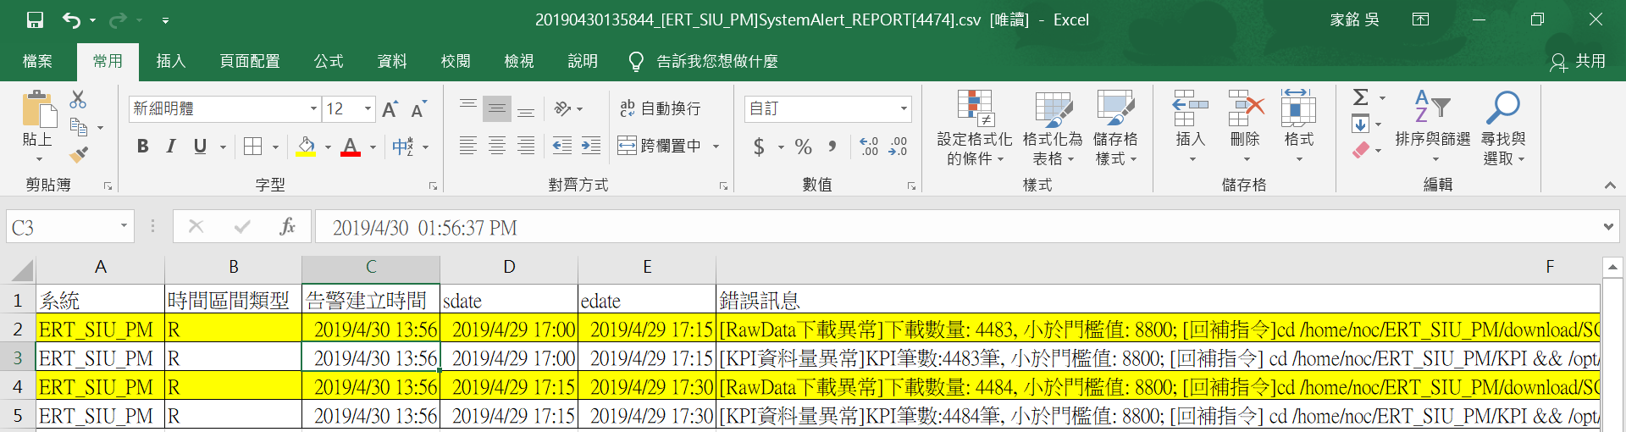

### 驗證Alert email與Alert DB告警數一致

* ssh登入SIU AP Server 主機，​IP 為172.26.37.4，用戶名為 noc
* 接收mail涵蓋的告警時間範圍:
  + 起: 2019-04-30 13:56:37
  + 迄: 2019-04-30 13:56:44
* Alert DB和Alert mail資料筆數:
  + Alert mail: 4
  + Alert DB: 4
* 資料筆數一致
* 查詢指令

用putty登入172.26.37.4後

#登入MySQL

mysql -uert_pm_parser -p

SELECT COUNT(*) FROM ERT_Alert.`system_alert` WHERE create_time >= '2019-04-30 13:56:37' AND create_time <= '2019-04-30 13:56:44' AND system = 'ERT_SIU_PM' AND `status` = 1\G

COUNT(*): 4

### 驗證Alert email與Alert DB測試告警內容一致

* ssh登入SIU AP Server 主機，​IP 為172.26.37.4，用戶名為 noc
* 複製Alert DB和Alert mail的告警內容到下圖

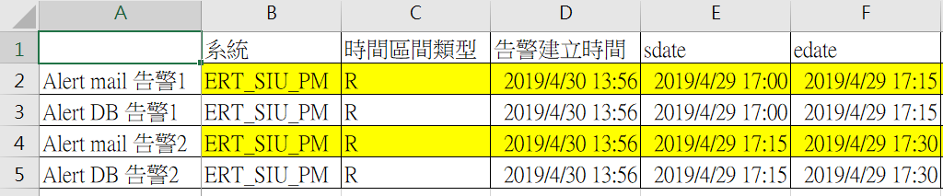

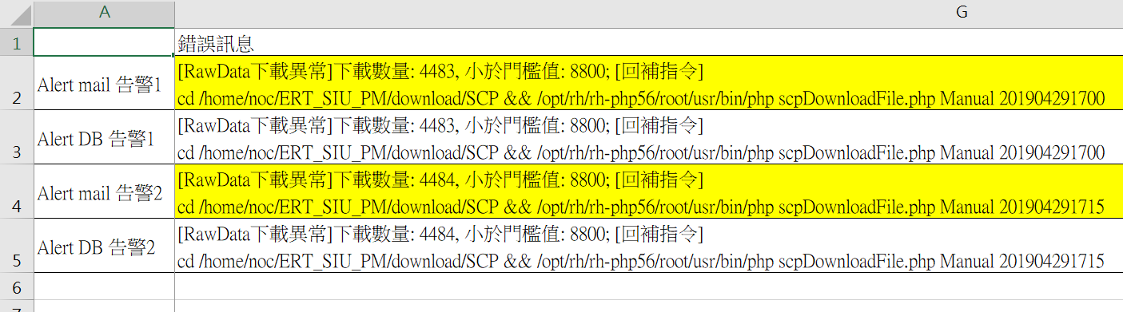

* 內容一致
* 指令

用putty登入172.26.37.4後

#登入MySQL

mysql -uert_pm_parser -p

-- 查詢告警1

SELECT system AS '系統', period AS '時間區間類型', create_time AS '告警建立時間', sdate, edate, error_info AS '錯誤訊息' FROM ERT_Alert.`system_alert` WHERE sdate = '2019-04-29 17:00:00' AND system = 'ERT_SIU_PM' AND period = 'R' AND type = 'RawData' AND `status`=1\G

*************************** 1. row ***************************

系統: ERT_SIU_PM

時間區間類型: R

告警建立時間: 2019-04-30 13:56:37

sdate: 2019-04-29 17:00:00

edate: 2019-04-29 17:15:00

錯誤訊息: [RawData下載異常]下載數量: 4483, 小於門檻值: 8800; [回補指令]cd /home/noc/ERT_SIU_PM/download/SCP && /opt/rh/rh-php56/root/usr/bin/php scpDownloadFile.php Manual 201904291700

-- 查詢告警2

SELECT system AS '系統', period AS '時間區間類型', create_time AS '告警建立時間', sdate, edate, error_info AS '錯誤訊息' FROM ERT_Alert.`system_alert` WHERE sdate = '2019-04-29 17:15:00' AND system = 'ERT_SIU_PM' AND period = 'R' AND type = 'RawData' AND `status`=1\G

*************************** 1. row ***************************

系統: ERT_SIU_PM

時間區間類型: R

告警建立時間: 2019-04-30 13:56:44

sdate: 2019-04-29 17:15:00

edate: 2019-04-29 17:30:00

錯誤訊息: [RawData下載異常]下載數量: 4484, 小於門檻值: 8800; [回補指令]cd /home/noc/ERT_SIU_PM/download/SCP && /opt/rh/rh-php56/root/usr/bin/php scpDownloadFile.php Manual 201904291715

### 環境復原

* 登入SIU DB Server 主機，​IP為172.26.37.4，用戶名為ert_pm_parser
* 設定值改回原本設定值
  + 復原後 min_size = 4400
* close測試告警
* 內容一致
* Alert DB查詢指令

用putty登入172.26.37.4後

#回查時段1

#登入MySQL

mysql -uert_pm_parser -p

-- 使用原本告警門檻值，下個週期如果正常用作必須不會發出告警

UPDATE ERT_Alert.compare_config SET min_size = min_size/2 WHERE system = 'ERT_SIU_PM';

Rows matched: 1 Changed: 1 Warnings: 0

SELECT min_size FROM ERT_Alert.compare_config WHERE system = 'ERT_SIU_PM'\G

min_size: 4400

-- 清除測試期間的告警 status 2就是不發mail

UPDATE ERT_Alert.`system_alert` SET `status` = 2 WHERE create_time >= '2019-04-30 13:56:37' AND system = 'ERT_SIU_PM';

Rows matched: 6 Changed: 6 Warnings: 0

### 環境復原驗證

* 恢復設定值後，手動執行Alert回查機制，確認系統不會產生告警
* 指令

用putty登入172.26.37.4後

#回查時段1

cd /home/noc/ERT_PM_MONITOR/src && /opt/rh/rh-php56/root/usr/bin/php checkAlert.php Manual R 201904291700 201904291700

#回查時段2

cd /home/noc/ERT_PM_MONITOR/src && /opt/rh/rh-php56/root/usr/bin/php checkAlert.php Manual R 201904291715 201904291715

#登入MySQL

mysql -uert_pm_parser -p

-- 查詢告警1

SELECT system AS '系統', period AS '時間區間類型', create_time AS '告警建立時間', sdate, edate, error_info AS '錯誤訊息' FROM ERT_Alert.`system_alert` WHERE sdate = '2019-04-29 17:00:00' AND system = 'ERT_SIU_PM' AND period = 'R' AND type = 'RawData' AND `status`=1\G

Empty set (0.00 sec)

-- 查詢告警2

SELECT system AS '系統', period AS '時間區間類型', create_time AS '告警建立時間', sdate, edate, error_info AS '錯誤訊息' FROM ERT_Alert.`system_alert` WHERE sdate = '2019-04-29 17:15:00' AND system = 'ERT_SIU_PM' AND period = 'R' AND type = 'RawData' AND `status`=1\G

Empty set (0.00 sec)

## 驗證總結

* ​​驗證Raw Data Server的檔案數量與實際下載檔案數量一致(13.4.1, 13.4.2,13.4.4)
* 驗證實際檔案數量與下載紀錄一致(13.4.2, 13.4.3, 13.4.4)
* 驗證告警門檻值調整流程(13.4.5)
* 驗證下載紀錄的檔案數量小於告警門檻值會產生告警訊息(13.4.6)
* 驗證Alert機制根據告警訊息產生Alert email(13.4.7)
* 驗證Alert email告警訊息內容與Alert DB內容一致(13.4.8, 13.4.9)
* 上述內容等於下載檔案數量低於告警門檻值時發Alert email

# TC_14 檢查KPI R/H/D 資料筆數低於告警門檻值時發Alert email

## 驗證項目

* ​​驗證R/H/D實際資料筆數與KPI執行紀錄一致
* 驗證手動調整告警門檻值流程
* 驗證KPI執行紀錄的資料筆數小於告警門檻值會產生告警訊息
* 驗證Alert機制根據告警訊息產生Alert email
* 驗證Alert email告警訊息內容與Alert DB內容一致

## 驗證方式

* 登入到KPI DB查詢R/H/D各1個sdate的資料量
* 從Alert DB檢查KPI執行紀錄R/H/D各1個sdate的資料量
* ​​比對KPI DB和Alert DB上的相同sdate的資料量相同
* 在Alert DB修改告警門檻值為原值2倍
* 手動執行Alert回查機制產生R/H/D時段的告警訊息
* Alert機制的發email功能使User可收到Alert email
* 擷取User的Alert email與並計算筆數
* 驗證Alert email與Alert DB告警數一致
* 驗證Alert email與Alert DB測試告警內容一致

## 驗證條件

* 驗證R/H/D各1個sdate的檔案數量和下載紀錄一致
  + R sdate: 2019-04-30 13:45:00
  + H sdate: 2019-04-30 13:00:00
  + D sdate: 2019-04-29 00:00:00
* 驗證Alert機制回查功能可以指定時段產生告警訊息
* 驗證Alert機制發email
* 驗證Alert email告警訊息內容與Alert DB內容一致

## 驗證流程

### 登入到KPI DB查詢R/H/D各1個sdate的資料量

* ​​ssh登入SIU AP Server 主機，​IP為172.26.37.4，用戶名為 noc
* MySQL user: ert_pm_parser
* 資料保存於DB: ERT_SIU_KPI_R、ERT_SIU_KPI_H、ERT_SIU_KPI_D、Table: KPI
* 檢查KPI資料量
  + R
    - sdate: 2019-04-30 13:45:00
    - data_count: 4485
  + H
    - sdate: 2019-04-30 13:00:00
    - data_count: 4489
  + D
    - sdate: 2019-04-29 00:00:00
    - data_count: 4491
* 查詢指令如下：

用putty登入172.26.37.4後

mysql -uert_pm_parser -p

-- R

SELECT sdate, COUNT(*) AS 'data_count' FROM ERT_SIU_KPI_R.KPI WHERE sdate = '2019-04-30 13:45:00'\G

sdate: 2019-04-30 13:45:00

data_count: 4485

-- H

SELECT sdate, COUNT(*) AS 'data_count' FROM ERT_SIU_KPI_H.KPI WHERE sdate = '2019-04-30 13:00:00'\G

sdate: 2019-04-30 13:00:00

data_count: 4489

-- D

SELECT sdate, COUNT(*) AS 'data_count' FROM ERT_SIU_KPI_D.KPI WHERE sdate = '2019-04-29 00:00:00'\G

sdate: 2019-04-29 00:00:00

data_count: 4491

### 從Alert DB檢查KPI執行紀錄R/H/D各1個sdate的資料量

* ssh登入SIU AP Server 主機，​IP 為172.26.37.4，用戶名為 noc
* MySQL user: ert_pm_parser
* ​​資料保存於DB: ERT_Alert、Table: KPI_monitor
* 檢查KPI資料量
  + R
    - sdate: 2019-04-30 13:45:00
    - data_count: 4485
  + H
    - sdate: 2019-04-30 13:00:00
    - data_count: 4489
  + D
    - sdate: 2019-04-29 00:00:00
    - data_count: 4491
* 查詢指令如下：

用putty登入172.26.37.4後

mysql -uert_pm_parser -p

-- R

SELECT sdate, data_count FROM ERT_Alert.`KPI_monitor` WHERE system = 'ERT_SIU_PM' AND period = 'R' AND sdate = '2019-04-30 13:45:00'\G

sdate: 2019-04-30 13:45:00

data_count: 4485

-- H

SELECT sdate, data_count FROM ERT_Alert.`KPI_monitor` WHERE system = 'ERT_SIU_PM' AND period = 'H' AND sdate = '2019-04-30 13:00:00'\G

sdate: 2019-04-30 13:00:00

file_count: 4489

-- D

SELECT sdate, data_count FROM ERT_Alert.`KPI_monitor` WHERE system = 'ERT_SIU_PM' AND period = 'D' AND sdate = '2019-04-29 00:00:00'\G

sdate: 2019-04-29 00:00:00

file_count: 4491

### 比對KPI DB和Alert DB上的相同sdate的資料量相同

* KPI DB和Alert DB結果完全相同
  + R各有4485
  + H各有4489
  + D各有 4491

### 在DB Server修改SIU的告警門檻值為原值的2倍

* 登入SIU DB Server 主機，​IP為172.26.37.4，用戶名為ert_pm_parser
* ​​資料保存於DB: ERT_Alert、Table: raw_data_monitor
* 目前告警門檻值: 4400
* 修改後告警門檻值: 8800
* 查詢指令如下：

​​用putty登入172.26.37.4後

mysql -uert_pm_parser -p

SELECT min_size FROM ERT_Alert.compare_config WHERE system = 'ERT_SIU_PM'\G

min_size: 4400

UPDATE ERT_Alert.compare_config SET min_size = min_size*2 WHERE system = 'ERT_SIU_PM';

Rows matched: 1 Changed: 1 Warnings: 0

SELECT min_size FROM ERT_Alert.compare_config WHERE system = 'ERT_SIU_PM'\G

min_size: 8800

### 手動執行Alert回查機制產生R/H/D時段的告警訊息

* ssh登入SIU AP Server 主機，​IP 為172.26.37.4，用戶名為 noc
* MySQL user: ert_pm_parser
* 告警訊息保存於DB: ERT_Alert、Table: system_alert
* 產生告警訊息
  + KPI R告警:
    - 系統: ERT_SIU_PM
    - 時間區間類型: R
    - 告警建立時間: 2019-04-26 11:08:36
    - sdate: 2019-04-30 13:45:00
    - edate: 2019-04-26 10:15:00
    - 錯誤訊息: [KPI資料量異常]KPI筆數:3筆, 小於門檻值: 6; [回補指令] cd /home/noc/ERT_SIU_PM/KPI && /opt/rh/rh-php56/root/usr/bin/php KPI.php Manual R SIU 201904301345
  + KPI H告警:
    - 系統: ERT_SIU_PM
    - 時間區間類型: H
    - 告警建立時間: 2019-04-26 11:08:47
    - sdate: 2019-04-30 13:00:00
    - edate: 2019-04-30 14:00:00
    - 錯誤訊息: [KPI資料量異常]KPI筆數:3筆, 小於門檻值: 6; [回補指令] cd /home/noc/ERT_SIU_PM/KPI && /opt/rh/rh-php56/root/usr/bin/php KPI.php Manual H SIU 2019042609
  + KPI D告警:
    - 系統: ERT_SIU_PM
    - 時間區間類型: D
    - 告警建立時間: 2019-04-26 11:08:55
    - sdate: 2019-04-29 00:00:00
    - edate: 2019-04-30 00:00:00
    - 錯誤訊息: [KPI資料量異常]KPI筆數:3筆, 小於門檻值: 6; [回補指令] cd /home/noc/ERT_SIU_PM/KPI && /opt/rh/rh-php56/root/usr/bin/php KPI.php Manual D SIU 20190425
* 指令

用putty登入172.26.37.4後

#回查KPI R

cd /home/noc/ERT_PM_MONITOR/src && /opt/rh/rh-php56/root/usr/bin/php checkAlert.php Manual R 201904301345 201904301345

#回查KPI H

cd /home/noc/ERT_PM_MONITOR/src && /opt/rh/rh-php56/root/usr/bin/php checkAlert.php Manual H 201904301300 201904301300

#回查KPI D

cd /home/noc/ERT_PM_MONITOR/src && /opt/rh/rh-php56/root/usr/bin/php checkAlert.php Manual D 201904290000 201904290000

#登入MySQL

mysql -uert_pm_parser -p

-- 查詢KPI R告警

SELECT system AS '系統', period AS '時間區間類型', create_time AS '告警建立時間', sdate, edate, error_info AS '錯誤訊息' FROM ERT_Alert.`system_alert` WHERE system = 'ERT_SIU_PM' AND period = 'R' AND sdate = '2019-04-30 13:45:00' AND type = 'KPI' AND `status` = 1 \G

*************************** 1. row ***************************

系統: ERT_SIU_PM

時間區間類型: R

告警建立時間: 2019-04-30 14:30:39

sdate: 2019-04-30 13:45:00

edate: 2019-04-30 14:00:00

錯誤訊息: [KPI資料量異常]KPI筆數:4485筆, 小於門檻值: 8800; [回補指令] cd /home/noc/ERT_SIU_PM/KPI && /opt/rh/rh-php56/root/usr/bin/php KPI.php Manual R SIU 201904301345

-- 查詢KPI H告警

SELECT system AS '系統', period AS '時間區間類型', create_time AS '告警建立時間', sdate, edate, error_info AS '錯誤訊息' FROM ERT_Alert.`system_alert` WHERE system = 'ERT_SIU_PM' AND period = 'H' AND sdate = '2019-04-30 13:00:00' AND type = 'KPI' AND `status` = 1\G

*************************** 1. row ***************************

系統: ERT_SIU_PM

時間區間類型: H

告警建立時間: 2019-04-30 14:30:55

sdate: 2019-04-30 13:00:00

edate: 2019-04-30 14:00:00

錯誤訊息: [KPI資料量異常]KPI筆數:4489筆, 小於門檻值: 8800; [回補指令] cd /home/noc/ERT_SIU_PM/KPI && /opt/rh/rh-php56/root/usr/bin/php KPI.php Manual H SIU 2019043013

-- 查詢KPI D告警

SELECT system AS '系統', period AS '時間區間類型', create_time AS '告警建立時間', sdate, edate, error_info AS '錯誤訊息' FROM ERT_Alert.`system_alert` WHERE system = 'ERT_SIU_PM' AND period = 'D' AND sdate = '2019-04-29 00:00:00' AND type = 'KPI' AND `status` = 1 \G

*************************** 1. row ***************************

系統: ERT_SIU_PM

時間區間類型: D

告警建立時間: 2019-04-30 14:31:03

sdate: 2019-04-29 00:00:00

edate: 2019-04-30 00:00:00

錯誤訊息: [KPI資料量異常]KPI筆數:4491筆, 小於門檻值: 8800; [回補指令] cd /home/noc/ERT_SIU_PM/KPI && /opt/rh/rh-php56/root/usr/bin/php KPI.php Manual D SIU 20190429

### Alert機制的發email功能使User可收到Alert email

* ​​從172.26.37.4 ssh登入Mail AP Server 主機，​IP 為10.108.58.152，用戶名為 noc
* 發送email給user
* 發送指令

​​用putty登入172.26.37.4後

ssh noc@10.108.58.152

#發送指令

cd /home/noc/ParsingAlarm/pm_cm_src && /opt/lampp/bin/php sendSystemAlert.php

#檢查發送結果

vi ~/ParsingAlarm/log/trace2019-04-30.log #shift + G然後從後面找最近的執行紀錄

[2019-04-30 14:34:23][INFO][send mail success

Body=[

<html><body><table border = '2'>

<tr><td>﻿系統</td><td>時間區間類型</td><td>告警建立時間</td><td>sdate</td><td>edate</td><td>錯誤訊息</td></tr>

<tr><td>ERT_SIU_PM</td><td>D</td><td>2019-04-30 14:31:03</td><td>2019-04-29 00:00:00</td><td>2019-04-30 00:00:00</td><td>[KPI資料量異常]KPI筆數:4491筆, 小於門檻值: 8800; [回補指令] cd /home/noc/ERT_SIU_PM/KPI &amp;&amp; /opt/rh/rh-php56/root/usr/bin/php KPI.php Manual D SIU 20190429</td></tr>

<tr><td>ERT_SIU_PM</td><td>H</td><td>2019-04-30 14:30:55</td><td>2019-04-30 13:00:00</td><td>2019-04-30 14:00:00</td><td>[KPI資料量異常]KPI筆數:4489筆, 小於門檻值: 8800; [回補指令] cd /home/noc/ERT_SIU_PM/KPI &amp;&amp; /opt/rh/rh-php56/root/usr/bin/php KPI.php Manual H SIU 2019043013</td></tr>

<tr><td>ERT_SIU_PM</td><td>R</td><td>2019-04-30 14:30:39</td><td>2019-04-30 13:45:00</td><td>2019-04-30 14:00:00</td><td>[RawData下載異常]下載數量: 4485, 小於門檻值: 8800; [回補指令]cd /home/noc/ERT_SIU_PM/download/SCP &amp;&amp; /opt/rh/rh-php56/root/usr/bin/php scpDownloadFile.php Manual 201904301345</td></tr>

<tr><td>ERT_SIU_PM</td><td>R</td><td>2019-04-30 14:30:39</td><td>2019-04-30 13:45:00</td><td>2019-04-30 14:00:00</td><td>[KPI資料量異常]KPI筆數:4485筆, 小於門檻值: 8800; [回補指令] cd /home/noc/ERT_SIU_PM/KPI &amp;&amp; /opt/rh/rh-php56/root/usr/bin/php KPI.php Manual R SIU 201904301345</td></tr>

<tr><td>ERT_SIU_PM</td><td>R</td><td>2019-04-30 14:30:01</td><td>2019-04-30 14:00:00</td><td>2019-04-30 14:15:00</td><td>[RawData下載異常]下載數量: 4486, 小於門檻值: 8800; [回補指令]cd /home/noc/ERT_SIU_PM/download/SCP &amp;&amp; /opt/rh/rh-php56/root/usr/bin/php scpDownloadFile.php Manual 201904301400</td></tr>

<tr><td>ERT_SIU_PM</td><td>R</td><td>2019-04-30 14:30:01</td><td>2019-04-30 14:00:00</td><td>2019-04-30 14:15:00</td><td>[KPI資料量異常]KPI筆數:4486筆, 小於門檻值: 8800; [回補指令] cd /home/noc/ERT_SIU_PM/KPI &amp;&amp; /opt/rh/rh-php56/root/usr/bin/php KPI.php Manual R SIU 201904301400</td></tr>

</table></body></html>

]]

### 擷取User的Alert email並計算筆數

* 請User轉寄收到的告警email
* 截圖email附加的csv
* 測試告警R/H/D KPI告警各1筆標示黃色，其他是排程產生
* 共有6筆告警

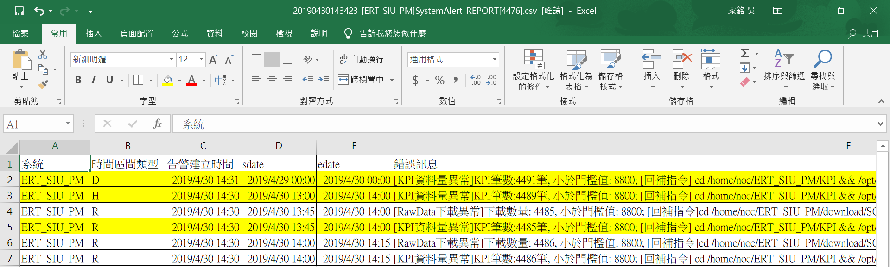

### 驗證Alert email與Alert DB告警數一致

* ssh登入SIU AP Server 主機，​IP 為172.26.37.4，用戶名為 noc
* 接收mail涵蓋的告警時間範圍:
  + 起: 2019-04-30 14:30:01
  + 迄: 2019-04-30 14:31:03
* Alert DB和Alert mail資料筆數:
  + Alert mail: 6
  + Alert DB: 6
* 資料筆數一致
* 查詢指令

用putty登入172.26.37.4後

#登入MySQL

mysql -uert_pm_parser -p

SELECT COUNT(*) FROM ERT_Alert.`system_alert` WHERE create_time >= '2019-04-30 14:30:01' AND create_time <= '2019-04-30 14:31:03' AND system = 'ERT_SIU_PM' AND `status` = 1\G

COUNT(*): 6

### 驗證Alert email與Alert DB測試告警內容一致

* ssh登入SIU AP Server 主機，​IP為172.26.37.4，用戶名為 noc
* 複製Alert DB和Alert mail的告警內容到下圖
  + R/H/D

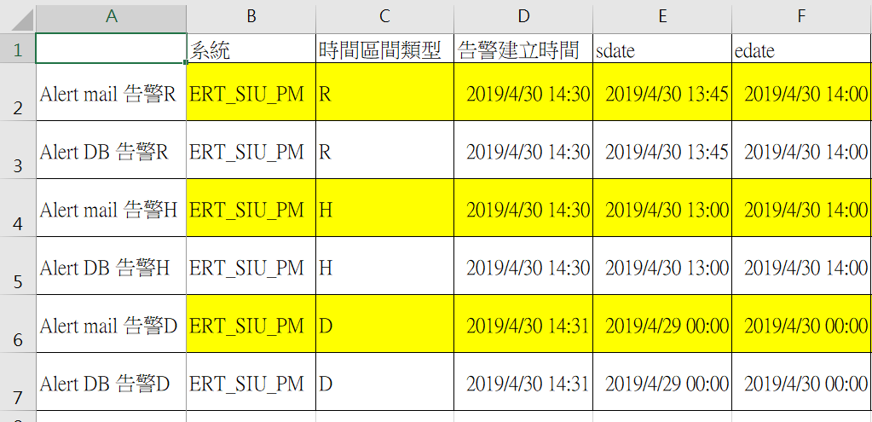

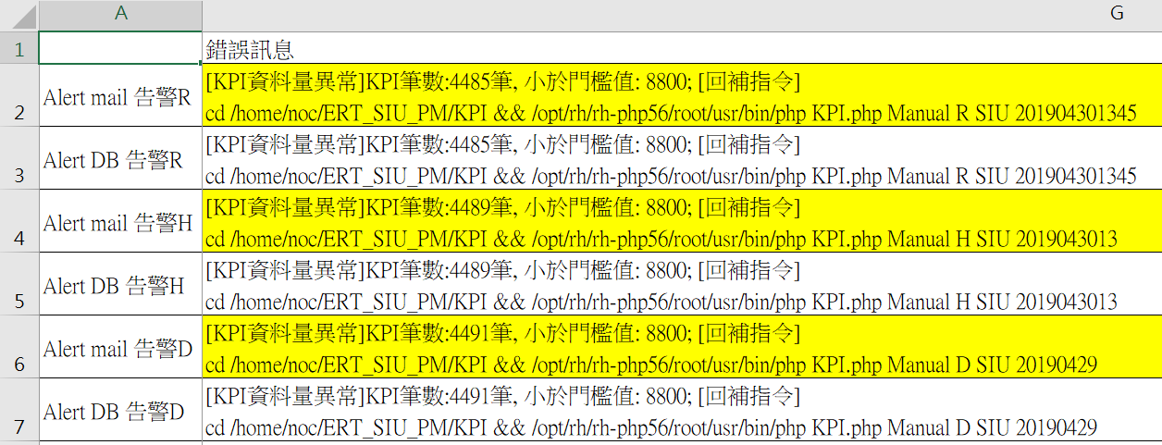

* 內容一致
* 指令

用putty登入172.26.37.4後

#登入MySQL

mysql -uert_pm_parser -p

-- 查詢KPI R告警

SELECT system AS '系統', period AS '時間區間類型', create_time AS '告警建立時間', sdate, edate, error_info AS '錯誤訊息' FROM ERT_Alert.`system_alert` WHERE system = 'ERT_SIU_PM' AND period = 'R' AND sdate = '2019-04-30 13:45:00' AND type = 'KPI' AND `status` = 1 \G

*************************** 1. row ***************************

系統: ERT_SIU_PM

時間區間類型: R

告警建立時間: 2019-04-30 14:30:39

sdate: 2019-04-30 13:45:00

edate: 2019-04-30 14:00:00

錯誤訊息: [KPI資料量異常]KPI筆數:4485筆, 小於門檻值: 8800; [回補指令] cd /home/noc/ERT_SIU_PM/KPI && /opt/rh/rh-php56/root/usr/bin/php KPI.php Manual R SIU 201904301345

-- 查詢KPI H告警

SELECT system AS '系統', period AS '時間區間類型', create_time AS '告警建立時間', sdate, edate, error_info AS '錯誤訊息' FROM ERT_Alert.`system_alert` WHERE system = 'ERT_SIU_PM' AND period = 'H' AND sdate = '2019-04-30 13:00:00' AND type = 'KPI' AND `status` = 1\G

*************************** 1. row ***************************

系統: ERT_SIU_PM

時間區間類型: H

告警建立時間: 2019-04-30 14:30:55

sdate: 2019-04-30 13:00:00

edate: 2019-04-30 14:00:00

錯誤訊息: [KPI資料量異常]KPI筆數:4489筆, 小於門檻值: 8800; [回補指令] cd /home/noc/ERT_SIU_PM/KPI && /opt/rh/rh-php56/root/usr/bin/php KPI.php Manual H SIU 2019043013

-- 查詢KPI D告警

SELECT system AS '系統', period AS '時間區間類型', create_time AS '告警建立時間', sdate, edate, error_info AS '錯誤訊息' FROM ERT_Alert.`system_alert` WHERE system = 'ERT_SIU_PM' AND period = 'D' AND sdate = '2019-04-29 00:00:00' AND type = 'KPI' AND `status` = 1 \G

*************************** 1. row ***************************

系統: ERT_SIU_PM

時間區間類型: D

告警建立時間: 2019-04-30 14:31:03

sdate: 2019-04-29 00:00:00

edate: 2019-04-30 00:00:00

錯誤訊息: [KPI資料量異常]KPI筆數:4491筆, 小於門檻值: 8800; [回補指令] cd /home/noc/ERT_SIU_PM/KPI && /opt/rh/rh-php56/root/usr/bin/php KPI.php Manual D SIU 20190429

### 環境復原

* 登入SIU DB Server 主機，​IP為172.26.37.4，用戶名為ert_pm_parser
* 設定值改回原本設定值
  + 復原後 min_size = 4400
* close測試告警
* 內容一致
* Alert DB查詢指令

用putty登入172.26.37.4後

#回查時段1

#登入MySQL

mysql -uert_pm_parser -p

-- 使用原本告警門檻值，下個週期如果正常用作必須不會發出告警

UPDATE ERT_Alert.compare_config SET min_size = min_size/2 WHERE system = 'ERT_SIU_PM';

Rows matched: 1 Changed: 1 Warnings: 0

SELECT min_size FROM ERT_Alert.compare_config WHERE system = 'ERT_SIU_PM'\G

min_size: 4400

-- 清除測試期間的告警 status 2就是不發mail

UPDATE ERT_Alert.`system_alert` SET `status` = 2 WHERE create_time >= '2019-04-30 14:30:01' AND system = 'ERT_SIU_PM';

Rows matched: 8 Changed: 8 Warnings: 0

### 環境復原驗證

* 恢復設定值後，手動執行Alert回查機制，確認系統不會產生告警
* 指令

用putty登入172.26.37.4後

#回查KPI R

cd /home/noc/ERT_PM_MONITOR/src && /opt/rh/rh-php56/root/usr/bin/php checkAlert.php Manual R 201904301345 201904301345

#回查KPI H

cd /home/noc/ERT_PM_MONITOR/src && /opt/rh/rh-php56/root/usr/bin/php checkAlert.php Manual H 201904301300 201904301300

#回查KPI D

cd /home/noc/ERT_PM_MONITOR/src && /opt/rh/rh-php56/root/usr/bin/php checkAlert.php Manual D 201904290000 201904290000

#登入MySQL

mysql -uert_pm_parser -p

-- 查詢KPI R告警

SELECT system AS '系統', period AS '時間區間類型', create_time AS '告警建立時間', sdate, edate, error_info AS '錯誤訊息' FROM ERT_Alert.`system_alert` WHERE system = 'ERT_SIU_PM' AND period = 'R' AND sdate = '2019-04-30 13:45:00' AND type = 'KPI' AND `status` = 1 \G

Empty set (0.00 sec)

-- 查詢KPI H告警

SELECT system AS '系統', period AS '時間區間類型', create_time AS '告警建立時間', sdate, edate, error_info AS '錯誤訊息' FROM ERT_Alert.`system_alert` WHERE system = 'ERT_SIU_PM' AND period = 'H' AND sdate = '2019-04-30 13:00:00' AND type = 'KPI' AND `status` = 1\G

Empty set (0.00 sec)

-- 查詢KPI D告警

SELECT system AS '系統', period AS '時間區間類型', create_time AS '告警建立時間', sdate, edate, error_info AS '錯誤訊息' FROM ERT_Alert.`system_alert` WHERE system = 'ERT_SIU_PM' AND period = 'D' AND sdate = '2019-04-29 00:00:00' AND type = 'KPI' AND `status` = 1 \G

Empty set (0.00 sec)

## 驗證總結

* ​​驗證R/H/D實際資料筆數與KPI執行紀錄一致(14.4.1, 14.4.2, 14.4.3)
* 驗證手動調整告警門檻值流程(14.4.4)
* 驗證KPI執行紀錄的資料筆數小於告警門檻值會產生告警訊息(14.4.4, 14.4.5)
* 驗證Alert機制根據告警訊息產生Alert email(14.4.6)
* 驗證Alert email告警訊息內容與Alert DB內容一致(14.4.7, 14.4.8, 14.4.9)
* 上述內容等於KPI R/H/D資料筆數低於告警門檻值時發Alert email

# 檢查counter (MAX/MIN/AVG/SUM)的值正確

|  |  |  |
| --- | --- | --- |
| Test Case | TC_15 | |
| Description | 檢查counter (MAX/MIN/AVG/SUM)的值正確，若實際上這套系統沒有用到某些公式，必須自訂公式進行測試 | |
| Test Execution | 1. 查詢現有的公式與counter的對照表  |  |  | | --- | --- | | 動作 | SQL | | 查詢各種公式的counter的數量 | SELECT Type, Formula, COUNT(*)  FROM ERT_Config.ERT_merge_formula  WHERE Type = 'ERT_SIU'  GROUP BY Formula; | | 查詢指定moclass現在的公式 | SELECT Type, `Table`, ColumnName, Formula  FROM ERT_Config.ERT_merge_formula  WHERE Type = 'ERT_SIU' AND `TABLE` = 'VLAN'; |  1. 挑選4個counter做測試  |  |  | | --- | --- | | 動作 | 操作說明 | | 選定測試的counter | 選擇counter及說明後續測試使用的合併公式 | | 尋找適合測試的資料(4個欄位的daily資料全不為0) | SELECT sdate,SubNetwork, ManagedElement, VLAN,  ifHCInBroadcastPkts,ifHCInMulticastPkts,  ifHCInOctets,ifHCInUcastPkts FROM ERT_SIU_D.VLAN  WHERE sdate > '2018-10-15' AND ifHCInBroadcastPkts > 0 AND ifHCInMulticastPkts > 0 AND  ifHCInOctets > 0 AND  ifHCInUcastPkts > 0 ; | | 修改公式 | UPDATE `ERT_Config`.`ERT_merge_formula` SET `Formula`='MAX' WHERE `Type`='ERT_SIU' AND `Table`='VLAN' AND `ColumnName`='ifHCInOctets';  UPDATE `ERT_Config`.`ERT_merge_formula` SET `Formula`='MIN' WHERE `Type`='ERT_SIU' AND `Table`='VLAN' AND `ColumnName`='ifHCInMulticastPkts';  UPDATE `ERT_Config`.`ERT_merge_formula` SET `Formula`='AVG' WHERE `Type`='ERT_SIU' AND `Table`='VLAN' AND `ColumnName`='ifHCInUcastPkts';  UPDATE `ERT_Config`.`ERT_merge_formula` SET `Formula`='SUM' WHERE `Type`='ERT_SIU' AND `Table`='VLAN' AND `ColumnName`='ifHCInBroadcastPkts';  SELECT Type, `Table`, ColumnName, Formula FROM ERT_Config.ERT_merge_formula  WHERE Type = 'ERT_SIU' AND `TABLE` = 'VLAN' AND `ColumnName`  IN ('ifHCInOctets', 'ifHCInMulticastPkts', 'ifHCInUcastPkts', 'ifHCInBroadcastPkts'); | | 使用回補counter重新計算 | date && cd /home/noc/ERT_SIU_PM/Cumulation && nohup php CumulationTool.php H 2018102300 2018102323 &  date && cd /home/noc/ERT_SIU_PM/Cumulation && nohup php CumulationTool.php D 20181023 20181023 & | | 查詢結果比較 | SET @minsdate = '2018-10-23', @maxsdate = '2018-10-24',  @SubNetwork = 'SIU_NK11', @ManagedElement = 'SIU_221031',  @VLAN = '3PP_eNB;3PP1VLAN_3';  SELECT 'D' Period, COUNT(*), sdate, ManagedElement,  MAX(ifHCInOctets), MIN(ifHCInMulticastPkts),  ROUND(AVG(ifHCInUcastPkts)), SUM(ifHCInBroadcastPkts)  FROM ERT_SIU_D.VLAN  WHERE sdate = @minsdate AND SubNetwork = @SubNetwork  AND ManagedElement = @ManagedElement AND VLAN= @VLAN  UNION ALL  SELECT 'H' Period, COUNT(*), sdate, ManagedElement,  MAX(ifHCInOctets), MIN(ifHCInMulticastPkts),  ROUND(AVG(ifHCInUcastPkts)), SUM(ifHCInBroadcastPkts)  FROM ERT_SIU_H.VLAN  WHERE sdate >= @minsdate AND sdate < @maxsdate  AND SubNetwork = @SubNetwork  AND ManagedElement = @ManagedElement AND VLAN= @VLAN  UNION ALL  SELECT 'R' Period, COUNT(*), sdate, ManagedElement,  MAX(ifHCInOctets), MIN(ifHCInMulticastPkts),  ROUND(AVG(ifHCInUcastPkts)), SUM(ifHCInBroadcastPkts)  FROM ERT_SIU_R.VLAN  WHERE sdate >= @minsdate AND sdate < @maxsdate  AND SubNetwork = @SubNetwork  AND ManagedElement = @ManagedElement AND VLAN= @VLAN | | 復原公式 | UPDATE `ERT_Config`.`ERT_merge_formula` SET `Formula`='AVG' WHERE `Type`='ERT_SIU' AND `Table`='VLAN' AND `ColumnName`='ifHCInOctets';  UPDATE `ERT_Config`.`ERT_merge_formula` SET `Formula`='AVG' WHERE `Type`='ERT_SIU' AND `Table`='VLAN' AND `ColumnName`='ifHCInMulticastPkts';  UPDATE `ERT_Config`.`ERT_merge_formula` SET `Formula`='AVG' WHERE `Type`='ERT_SIU' AND `Table`='VLAN' AND `ColumnName`='ifHCInUcastPkts';  UPDATE `ERT_Config`.`ERT_merge_formula` SET `Formula`='AVG' WHERE `Type`='ERT_SIU' AND `Table`='VLAN' AND `ColumnName`='ifHCInBroadcastPkts';  SELECT Type, `Table`, ColumnName, Formula FROM ERT_Config.ERT_merge_formula  WHERE Type = 'ERT_SIU' AND `TABLE` = 'VLAN' AND `ColumnName`  IN ('ifHCInOctets', 'ifHCInMulticastPkts', 'ifHCInUcastPkts', 'ifHCInBroadcastPkts'); | | 使用回補counter重新計算 | date && cd /home/noc/ERT_SIU_PM/Cumulation && nohup php CumulationTool.php H 2018102300 2018102323 &  date && cd /home/noc/ERT_SIU_PM/Cumulation && nohup php CumulationTool.php D 20181023 20181023 &  測試當天 2018-11-01 Counter H  date && cd /home/noc/ERT_SIU_PM/Cumulation && nohup php CumulationTool.php H 2018110112 2018110116 &  測試當天 2018-11-01 KPI H  date && cd /home/noc/ERT_SIU_PM/KPI && nohup php KPITool.php H 2018110112 2018110116 & | | |
| Excepted Result | 1. 查詢現有的公式與counter的對照表  |  |  | | --- | --- | | 動作 | 截圖 | | 查詢各種公式的counter的數量 |  | | 查詢指定moclass現在的公式 |  |  1. 挑選4個counter做測試  |  |  | | --- | --- | | 動作 | 操作說明 | | 選定測試的counter | ifHCInBroadcastPkts改為MAX,  ifHCInMulticastPkts改為MIN,  ifHCInOctets改為AVG,  ifHCInUcastPkts改為SUM | | 尋找適合測試的資料(4個欄位的daily資料全不為0) | 選擇20181023進行測試 | | 修改公式 |  | | 使用回補counter重新計算 | 2018-10-23 H      2018-10-23 D | | 查詢結果比較 | 為什麼MIN(ifHCInMulticastPkts)都是0?請見下圖分析  R:    H:    由上圖可見只要有一整個小時的4個R都是0就會導致H有0的值，24個H取其最小值必然為0 | | 復原公式 |  | | 使用回補counter重新計算 | 2018-10-23 H      2018-10-23 D      測試當天 2018-11-01 Counter H      測試當天 2018-11-01 KPI H | | |
| Result: | ■ OK □ NOK |

# 能自訂counter 的滙整規則( MAX/MIN/AVG/SUM)

|  |  |  |
| --- | --- | --- |
| Test Case | TC_16 | |
| Description | 能自訂counter 的滙整規則( MAX/MIN/AVG/SUM) | |
| Test Execution | 1. 說明如何設定counter的彙整公式 2. 挑選1~4個適合測試的counter  |  |  | | --- | --- | | 動作 | SQL | | 找出未定義的counter | SELECT TABLE_NAME, COLUMN_NAME  FROM INFORMATION_SCHEMA.COLUMNS AS isc  LEFT JOIN ERT_Config.`ERT_merge_formula` AS EMF ON EMF.Type = 'ERT_SIU' AND  EMF.`Table` = isc.TABLE_NAME AND  EMF.ColumnName = isc.COLUMN_NAME  WHERE isc.TABLE_SCHEMA='ERT_SIU_R'  AND EMF.Type IS NULL | | 尋找daily資料不為0的counter及日期，PK | SELECT  sdate, SubNetwork, ManagedElement, Synchronization,  SUM(IFNULL(TS_NoTS_Reselections ,0))  FROM ERT_SIU_D.Synchronization WHERE  sdate >= '2018-10-25'  GROUP BY sdate, SubNetwork, ManagedElement, Synchronization  HAVING SUM(IFNULL(TS_NoTS_Reselections ,0)) > 0 |   PS. 實際測試時選出   |  |  |  |  | | --- | --- | --- | --- | | sdate | SubNetwork | ManagedElement | Synchronization | | 2018-10-28 00:00:00 | SIU_KH12 | SIU_704020 | 0 |  1. 驗證4種公式   3.1 MAX   |  |  | | --- | --- | | 動作 | SQL | | 新增規則 | INSERT INTO `ERT_Config`.`ERT_merge_formula` (`Type`, `Table`, `ColumnName`, `Formula`) VALUES ('ERT_SIU', 'Synchronization', 'TS_NoTS_Reselections', 'MAX');  SELECT Type, `Table`, ColumnName, Formula FROM ERT_Config.ERT_merge_formula  WHERE Type = 'ERT_SIU' AND `TABLE` = 'Synchronization ' AND `ColumnName` = 'TS_NoTS_Reselections'; | | 使用回補counter重新計算 | date && cd /home/noc/ERT_SIU_PM/Cumulation && nohup php CumulationTool.php H 2018102800 2018102823 &  date && cd /home/noc/ERT_SIU_PM/Cumulation && nohup php CumulationTool.php D 20181028 20181028 & | | 查詢結果比較 | SET @minsdate = '2018-10-28', @maxsdate = '2018-10-29',  @SubNetwork = 'SIU_KH12', @ManagedElement = 'SIU_704020',  @Synchronization = '0';  SELECT 'D' Period, COUNT(*), sdate, ManagedElement,  MAX(TS_NoTS_Reselections)  FROM ERT_SIU_D.Synchronization  WHERE sdate = @minsdate AND SubNetwork = @SubNetwork  AND ManagedElement = @ManagedElement  AND Synchronization= @Synchronization  UNION ALL  SELECT 'H' Period, COUNT(*), sdate, ManagedElement,  MAX(TS_NoTS_Reselections)  FROM ERT_SIU_H.Synchronization  WHERE sdate >= @minsdate AND sdate < @maxsdate  AND SubNetwork = @SubNetwork  AND ManagedElement = @ManagedElement  AND Synchronization= @Synchronization  UNION ALL  SELECT 'R' Period, COUNT(*), sdate, ManagedElement,  MAX(TS_NoTS_Reselections)  FROM ERT_SIU_R.Synchronization  WHERE sdate >= @minsdate AND sdate < @maxsdate  AND SubNetwork = @SubNetwork  AND ManagedElement = @ManagedElement  AND Synchronization= @Synchronization; | | 刪除公式 | DELETE FROM ERT_Config.ERT_merge_formula  WHERE Type = 'ERT_SIU' AND `TABLE` = 'Synchronization ' AND `ColumnName` = 'TS_NoTS_Reselections';  SELECT Type, `Table`, ColumnName, Formula FROM ERT_Config.ERT_merge_formula  WHERE Type = 'ERT_SIU' AND `TABLE` = 'Synchronization' AND `ColumnName` = 'TS_NoTS_Reselections'; | | 使用回補counter重新計算 | date && cd /home/noc/ERT_SIU_PM/Cumulation && nohup php CumulationTool.php H 2018102300 2018102323 &  date && cd /home/noc/ERT_SIU_PM/Cumulation && nohup php CumulationTool.php D 20181023 20181023 &  20181102測試期間counter資料回補  date && cd /home/noc/ERT_SIU_PM/Cumulation && nohup php CumulationTool.php H 2018110211 2018110216 &  20181102測試期間KPI資料回補  date && cd /home/noc/ERT_SIU_PM/KPI && nohup php KPITool.php H 2018110211 2018110216 & |   3.2 MIN   |  |  | | --- | --- | | 動作 | SQL | | 新增規則 | INSERT INTO `ERT_Config`.`ERT_merge_formula` (`Type`, `Table`, `ColumnName`, `Formula`) VALUES ('ERT_SIU', 'Synchronization', 'TS_NoTS_Reselections', 'MIN');  SELECT Type, `Table`, ColumnName, Formula FROM ERT_Config.ERT_merge_formula  WHERE Type = 'ERT_SIU' AND `TABLE` = 'Synchronization ' AND `ColumnName` = 'TS_NoTS_Reselections'; | | 使用回補counter重新計算 | date && cd /home/noc/ERT_SIU_PM/Cumulation && nohup php CumulationTool.php H 2018102800 2018102823 &  date && cd /home/noc/ERT_SIU_PM/Cumulation && nohup php CumulationTool.php D 20181028 20181028 & | | 查詢結果比較 | SET @minsdate = '2018-10-28', @maxsdate = '2018-10-29',  @SubNetwork = 'SIU_KH12', @ManagedElement = 'SIU_704020',  @Synchronization = '0';  SELECT 'D' Period, COUNT(*), sdate, ManagedElement,  MIN(TS_NoTS_Reselections)  FROM ERT_SIU_D.Synchronization  WHERE sdate = @minsdate AND SubNetwork = @SubNetwork  AND ManagedElement = @ManagedElement  AND Synchronization= @Synchronization  UNION ALL  SELECT 'H' Period, COUNT(*), sdate, ManagedElement,  MIN(TS_NoTS_Reselections)  FROM ERT_SIU_H.Synchronization  WHERE sdate >= @minsdate AND sdate < @maxsdate  AND SubNetwork = @SubNetwork  AND ManagedElement = @ManagedElement  AND Synchronization= @Synchronization  UNION ALL  SELECT 'R' Period, COUNT(*), sdate, ManagedElement,  MIN(TS_NoTS_Reselections)  FROM ERT_SIU_R.Synchronization  WHERE sdate >= @minsdate AND sdate < @maxsdate  AND SubNetwork = @SubNetwork  AND ManagedElement = @ManagedElement  AND Synchronization= @Synchronization; | | 刪除公式 | DELETE FROM ERT_Config.ERT_merge_formula  WHERE Type = 'ERT_SIU' AND `TABLE` = 'Synchronization ' AND `ColumnName` = 'TS_NoTS_Reselections';  SELECT Type, `Table`, ColumnName, Formula FROM ERT_Config.ERT_merge_formula  WHERE Type = 'ERT_SIU' AND `TABLE` = 'Synchronization' AND `ColumnName` = 'TS_NoTS_Reselections'; | | 使用回補counter重新計算 | date && cd /home/noc/ERT_SIU_PM/Cumulation && nohup php CumulationTool.php H 2018102800 2018102823 &  date && cd /home/noc/ERT_SIU_PM/Cumulation && nohup php CumulationTool.php D 20181028 20181028 &  20181102測試期間counter資料回補  date && cd /home/noc/ERT_SIU_PM/Cumulation && nohup php CumulationTool.php H 2018110211 2018110216 &  20181102測試期間KPI資料回補  date && cd /home/noc/ERT_SIU_PM/KPI && nohup php KPITool.php H 2018110211 2018110216 & |   3.3 AVG   |  |  | | --- | --- | | 動作 | SQL | | 新增規則 | INSERT INTO `ERT_Config`.`ERT_merge_formula` (`Type`, `Table`, `ColumnName`, `Formula`) VALUES ('ERT_SIU', 'Synchronization', 'TS_NoTS_Reselections', 'AVG');  SELECT Type, `Table`, ColumnName, Formula FROM ERT_Config.ERT_merge_formula  WHERE Type = 'ERT_SIU' AND `TABLE` = 'Synchronization ' AND `ColumnName` = 'TS_NoTS_Reselections'; | | 使用回補counter重新計算 | date && cd /home/noc/ERT_SIU_PM/Cumulation && nohup php CumulationTool.php H 2018102800 2018102823 &  date && cd /home/noc/ERT_SIU_PM/Cumulation && nohup php CumulationTool.php D 20181028 20181028 & | | 查詢結果比較 | SET @minsdate = '2018-10-28', @maxsdate = '2018-10-29',  @SubNetwork = 'SIU_KH12', @ManagedElement = 'SIU_704020',  @Synchronization = '0';  SELECT 'D' Period, COUNT(*), sdate, ManagedElement,  ROUND(AVG(TS_NoTS_Reselections))  FROM ERT_SIU_D.Synchronization  WHERE sdate = @minsdate AND SubNetwork = @SubNetwork  AND ManagedElement = @ManagedElement  AND Synchronization= @Synchronization  UNION ALL  SELECT 'H' Period, COUNT(*), sdate, ManagedElement,  ROUND(AVG(TS_NoTS_Reselections))  FROM ERT_SIU_H.Synchronization  WHERE sdate >= @minsdate AND sdate < @maxsdate  AND SubNetwork = @SubNetwork  AND ManagedElement = @ManagedElement  AND Synchronization= @Synchronization  UNION ALL  SELECT 'R' Period, COUNT(*), sdate, ManagedElement,  ROUND(AVG(TS_NoTS_Reselections))  FROM ERT_SIU_R.Synchronization  WHERE sdate >= @minsdate AND sdate < @maxsdate  AND SubNetwork = @SubNetwork  AND ManagedElement = @ManagedElement  AND Synchronization= @Synchronization; | | 刪除公式 | DELETE FROM ERT_Config.ERT_merge_formula  WHERE Type = 'ERT_SIU' AND `TABLE` = 'Synchronization ' AND `ColumnName` = 'TS_NoTS_Reselections';  SELECT Type, `Table`, ColumnName, Formula FROM ERT_Config.ERT_merge_formula  WHERE Type = 'ERT_SIU' AND `TABLE` = 'Synchronization' AND `ColumnName` = 'TS_NoTS_Reselections'; | | 使用回補counter重新計算 | date && cd /home/noc/ERT_SIU_PM/Cumulation && nohup php CumulationTool.php H 2018102800 2018102823 &  date && cd /home/noc/ERT_SIU_PM/Cumulation && nohup php CumulationTool.php D 20181028 20181028 &  20181102測試期間counter資料回補  date && cd /home/noc/ERT_SIU_PM/Cumulation && nohup php CumulationTool.php H 2018110211 2018110216 &  20181102測試期間KPI資料回補  date && cd /home/noc/ERT_SIU_PM/KPI && nohup php KPITool.php H 2018110211 2018110216 & |   3.4 SUM   |  |  | | --- | --- | | 動作 | SQL | | 新增規則 | INSERT INTO `ERT_Config`.`ERT_merge_formula` (`Type`, `Table`, `ColumnName`, `Formula`) VALUES ('ERT_SIU', 'Synchronization', 'TS_NoTS_Reselections', 'SUM');  SELECT Type, `Table`, ColumnName, Formula FROM ERT_Config.ERT_merge_formula  WHERE Type = 'ERT_SIU' AND `TABLE` = 'Synchronization ' AND `ColumnName` = 'TS_NoTS_Reselections'; | | 使用回補counter重新計算 | date && cd /home/noc/ERT_SIU_PM/Cumulation && nohup php CumulationTool.php H 2018102800 2018102823 &  date && cd /home/noc/ERT_SIU_PM/Cumulation && nohup php CumulationTool.php D 20181028 20181028 & | | 查詢結果比較 | SET @minsdate = '2018-10-28', @maxsdate = '2018-10-29',  @SubNetwork = 'SIU_KH12', @ManagedElement = 'SIU_704020',  @Synchronization = '0';  SELECT 'D' Period, COUNT(*), sdate, ManagedElement,  SUM(TS_NoTS_Reselections)  FROM ERT_SIU_D.Synchronization  WHERE sdate = @minsdate AND SubNetwork = @SubNetwork  AND ManagedElement = @ManagedElement  AND Synchronization= @Synchronization  UNION ALL  SELECT 'H' Period, COUNT(*), sdate, ManagedElement,  SUM(TS_NoTS_Reselections)  FROM ERT_SIU_H.Synchronization  WHERE sdate >= @minsdate AND sdate < @maxsdate  AND SubNetwork = @SubNetwork  AND ManagedElement = @ManagedElement  AND Synchronization= @Synchronization  UNION ALL  SELECT 'R' Period, COUNT(*), sdate, ManagedElement,  SUM(TS_NoTS_Reselections)  FROM ERT_SIU_R.Synchronization  WHERE sdate >= @minsdate AND sdate < @maxsdate  AND SubNetwork = @SubNetwork  AND ManagedElement = @ManagedElement  AND Synchronization= @Synchronization; | | 刪除公式 | DELETE FROM ERT_Config.ERT_merge_formula  WHERE Type = 'ERT_SIU' AND `TABLE` = 'Synchronization ' AND `ColumnName` = 'TS_NoTS_Reselections';  SELECT Type, `Table`, ColumnName, Formula FROM ERT_Config.ERT_merge_formula  WHERE Type = 'ERT_SIU' AND `TABLE` = 'Synchronization' AND `ColumnName` = 'TS_NoTS_Reselections'; | | 使用回補counter重新計算 | date && cd /home/noc/ERT_SIU_PM/Cumulation && nohup php CumulationTool.php H 2018102800 2018102823 &  date && cd /home/noc/ERT_SIU_PM/Cumulation && nohup php CumulationTool.php D 20181028 20181028 &  20181102測試期間counter資料回補  date && cd /home/noc/ERT_SIU_PM/Cumulation && nohup php CumulationTool.php H 2018110211 2018110216 &  20181102測試期間KPI資料回補  date && cd /home/noc/ERT_SIU_PM/KPI && nohup php KPITool.php H 2018110211 2018110216 & | | |
| Excepted Result | 1. 說明如何設定counter的彙整公式   SQL : DB IP:172.26.37.4  INSERT INTO `ERT_Config`.`ERT_merge_formula` (`Type`, `Table`, `ColumnName`, `Formula`) VALUES ('系統別', '資料表名稱', '欄位名稱', '公式');   |  |  | | --- | --- | | 參數名稱 | 參數值或參數值說明 | | 系統別 | ERT_SIU | | 資料表名稱 | ERT的Raw Data的moclass | | 欄位名稱 | counter name | | 公式 | MAX/MIN/AVG/SUM |      1. 挑選1~4個適合測試的counter  |  |  | | --- | --- | | 動作 | SQL | | 找出未定義的counter |  | | 尋找daily資料不為0的counter及日期，PK |  |   選出進行後續測試   |  |  |  |  | | --- | --- | --- | --- | | sdate | SubNetwork | ManagedElement | Synchronization | | 2018-10-28 00:00:00 | SIU_KH12 | SIU_704020 | 0 |  1. 驗證4種公式   3.1 MAX   |  |  | | --- | --- | | 動作 | SQL | | 新增規則 |  | | 使用回補counter重新計算 | 20181028 H      20181028 D | | 查詢結果比較 |  | | 刪除公式 |  | | 使用回補counter重新計算 | 20181028 H      20181028 D      20181102測試期間counter資料回補      20181102測試期間KPI資料回補 |   3.2 MIN   |  |  | | --- | --- | | 動作 | SQL | | 新增規則 |  | | 使用回補counter重新計算 | 20181028 H      20181028 D | | 查詢結果比較 |  | | 刪除公式 |  | | 使用回補counter重新計算 | 20181028 H      20181028 D      20181102測試期間counter資料回補      20181102測試期間KPI資料回補 |   3.3 AVG   |  |  | | --- | --- | | 動作 | SQL | | 新增規則 |  | | 使用回補counter重新計算 | 20181028 H      20181028 D | | 查詢結果比較 |  | | 刪除公式 |  | | 使用回補counter重新計算 | 20181028 H      20181028 D      20181102測試期間counter資料回補      20181102測試期間KPI資料回補 |   3.4 SUM   |  |  | | --- | --- | | 動作 | SQL | | 新增規則 |  | | 使用回補counter重新計算 | 20181028 H      20181028 D | | 查詢結果比較 |  | | 刪除公式 |  | | 使用回補counter重新計算 | 20181028 H      20181028 D      20181102測試期間counter資料回補      20181102測試期間KPI資料回補 | | |
| Result: | ■ OK □ NOK |

# 驗證Parsing Log 是否生成

|  |  |  |
| --- | --- | --- |
| Test Case | TC_17 | |
| Description | 驗證Parsing Log 是否生成 | |
| Test Execution | 1. 檢查log是否生成 2. 截圖log | |
| Excepted Result | 1. log路徑: /home/noc/ERT_SIU_PM/log 2. log清單:  |  |  | | --- | --- | | 功能 | 檔名 | | 檔案下載排程 | trace_scpDownloadFile2018-10-25.log | | 資料轉換排程 | trace_insert2db2018-10-25.log | | 期間合併排程 | trace_Cumulation2018-10-25.log | | KPI計算排程 | trace_KPI2018-10-25.log |  1. log截圖   今日生成log    檔案下載排程:    資料轉換排程:    期間合併排程:    KPI計算排程: | |
| Result: | ■ OK □ NOK |